


EPI INFO™ GUIDE TO
CHECK CODE
Preface

Epi Info™ is a public domain suite of interoperable software tools designed for the global community of public health practitioners and researchers. Perform data analysis with epidemiologic statistics, maps, and graphs. Build data entry forms, construct a database, and customize statistics applications. Physicians, Epidemiologists, and public health officials without a technical background can easily work with critical data using Epi Info™ tools.
Use this guide alone or as a supplement to other Epi Info™ guides. On the next page, view the complete collection of helpful guides available for Epi Info™ tools. The diagram shows how this guide highlighted with the bookmark icon fits into the big picture of the Epi Info™ suite. Additional guides may offer prerequisite information for the tool you’re working with. For example, if you’re working with Epi Info™ Check Code (EICC), then you are using code to customize fields in Form Designer. Therefore, you may need to begin by consulting the Epi Info™ Guide to Form Designer and Epi Info™ Guide as indicated by the prerequisite documentation icon (). Additionally, you may find helpful other guides that are indicated by the optional documentation icon ().

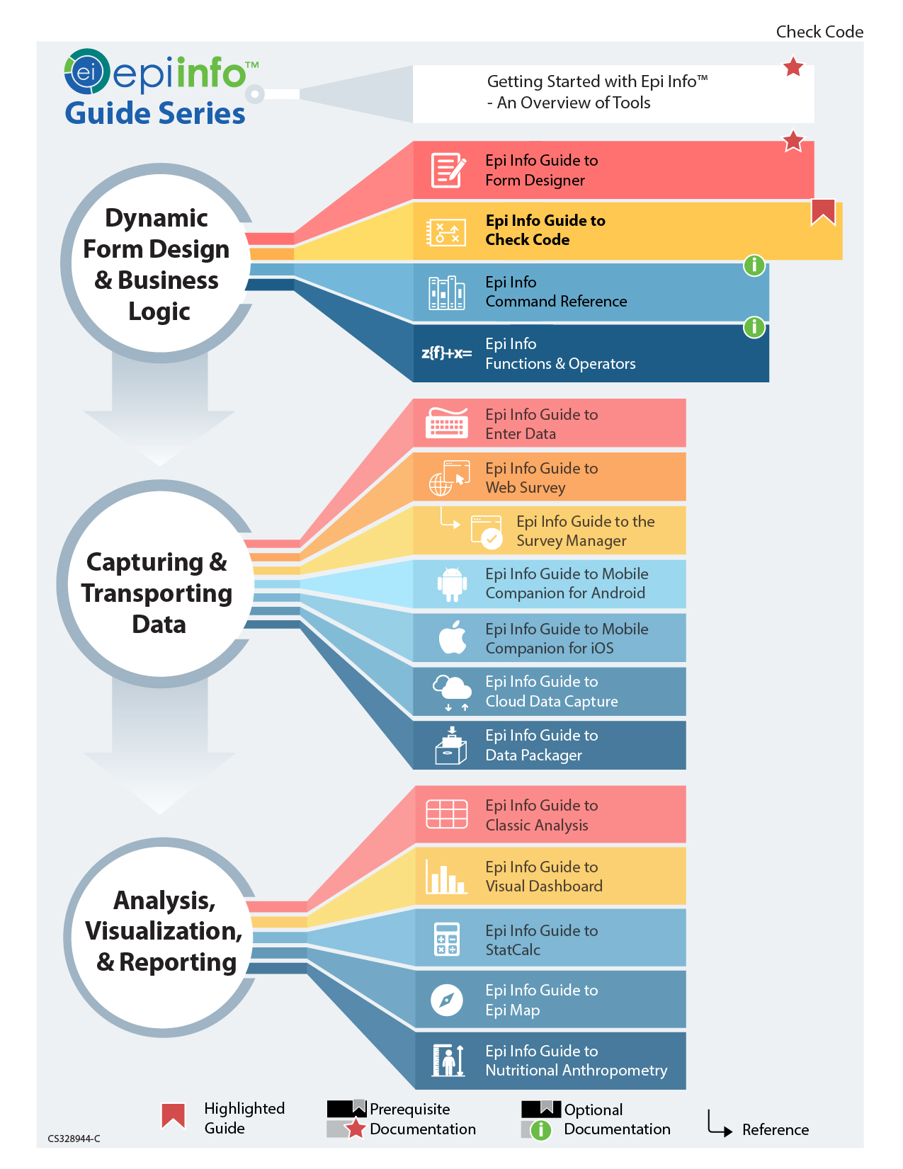

This page has been intentionally left blank.
TABLE OF CONTENTS
Introduction 1
Accessing Check Code Program Editor 2
Navigating Check Code Program Editor 2
Check Code Commands 4
Basic Check Code Command Rules 6
Create a Check Code Block 6
Create a Skip Pattern with GOTO 9
Using Functions with a Date Field 15
Interact with Users using the DIALOG Command 18
Searching for Records – Using the AUTOSEARCH Command 21
Copy Field Values from Main Forms to Related Forms 25
Concatenate Fields 29
Concatenate Fields with the Ampersand '&' Operator 29
Concatenate Fields with the Substring Function 31
Create Check Code for Option Box Fields 34
Delete a Line of Code from the Check Code Editor 36
Additional Check Code Commands 36
CALL 37
CLEAR 39
DEFINE 40
DISABLE 41
HIDE/UNHIDE 45
ENABLE/DISABLE 48
EXECUTE 49
GEOCODE 51
HELP 55
NEWRECORD 56
QUIT 56
Check Features Covered Elsewhere 58
How to Use the Epiweek Function 59
Proper Check Code Syntax 60

This Page has been intentionally left blank.

Check Code: Customizing the Data Entry Process

Introduction

The Check Code tool allows users to customize the data entry process. Use Check Code to check for errors during data entry, conduct automatic calculations in survey fields, and to skip parts of the survey if they meet certain conditions. Protect collected data against many common errors by creating rules for data entry. Check Code operations run each time a participant enters data or when triggered by certain values. Check Code is optional but advantageous. It provides a customized data entry process.
Check Code operations include:
- Displaying messages that appear to be part of the questionnaire
- Calculating fields from mathematical operations
- Checking one or more fields for relationships (e.g., making sure birth date is earlier than current date)
- Checking fields for inconsistencies (e.g., vaccination date is entered but response stated that record was not vaccinated)
- Displaying error messages because of improper entries in a field
- Complex statistics or other operations, written in other languages
- Field automatic indexing for faster searching
- Automatic searches during data entry

Accessing Check Code Program Editor

Click the Check Code button to navigate to the Check Code Program Editor in the Form Designer tool bar after opening your Epi Info™ 7 project.
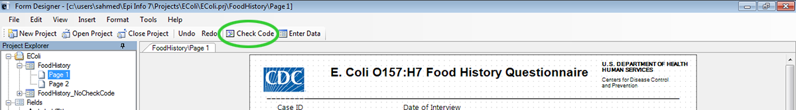

Check Code button

You can also select Tools > Check Code Editor from the Form Designer navigation menu.
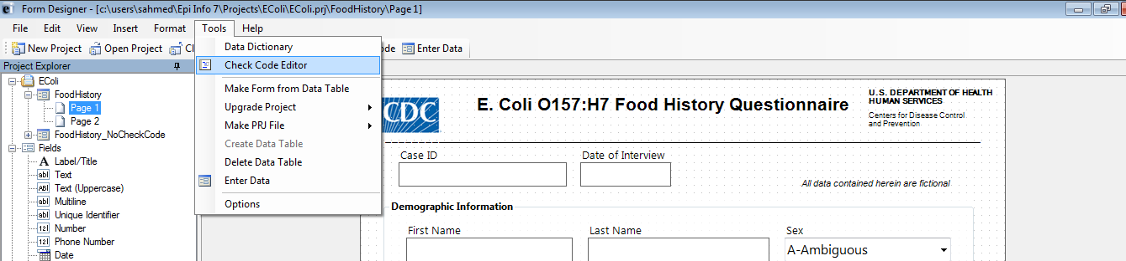
Form Designer menu

Navigating Check Code Program Editor

The Check Code Editor window contains four sections:
- Choose Field Block for Action
- Add Command to Field Block
- Program Editor
- Messages

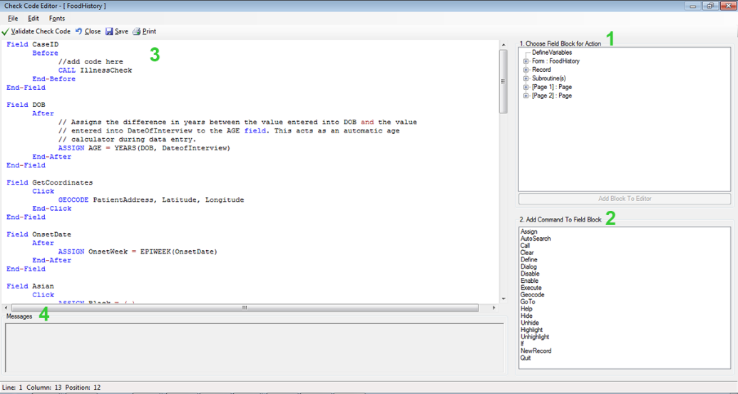

Check Code Program Editor
Sections:
- Choose Field Block for Action tree — allows you to select form fields and establishes when Check Code Commands occur during data entry.
- Add Command to Field Block window — displays all current Check Code commands in the Form Designer program.
- Program Editor window — displays the code generated by commands created from Choose Field Block for Action or Add Command to Field Block window. Users can also type directly and save the code into the Program Editor.
- Message window — alerts the user of any check command problems.
There are several options on the toolbar at the top left, allowing you to save, edit, validate, and change fonts in Program Editor.
Close Check Code Program Editor and return to your form by clicking on the X button at the top right of your screen. You can also click on the Close button or press the F10 key.

Check Code Commands
Check Code commands must be within a field-name block. Command blocks begins with a field, page or form name and end with the word End. Commands in a block, activate before or after entering data into a field. For some field types, blocks activate when clicking on the control (i.e.: checkboxes and command buttons). Usually, commands activate after the user presses the Enter key, or when the cursor has left the field. Change command activation by placing commands in Before blocks. Below is a list of typical Check Code formatting:
Field <Variablename>
After
—Check Code syntax inserted here—
End-After
End-Field

- Field parameter establishes a field name and the beginning of a corresponding Check Code block.
- After parameter specifies when actions occur. An After event executes as soon as the cursor leaves the field. Before and Click are the other two events supported. A Click event executes when the user clicks on the field and is only supported for Legal Values, Comment Legal, Checkboxes, and Command buttons. The Before event executes as soon as the cursor moves into the field.
- End-After parameter specifies the end of the command execution of Check Code. Code is placed between the After and End-After sections and code gets executed after the cursor leaves the field.
- End-Field parameter closes a block of commands for the corresponding field.

In the example below, we have incorporated an After event for a field called DOB. The Check Code block executes a value assignment to the field Age, using the YEARS function. The YEARS function calculates the difference between two date fields and provides the results in number of years.
Field DOB
After
ASSIGN AGE = YEARS(DOB, SYSTEMDATE)
End-After
End-Field

Basic Check Code Command Rules
- Always place Check Code commands in a block corresponding to a variable/field in the form. Execute commands in provided sections, before or after you display a form, page, or record.
- Place comments preceded by two forward slashes ("//") within blocks of commands. Comments are ignored during the execution of Check Code.
- Block commands activate:
- Before or after you make an entry in the field or when you click on the field (if Legal Value, Comment Legal, Checkbox, or Command button).
- After completing an entry with Enter, PgUp, PgDn, or Tab.
- When a command moves the cursor out of the field (e.g., GOTO).

- Form field records, contain Check commands.
- User interaction with the dialog boxes triggers Check commands. Syntax is displayed in the Check Code Editor. You can edit and save text in the Program Editor.
- Insert Before and After commands into forms, fields, pages, or records.

Create a Check Code Block
Steps:
- Select and expand the form, page, record, or field that will receive the commands. Expand by clicking the + sign.
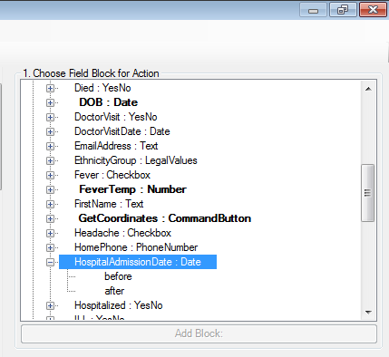
Choose Field Block for Action: Date
- Select command execution. (i.e.: before or after data entry into the form, page, record, or field. View the example using after, below).
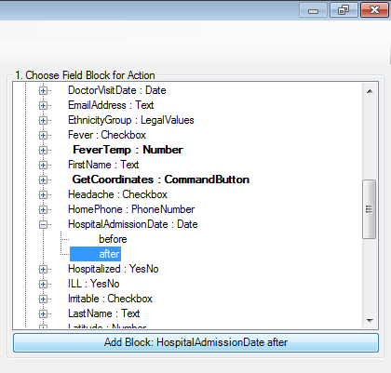
After event
- Double-click on the after event or click on the after event and then click the Add Block button to insert the block. The Check Code block appears in the Check Code editor.

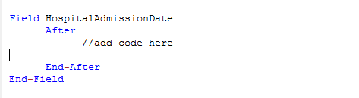
Code Block added
Insert commands within a new Check Code block using the Add Command to Field Block section.

Create a Skip Pattern with GOTO
Create skip patterns by changing tab order and setting new cursor sequences in forms. Try creating Check Code using the GOTO command. Create skip patterns for answers to questions using IF/THEN statements. In the following example, added Check Code moves the cursor to the Ethnicity field after participants enter data into the DOB field and skipping the AGE field.
Steps:
- Open the Ecoli.prj project from Form Designer,
- Double click on the FoodHistory_NoCheckCode form.
- Click Check Code or select Tools > Check Code Editor. The Check Code Editor opens.
- Expand the node for Page 1, from the Choose Field Block for Action section and view the various fields on the first page.
- Expand the node for the field DOB.
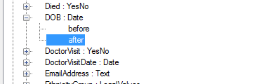
Dialog Block for action After DOB

- Double click on the after event.
- A block of code for the DOB field displays in the Check Code editor.
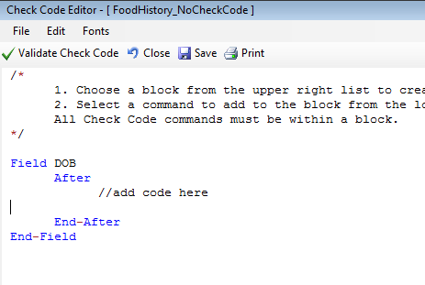
Check Code Block for Action
Click GOTO from the Add Command To Field Block list box. The GOTO dialog box opens.
Select the EthnicityGroup field for cursor placement, after an entry in the DOB field. The code will run after the cursor leaves the field.
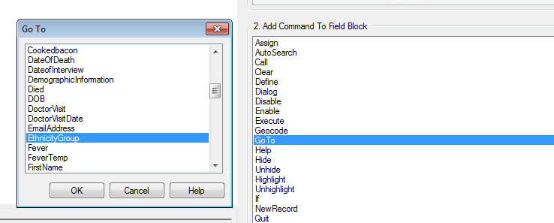
Skip Pattern GoTo dialog box
Click OK. The code appears in the Check Code Editor.
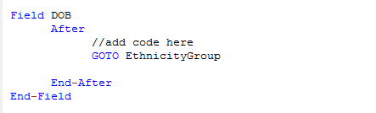
Skip Pattern Check Code Command
Follow the next series of actions to verify your syntax:
- Click Verify Check Code from the Check Code Editor.
- Click Save from the Check Code Editor.
- Click Close to return to the form.

Test the skip pattern by opening the form in the Enter Data tool. Move to the Data of Birth field and press the tab key to execute the GOTO command.
Create a skip pattern using IF/THEN and GOTO.
Use IF/THEN statements to create skip patterns based on answers to questions in the form. This example creates code for a participant who answers “No” for the Hospitalized field, then the cursor jumps to the field: Was the patient treated with antibiotics? Then, skips the Hospital Admission date field.
- From Form Designer, Open the Ecoli.prj project.
- Double click on the FoodHistory_NoCheckCode form.
- Click Check Code or select Tools > Check Code Editor. The Check Code Editor opens.
- From the Choose Field Block for Action section, expand the node for the first page and view the various fields.
- Expand the node for the Hospitalized field.
- The action occurs after a respondent fills in the Hospitalized field.
- Double click on the after event.
- Check Code Editor displays a block of code for the Hospitalized field.
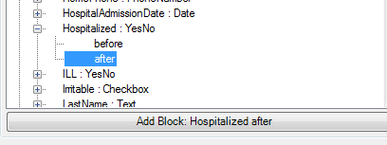
Dialog Block for Action After Hospitalized
- The Check Code Editor displays the code.
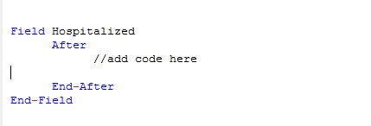
IF/THEN Block Code After Hospitalized
- Click If from the Add Command to Field Block list box. The If dialog box opens.
- Select the field from the Available Variables drop-down list to contain the action. For this example, select Hospitalized. The selected variable appears in the If Condition field.
- Click the = operator from the operators list,
- Click No from the operators list. The If Condition field will read Hospitalized = (-).
- Click the code snippet button in the Then section. A list of commands appears.
- From the command list, select GOTO. The GOTO dialog box opens.
- Select the field for cursor placement if the participant answers, No, from the list of variables. For this example, select Antibiotics.
- In the GOTO dialog box, click OK to return to the If dialog box.
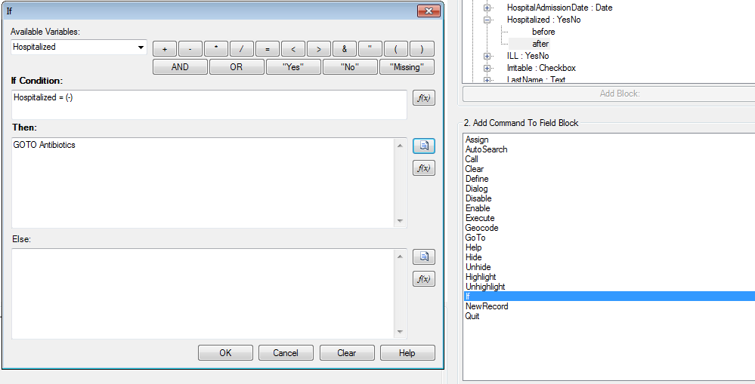
IF/THEN dialog box

Click OK. The Check Code editor displays the code. The example code appears:
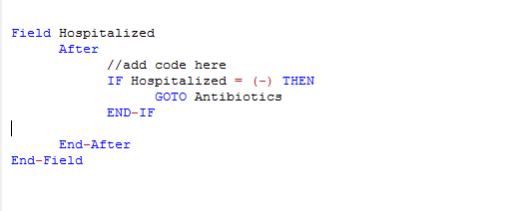
IF/THEN Check Code Command
- Click the Verify Check Code button from the Check Code Editor.
- Click the Save, from the Check Code Editor.

Using Functions with a Date Field
To program a mathematical function, use the Program Editor and ASSIGN command. For example, Check Code calculates the age of a participant based on date of birth and the form completion date (calibrated to the system date).
This example uses the Date Of Birth (DOB) and Age fields. (i.e.: from the FoodHistory_NoCheckCode form in the E. coli project). The example demonstrates the ASSIGN command and the function, YEARS.
- Click Check Code or select Tools > Check Code Editor. The Check Code Editor opens.
- Expand the node from the Choose Field Block for Action section, where the DOB field is located (i.e. Page 1)
- Expand the node for the date of birth field called DOB.
- Double click on the after event.
- The Check Code Editor displays a block of code for the DOB field.
- Click Assign, from the Add Command to Field Block list box. The Assign dialog box opens.
- Select the field where the calculated value should appear.
- Select the Age field from the Assign Variable drop-down list.
- Click on the functions button.
- Select the Date Functions option.
- Click on the YEARS function.
- Double click on the <start_date> parameter. This highlights the command section.
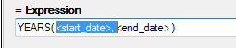
Start Date Parameter
- Select DOB from the list of variables
- Double click on the <end_date> parameter. This action highlights the command section.
End Date Parameter
- Click on the functions button that looks like
- Select the System Functions option.
- Click the SYSTEMDATE function. Once completed, the inserted syntax appears in the dialog window.
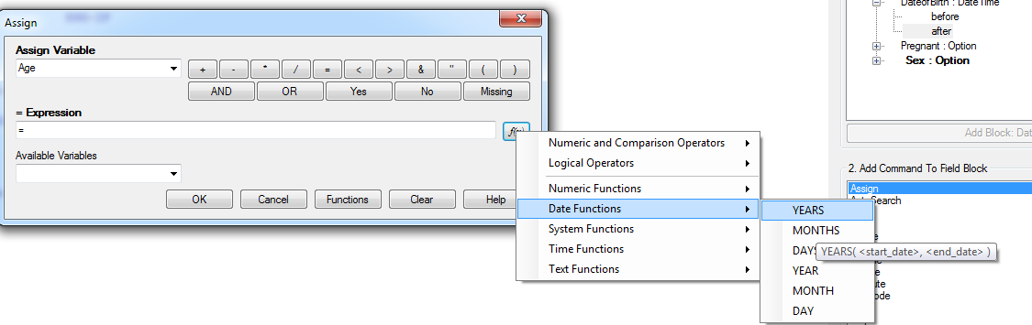
Date Function options
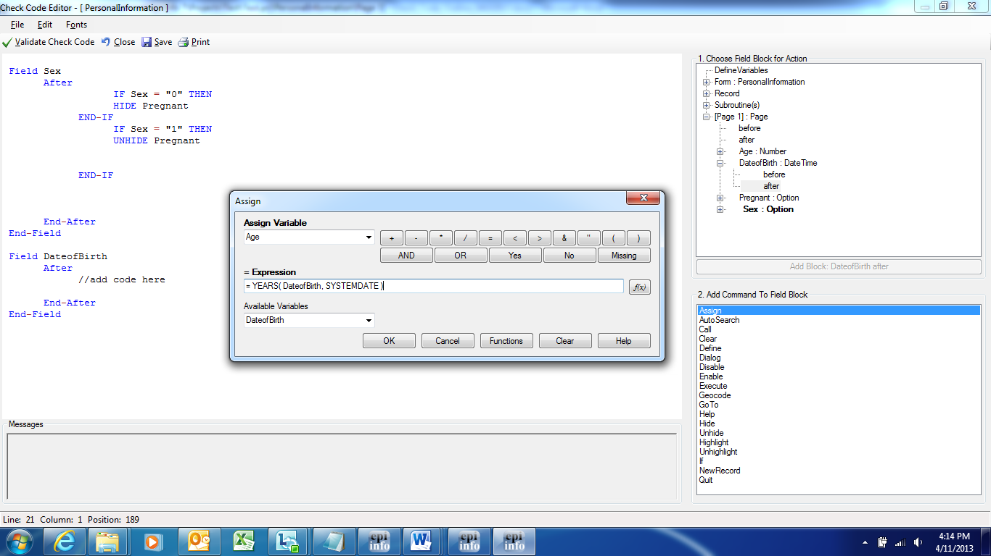
Assign dialog box
- Click OK. Check Code appears in the Check Code Editor.
- Click the Verify Check Code button in the Check Code Editor.
- Click the Save button in the Check Code Editor.
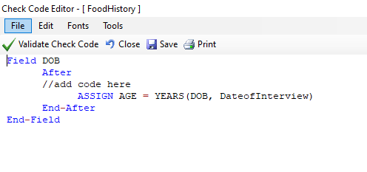
Assign Check Code Command
When entering a date of birth into the form, the Age field populates.

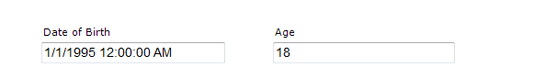
Assignment of Age in Enter Data

Interact with Users using the DIALOG Command
Interact with data entry personnel from within the program, using the DIALOG command. Dialogs display information, requests and receives input, and generates helpful lists, assisting survey respondents. In the following example, the DIALOG command creates a reminder that respondents must complete all fields on page two.
- From Form Designer, Open the FoodHistory_NoCheckCode form in the EColi.prj.
- Click Check Code or select Tools > Check Code Editor. The Check Code Editor opens.
- Select page 2 from the Choose Field Block for Action list box. The action occurs before the page loads.
- Select Before from the Before or After section.
- Click the Add Block button.
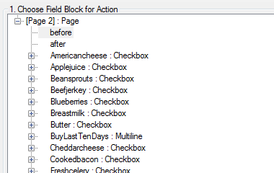
Before action
- The code appears in the Check Code Editor.
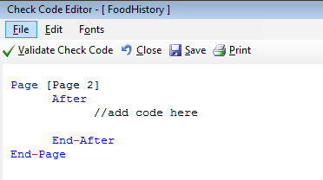
Dialog Block Code
- From the Add Command to Field Block list box, select Dialog. The Dialog box opens.
- Select Simple from the Dialog Type radio button.
- In the Title field, type “Alert.”
- In the Prompt field, type: “All fields on page two must be completed.”
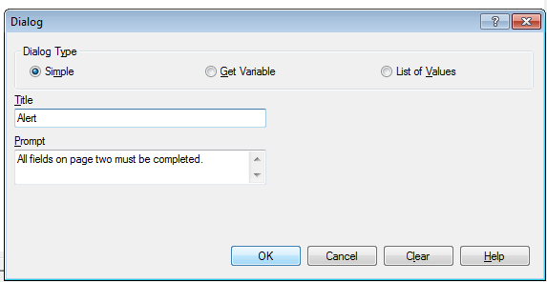
Dialog commands box
- Click OK. The code appears in the Check Code Editor.
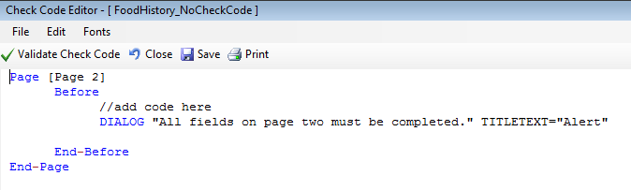
Dialog Check Code Command
- Click the Verify Check Code button from the Check Code Editor.
- Click the Save button in the Check Code Editor.

Searching for Records – Using the AUTOSEARCH Command
The AUTOSEARCH command searches for existing records matching entered values and notifies the user. You can edit the matching record or continue entering data in a new record. The AUTOSEARCH command detects and prevents duplicate records. View the example using AUTOSEARCH on the CaseID field.
- From Form Designer, Open the FoodHistory_NoCheckCode form in the EColi.prj.
- Click Check Code or select Tools > Check Code Editor. The Check Code Editor opens.
- From the Choose Field Block for Action section, expand the node for page 1 and locate the CaseID field.
- Expand the node for the CaseID field .
- Double click on the after event.
- Check Code Editor displays a block of code for the CaseID field.
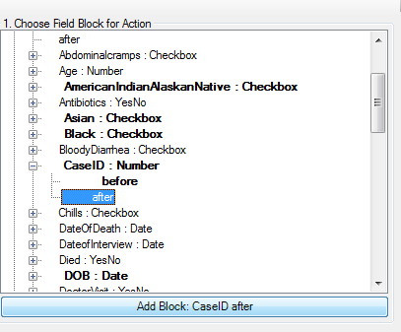
AUTOSEARCH Block for Action
- Check Code Editor displays the code.
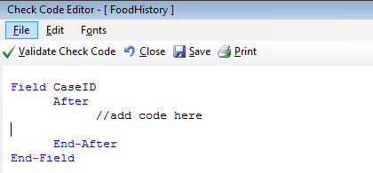
AUTOSEARCH Block Code
From the Add Command to Field Block list box, click AUTOSEARCH. The AUTOSEARCH window opens.
Select the search variable(s) during data entry. In this example, select CaseID.
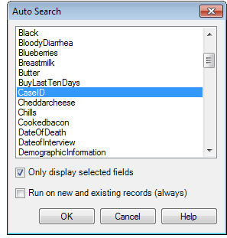
AUTOSEARCH dialog box
Click OK. The code appears in the Check Code Editor window.
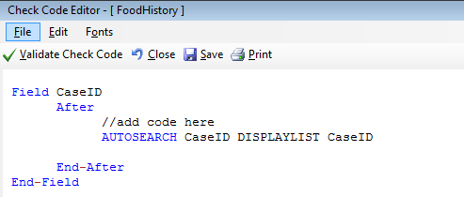
AUTOSEARCH Check Code Command
Follow the next series of actions to verify your syntax:
- Click Verify Check Code from the Check Code Editor.
- Click Save from the Check Code Editor.
- Click Close to return to the form.

The AUTOSEARCH dialog box opens with all the matching records when a duplicate record is entered from the Enter Data tool. View and clear the duplicate record by double-clicking the arrow next to the record. Otherwise, click Cancel to remain on the current record and accept the duplicate value. To display other matching record variables, add the variable names after the DISPLAYLIST parameter (i.e., Last Name, First Name and Date of Birth as shown below).

Field CaseID
After
//add code here
AUTOSEARCH CaseId DISPLAYLIST CaseID LastName FirstName DOB
End-After
End-Field

In the Check Code above, AUTOSEARCH will find matching records on the field CaseID. Detected matching records display the following fields on the grid: CaseID LastName, FirstName and DOB.
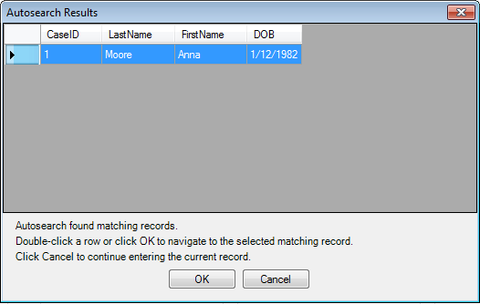
AUTOSEARCH Results box
Note: For more information on using AUTOSEARCH, please see the AUTOSEARCH topic in the Command reference section.

Copy Field Values from Main Forms to Related Forms
After building a relational database using Epi Info™ 7, best practices suggest transferring field values in the parent form (i.e., core demographics) to the child form (i.e., visits information). Accomplishing this requires existing Check Code from field values in both parent and child forms. (i.e., Visible Case ID Number or Patient’s Name must exist in parent and child forms).
The following instructions assume the parent and child forms already exist. Let’s name the parent form Surveillance while the child form is called Hepatitis. A field in Surveillance, must be present in Hepatitis. Otherwise, users need to create it. Afterward, use Check Code in Hepatitis (i.e., LastName in parent form is transferred to LastName in child form). Let’s call the parent form field name: PatientId. Let’s copy PatientID values to a child form.
Open your project from Form Designer and click on the child form from the Project Explorer tree.
- Create a new field. The new field must be the same field type as the field being copied from the parent form. For this example, use PatientId.
- Select the Read Only option.
- Click OK. The new field appears in the form. A value from the parent form will be assigned and displayed during data entry on the child form.
- Click Check Code or select Tools > Check Code Editor. The Check Code Editor opens.
- From the Choose Field Block for Action list box, select the page corresponding to the location of the PatientId field. Let’s assume this field is on page 1. For the page, select the <before> from the before or after section.
- Click the Add Block button.
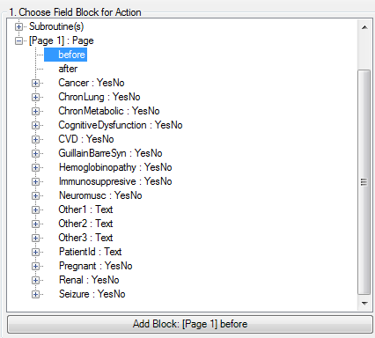
Choose Field Block for Action
- From the Add Command to Field Block list box, click Assign. The Assign dialog box appears.
- From the Available Variables drop-down list, select the new variable, PatientId.
- In the = Expression area, type the field name from the parent form. In this case, use PatientId. Add a prefix followed by a period for the field name, in Assign expression (parentformname.). The prefix is the parent form name. Modify as described after the command writes to the Program Editor:
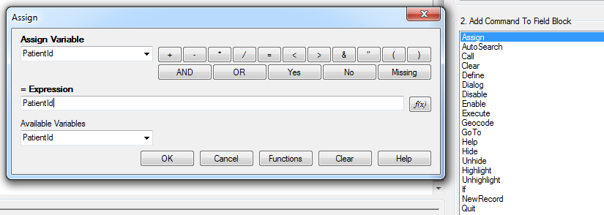
Copy Value- Assign dialog box

- Click OK.
Check Code Editor displays the code. If parent and child forms have the same field name, distinguish the field name during the copy operation. Always prefix the field name with the parent form name.
Steps:
- Determine if the child field and the parent field have the same name
- Add a prefix to the field name.
- Add a period in Assign expression.
Note: Syntax: <parentformname.childfieldname>
View the example in the image below.
Hepatitis is the name of the child form; Surveillance is the name of the parent form. If parent and child forms do not have the same field name, only use the field name in the syntax. Follow the syntax example in the image below.
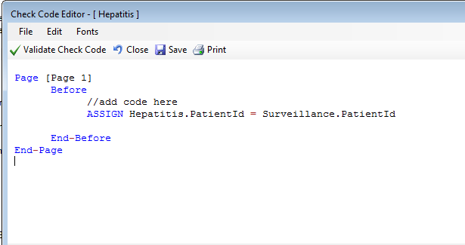
Copy Value Check Code Command
Click the Validate Check Code and correct any issues. Then click Save.

Concatenate Fields
Check Code syntax will work for new records with concatenating fields. Check Code syntax won’t work retroactively. Your code won’t execute on old records with concatenating fields. Instead, use concatenation commands for previous records. Refer to the Classic Analysis section of the manual.

Concatenate Fields with the Ampersand '&' Operator
This example illustrates how to join data from two fields and assign it into a third field using the ‘&’ operator. The example shows how PatientFullName is assigned to the concatenation of FirstName and LastName.
- Open your form in Form Designer.
- Click Check Code, the Check Code Editor opens.
- Select LastName from the Choose Field Block for Action list box.
- Select After from the <Before> and After Section.
- Click the Add Block button.
- Go to the Add Command to Field Block list box, click Assign. The Assign dialog box opens.
- From the Assign Variable drop-down list, select the field for the concatenated value.
- Create the = expression using the & operator. In this example, Assign PatientFullName = FirstName & LastName.
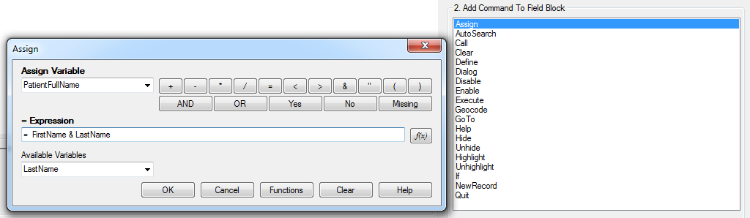
Concatenate - Assign dialog box
- Click OK. Check Code appears in the Check Code Editor.
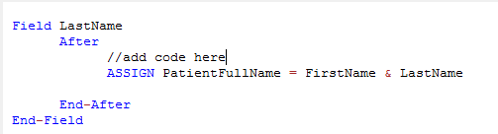
Concatenate No Space Check Code Command
- Click the Validate Check Code button and correct any issues and click Save.
For example, using the Enter Data tool, add Carl for FirstName and Gao for LastName. The result for PatientFullName would be CarlGao. Add a space between CarlGao by changing the ASSIGN statement. Add a blank space in quotes between the first and last names.
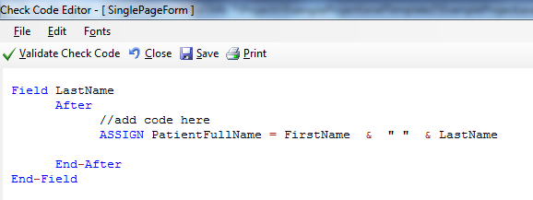
Concatenate Include Space Check Code Command

Concatenate Fields with the Substring Function
This example illustrates how to join segments of two variables to create a unique text ID. In this example, create a Patient ID made up of segments of the patient's last and first name. Use the ampersand (&) operator and join the two segments together.
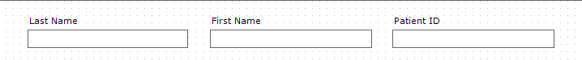
Enter Form - Name
Steps:
- Click Check Code from the Form Designer. The Check Code Editor opens.
- Select FirstName, from the Choose Field Block for Action list box.
- Select After from the Before and After Section.
- Click the Add Block button.
- Click Assign, from Add Command to Field Block list box The Assign dialog box opens.
- Select the field to contain the concatenated value from the Assign Variable drop-down list. In this example, select PatientID.
- Create the = expression using the SUBSTRING syntax.
- SUBSTRING(<variable>, position #, #characters), whereas the expression <variable> is the field or variable.
- position # is the position of the first character extracted from the variable
- #characters is the number of characters to extract
In this example, the PatientID variable contains a combination of the first position and four characters of the last name plus the first position and three characters of the first name.

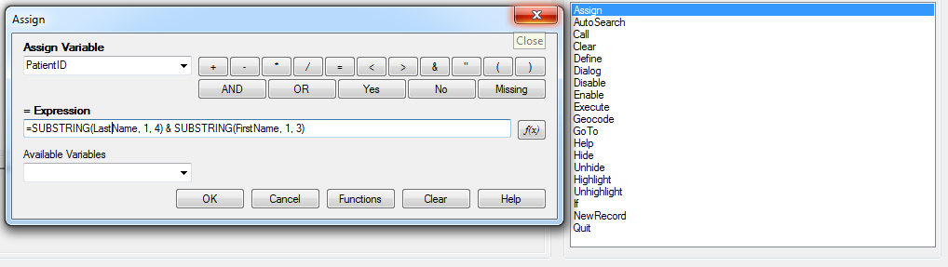
Concatenate with Substring Assign dialog box
- Click OK. Check Code Editor window displays the code.
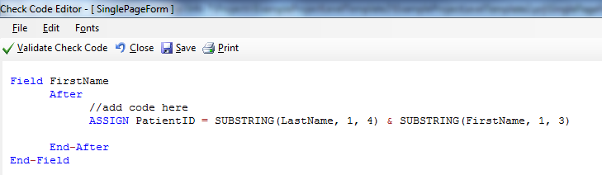
Concatenate with Substring Check Code Command
- Click Validate Check Code button and correct any issues, and then click Save.
The example functions as described below.
- Last Name: Smith
- First Name: Megan
- Patient ID: SmitMeg
- The Patient ID field being calculated is read only.
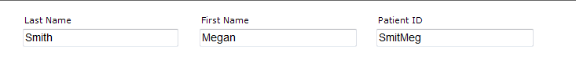
Concatenate with Substring Enter Form

Create Check Code for Option Box Fields
Add Check Code to option box fields. Add Code to any line/choice in the option boxes. Use the Check Code Editor and create complex Check Code for option box fields.
The Check Code GOTO command works in the following scenario. If the answer to Test Options is Choice 1, the cursor will jump to Question 2. If the answer to Test Options is Choice 2 or Choice 3, the cursor will jump to Question 1. Check the tab order before creating the Check Code to ensure accuracy.
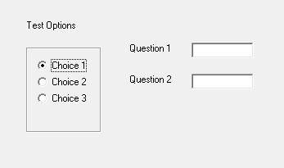
Text Options box
- Create an Option Box in a form. Note the name of the variable.
- The variable is: TestOptions.
- Each text line represents a choice in the form represents a numeric position in the Check Code Editor.
- For example, there are three potential lines in the variable TestOptions. In the Check Code Editor, the choices are numeric, Choice 1 = position 0, Choice 2 = position 1, and Choice 3 = position 2.
- Open the Check Code Editor.
- Select TestOptions, From the Choose Field Block for Action list box.
- Select Click from the After or Click Section.
- Click the Add Block button.
- Click If from the Add Command to Field Block list. The IF dialog box opens.
- Type “Test Options = 1” from the If Condition field,
- Remember that the number 1 represents a text value, Choice 2.
- Click the Code Snippet button in the Then section. A list of commands appears.
- Select GOTO, from the command list. The GOTO dialog box opens.
- Select Question2.
- Click OK.
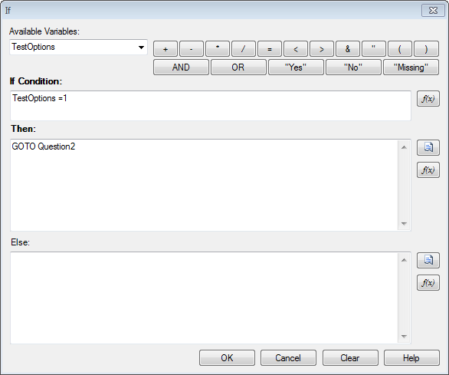
If dialog box
- Click Validate Check Code and correct any issues, then click Save.

Delete a Line of Code from the Check Code Editor
Steps:
- Highlight the line(s) of code/text that you desire to delete.
- Tap the Delete key on your keyboard.
- Click Save from the Check Code Editor toolbar.
Note: Confirm all deletions before making them. Deletions are permanent.

Additional Check Code Commands

CALL
This command redirects to another command block in Check Code and returns after execution. Calls and subroutines work together. Subroutines act as a Check Code common unit, usually dependent on two variables. The benefit of using subroutines is that it allows maintenance of Check Code in one common location. Here is an example of a subroutine:
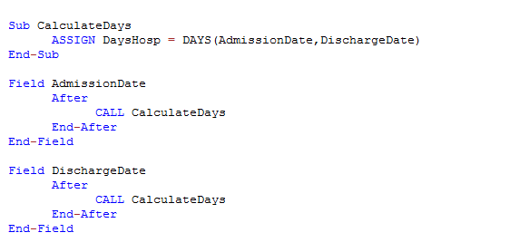
Check Code syntax for Subroutines
In the example above, determining the number of hospitalization days (DaysHosp) uses the After event. Place the After event after the AdmissionDate and DischargeDate. These expressions calculate the total number of days (CALL CalculateDays). Use Subroutines to update and maintain Check Code in one location. The CALL command executes a block of Check Code in multiple fields.
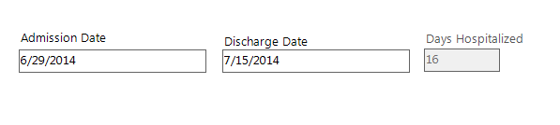
Calculation of Days Hospitalized
Create a Subroutine
Steps:
- Open your form from Form Designer,
- Click Check Code. The Check Code Editor opens.
- Expand the subroutine item from the Choose Field Block for Action list
- Double click on the Add new item. A New Subroutine window opens.
- Assign a name to your subroutine (i.e., MySubroutine1) and click OK.
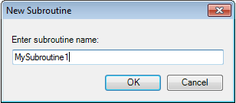
Enter New Subroutine box
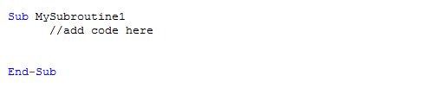
MySubroutine1 code block
A new block of code for the subroutine called MySubroutine1 displays in the Check Code Editor. Determine the Check Code commands for the subroutine. Verify your code and save your work. The user will need to place the CALL command with the name of the subroutine in each desired field in order to execute the Check Code captured in the subroutine.

CLEAR
If a field entry is incorrect, CLEAR sets the field with a null value as if it were blank. It’s useful when the entry in the field contains an error to use the CLEAR command with the GOTO command. Working in tandem, the commands return the cursor back into the field so the participant may try again. Below, CLEAR removes data from the DateofInterview field after flagging the user with a message, “Date of interview is greater than today’s date.” The entry is cleared, and the user can try again.
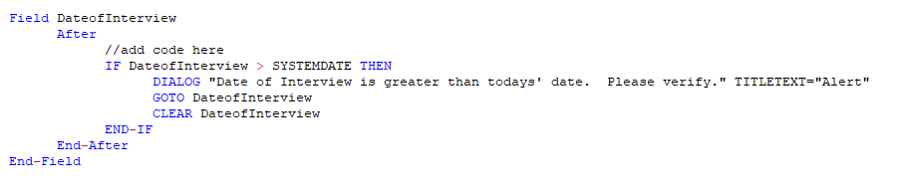
Check Code syntax for CLEAR command

DEFINE
This command creates a new variable. Check Code saves all user-defined variables in the DefineVariables section.
The proper syntax is:
- DEFINE <variable name> {<scope>} {<field type indicator>}
- <variable name> represents the name of the new variable. <variable> cannot be a reserved word. For a list of reserved words, see the List of Reserved Words Section of the User’s Manual.
- <scope> is optional and is the level of visibility and availability of the new variable. This parameter must be a reserved word: STANDARD, GLOBAL, or PERMANENT. If omitted, the code assigns STANDARD as the parameter and omits, a <field type indicator>.
- <field type indicator> is the data type of the new variable and must be one of the following reserved words: NUMERIC, TEXTINPUT, YN, DATEFORMAT, TIMEFORMAT and DLLOBJECT.
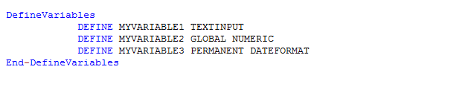
Check Code syntax for DEFINE command
 Warning: If omitted, the data type infers the variable type of the first assigned value. Thereafter, the variable type is unchangeable, and results in an error.
Below is a description of the SCOPE parameter. SCOPE is an optional parameter used with the DEFINE command.
- STANDARD variables keep their values only within the current record. Values reset when loading new records. Standard variables work like temporary variables, behaving like other fields in the database.
- GLOBAL variables keep their values across related forms, even after opening a new form. Global variables persist for the duration of program execution. Global variables end when closing the Enter Data tool.
- PERMANENT variables keep any assigned values. Values do not persist for undefined variables or, if altered by another assignment. Epi Info™ modules (Enter, Classic Analysis, etc.), sharing permanent variables persists even if the computer shuts down.
Note: Find Permanent variables in the EpiInfo.Config.xml file located in the \Epi Info 7 > Configuration directory.

DISABLE
If a field isn’t required for data collection, use the DISABLE Check Code command. Use If, Then, and Else conditionals Check Code commands to DISABLE a field. In this example, the field DoctorVisitDate will be disabled if the response to the DoctorVisit is No.
- Open the FoodHistory_NoCheckCode form in the EColi.prj.
- Click Check Code. The Check Code Editor opens.
- Select the DoctorVisit from the Choose Field Block for Action list box.
- Select after from the before or after Section.
- Click the Add Block button.

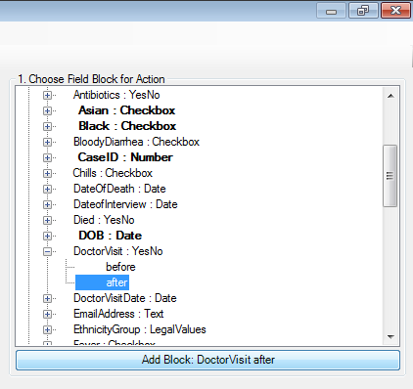
Add Block: DoctorVisit after
- The code block appears in the Check Code Editor.
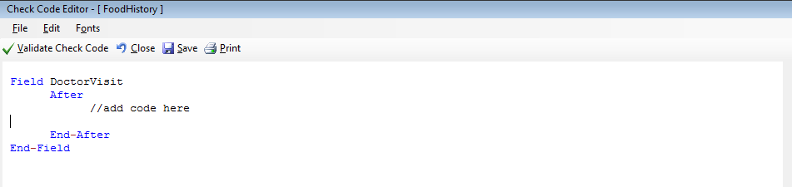
Disable Block Command
- Click IF from the Add Command to Field Block list box. The IF dialog box opens.
- From the Available Variables drop-down list, select the field to contain the action. For this example, select DoctorVisit. The selected variable appears in the If Condition field.
- From the operators list, click =.
- From the operators list, click No. If Condition field reads DoctorVisit=(-).
- Click the Code Snippet button in the Then section. A list of available commands appears.
- From the command list, select DISABLE. The DISABLE dialog box opens.
- Select to disable a field if the participant answers, “No.” Select DoctorVisitDate from the list of variables
- Click OK to return to the IF dialog box.
- Click the Code Snippet button in under the Then section. A list of available commands appears.
- Select Enable From the command list. The Enable dialog box opens.
- Select the field to enable based on a “Yes” answer from the list of variables. For this example, select DoctorVisitDate.
- Click OK to in the Enable dialog box to return to the If dialog box.
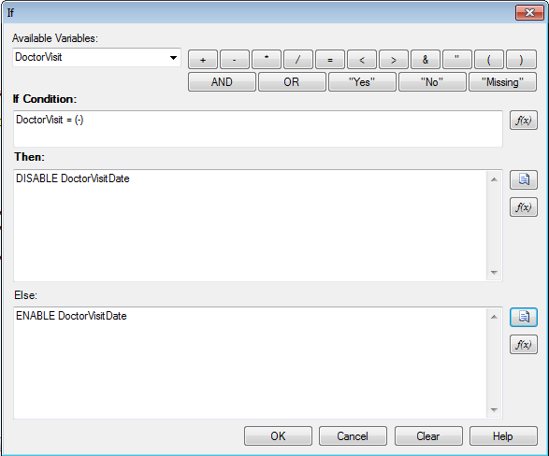
DISABLE - Then dialog box
- Click OK. The code appears in the Check Code Editor. View the code in the image below.
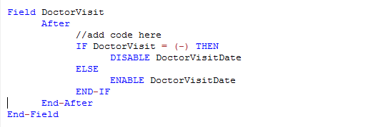
DISABLE Check Code Command
Click:
- Verify Check Code.
- Save.
- Close to return to the form.
Note: Test DISABLE by opening the form in the Enter Data tool. Entering “No” for the DoctorVisit field will disable the DoctorVisitDate field.

HIDE/UNHIDE
Form designers can hide a field by using the HIDE command. HIDE works for removing fields that are non-applicable. View the following example. HIDE removes the Pregnant option box. The response for sex triggers the HIDE command, removing the Pregnant option box, following a respondent answer to their sex.
- Click Check Code. The Check Code Editor opens.
- Select Sex from the Choose Field Block for Action list box.
- Select after from the before or after Section.
- Click the Add Block button. The code runs after data entry.
- Check Code Editor displays the code.
- Click If, from the Add Command to Field Block list box. The If dialog box opens.
- Select the field from the Available Variables drop-down list. Select Sex for this example. The If Condition field shows the selected variable.
- Click = from the Operators list.
- Type Sex = “Male” from the If Condition field. Remember that Sex is a text field, so always the value in quotes.
- Click the Code Snippet button under the Then section. A list of commands appears.
- Select HIDE, From the command list. The HIDE dialog box opens.
- Select Pregnant and click OK.
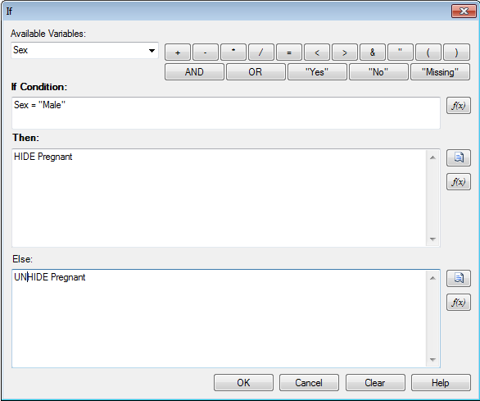
Then - Else dialog box
- Click the Code Snippet button in the Else section. A list of commands appears.
- Select UNHIDE from the command list, The UNHIDE dialog box opens.
- Select the field to unhide, if the participant answers, “yes.” Select Pregnant.
- Click OK in the Unhide dialog box, to return to the If dialog box.
- Click OK, and then again, OK. Check Code Editor displays the code.
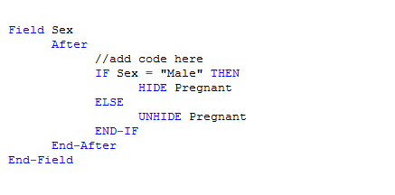
Hide Check Code Command
- Click the Save button.
- Click Close to return to the form.
Note: The Unhide command shows any hidden fields. You can select this command in the Add Command to Field Block section of Check Code Editor. Use a CLEAR command with the HIDE command to set to null, any information previously entered in the Pregnant field.

ENABLE/DISABLE
These commands can work in conjunction. The DISABLE command disallows data entry into a field while the ENABLE command allows data entry into a previously disabled field.
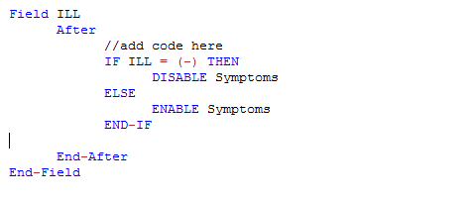
Check Code syntax for ENABLE/DISABLE command

EXECUTE
Executes a Windows program — either explicitly named in the command or designated within the Windows registry. (i.e., A file with extension listed in a Windows registry). Using the EXECUTE command, Windows launches the default program(s) listed in its registry. The EXECUTE command accepts a series of paths, separated by semicolons like the example below:
EXECUTE c:\Users\MyPC\myfile.xls;d:\myfile.xls

EXECUTE attempts to launch files in succession. In Check Code, place the EXECUTE command in any command block. You can use it with a command button. Execute Check Code syntax when you click on the command button.
EXECUTE WAITFOREXIT "<filename>"
EXECUTE NOWAITFOREXIT "<filename>"

- The <filename> represents the path and program name for .exe files and .com files (DOS binary executables).
- The <command-line parameters> represent any additional, program acceptable command-line arguments.
- When using the WAITFOREXIT command (modal), the command runs and Enter pauses until the command has finished. Then, Enter runs subsequent commands. When using the NOWAITFOREXIT command (non-modal), Enter continues running any subsequent commands without waiting for previous commands to finish. EXECUTE (modal), writes permanent variables before the command runs, and reloads them again, afterward.
In the example below, the CDC website page opens when the users click on a command button called OpenCDCWebsite. A PDF file opens when the users click on a command button called OpenPDFdocument.
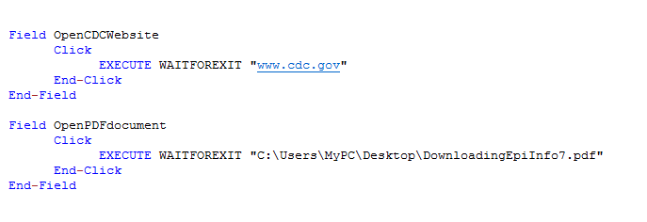
Check Code example of EXECUTE command syntax

GEOCODE
The Geocode command uses data entered in a text field which corresponds to an address. GEOCODE retrieves and populates Latitude and Longitude coordinates into the form. When using Desktop, this command will require an Internet connection.
- Open the FoodHistory_NoCheckCode form, from Form Designer. Go to the form in the EColi.prj.
- Click Check Code. The Check Code Editor opens.
- Select GetCoordinates from the Choose Field Block for Action list box.
- Select Click.
- Click the Add Block button. This creates code to run after the GetCoordinates command button is clicked.
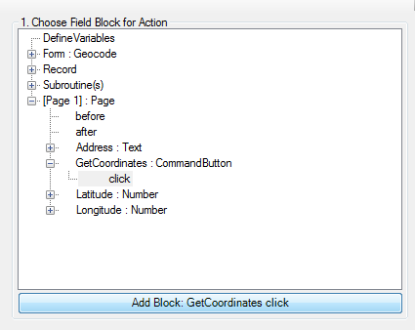
Geocode Block for Action
- The code appears in the Check Code Editor.
- Select Geocode from the Add Command to Field Block list box. The Geocode dialog box opens.
- Select Address from the Address Field drop-down list.
- Select Latitude from the Latitude Field drop-down list,
- Select Longitude from the Longitude Field drop-down list.
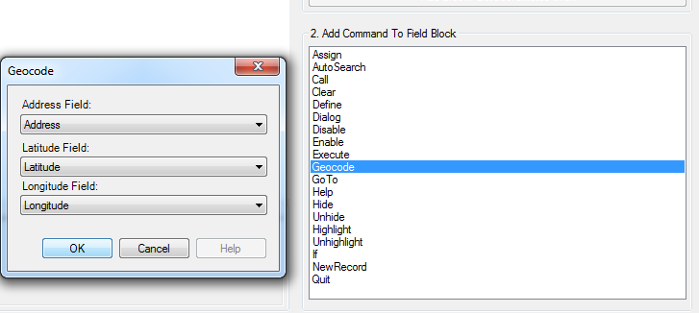
Geocode dialog box
- Click OK.
- Click OK. Check Code Editor displays the code. Click Save, then click Close.
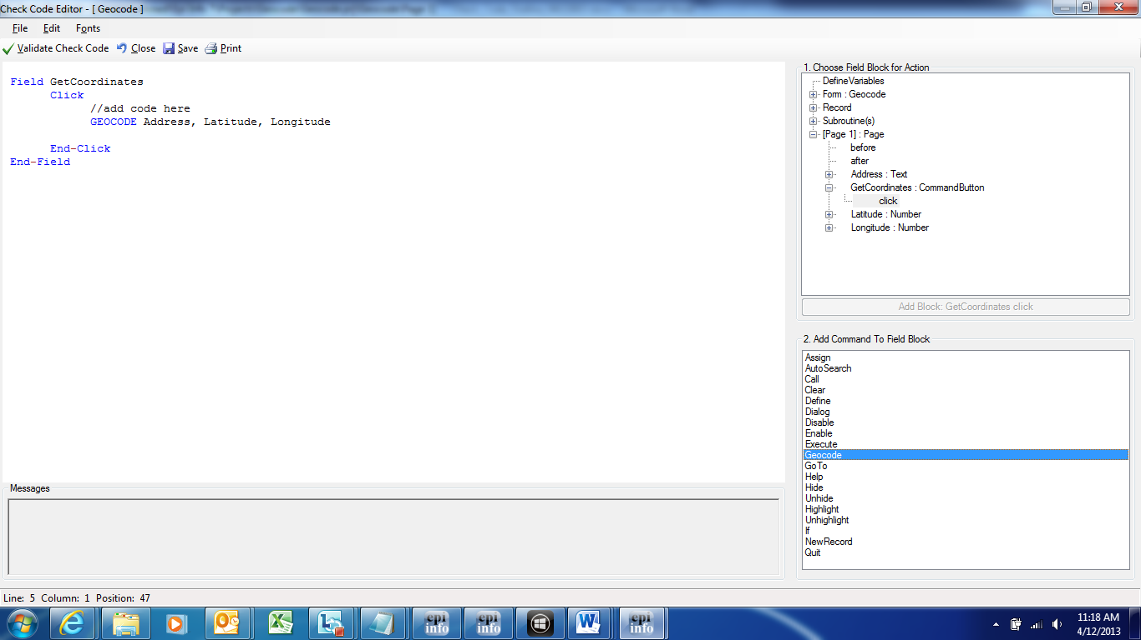
GEOCODE Check Code Command
- When clicking the GetCoordinates command button after adding an address from the Enter Data tool, the geocode results appear.
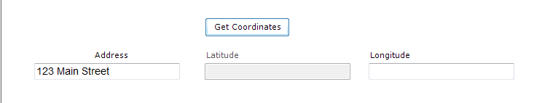
Geocode Enter Data Before
The Geocode Results dialog box contains the address, Latitude and Longitude coordinates. Also, you can view the confidence level of geocode service coordinates.
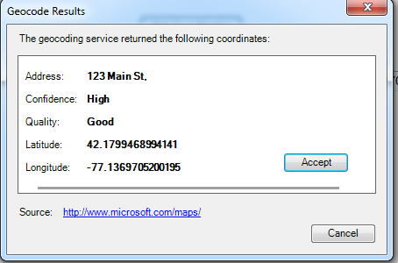
Geocode Results window
Click Accept in the Geocode Results dialog box. The geocode service coordinates fill the Latitude and Longitude fields in your form.
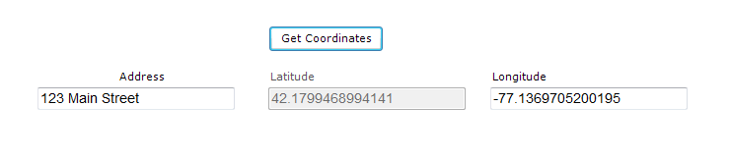
Geocode Enter Data After

HELP
Displays a pop-up help window containing a message. The help window works with large files by allowing users to move from one highlighted block of text to another. It works similarly to hypertext.

HIGHLIGHT/UNHIGHLIGHT
Highlight/Unhighlight emphasizes field locations by highlighting them in bright yellow. Highlighting is useful when errors are detected. Fields can be highlighted and unhighlighted. View the example below. The highlighted field Emergency is triggered by a response to the field: Vaccinated = “No”. So, the field: “Did you visit the emergency room?” is highlighted, skipping over the rest of the vaccination questions.
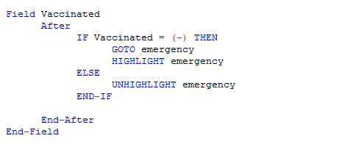
HIGHLIGHT/UNHIGHLIGHT command

NEWRECORD
The NewRecord command saves the current records data and opens a new record for data entry.
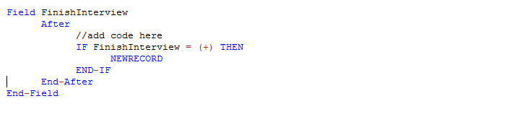
syntax for Field NEWRECORD command
QUIT
This command saves the current record and closes the Enter application.
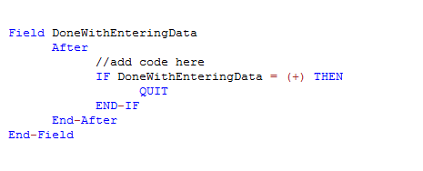
Check Code syntax for QUIT command
SET-REQUIRED and SET-NOT-REQUIRED
You can set fields to REQUIRED, based on respondent criteria. Fields set to REQUIRED prevent records from being saved until the fields are filled in. Entering data allows participants to continue. In the example below, the field: VaccinationDate is set to REQUIRED if the participant answers, “Yes” to “have you received a vaccination?” View the SET-REQUIRED example below. The REQUIRE property is set with Check Code, and not applied during field creation. Entering a specific criterion resets the field to its original state by using the SET-NOT-REQUIRED command.

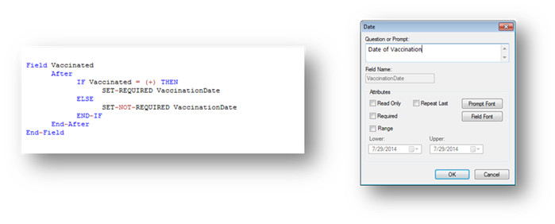
Check Code syntax for SET-REQUIRED command
Check Features Covered Elsewhere
You can setup the Enter Data application for complex operations not listed in this chapter. Examples include mathematical and logical operations using multiple fields, help window pop-ups and calls to field-content programs in various languages.

How to Use the Epiweek Function

Epidemiological weeks are complete weeks. Some worldwide ministries of health consider Sunday as the first epidemiological day of the week. Others consider the first epidemiological day of the week to be Saturday or Monday.
By default, Epi Info™ 7 marks Sunday, the beginning of the epidemiological week. Modify the parameter for the EpiWeek function, changing the first day of the epidemiological week.
Use the EpiWeek function if the year doesn’t matter. Using EpiWeek creates a numeric value stored in a numeric field. EPIWEEK requires the date parameter. Weeks are calculated based on the date (i.e.: year). View the epidemiological week syntax below:
ASSIGN MyEpiWeek = EPIWEEK( <start_date>, {<first_day_of_week>} )
The Check Code shown below, calculates EPIWEEK into the SurveillanceWeek field. It requires a value entry in OnsetDate.

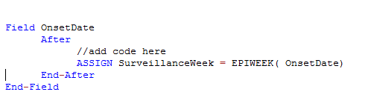
Check Code syntax for EPIWEEK function
Change the Check Code syntax if the first day of the epidemiological week doesn’t start on Sunday. In the example, set the epidemiological week to Monday (i.e., Sunday will be 1, Monday will be 2, Tuesday will be 3, etc.)
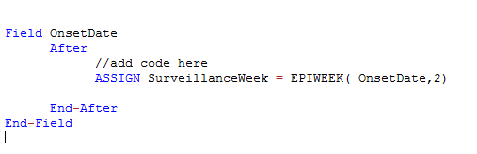
EPIWEEK with beginning week parameter

Proper Check Code Syntax

Check Code syntax must match the field type. Here are some examples of proper syntax for a field type:
- Assign the ‘Age’ field (numeric field type) the value 24
  - ASSIGN Age = 24
- Assign the ‘Ill’ field (Yes/No field type) the value No
  - ASSIGN Ill = (-)
- Assign the ‘AteChicken’ field (checkbox field type) the value Yes
  - ASSIGN AteChicken = (+)
- Assign the ‘DateOfInterview’ field (Date field type) the value 5/5/2012
  - ASSIGN DateOfInterview = 5/5/2012
- Assign the ‘CaseStatus’ field (legal values field type) the value “Confirmed”
  - ASSIGN CaseStatus = "Confirmed"
- Assign the ‘Gender’ field (Comment Legal field) the value “F”. The field code is M-Male, and F-Female.
  - ASSIGN Gender = "F"

This page has been intentionally left blank.


