A Guide to Adapting and Using Knowledge, Attitudes, and Practices (KAP) Surveys During an Ebola Response


This material was produced through a cooperation agreement (no. 1 NU2HGH000047-01-00) between the US Centers for Disease Control and Prevention (US CDC) and RTI International, 2022. It is offered free of charge for use in community analysis and research with acknowledgement of US CDC and RTI International as the original authors of the guide, the survey questionnaires, and all Excel templates and data dictionary. For more information, contact Giulia Earle-Richardson, US Centers for Disease Control and Prevention, National Center for Emerging and Zoonotic Diseases, GEarle-Richardson@cdc.gov.
The findings and conclusions in this document are those of the authors and do not necessarily represent the official position of the CDC.

Contents
1 How to use this document 3
2 Planning the resources needed for a KAP survey 3
3 Defining survey goals, selecting and adapting KAP survey questionnaires 6
4 Piloting the survey with intended audience 13
5 Choosing tablet or paper questionnaires 14
6 Sampling KAP survey participants 18
7 Recruiting survey data collectors 29
8 Training survey data collectors 29
9 Final planning for data collection 32
10 Data collection 34
11 Data entry, download and verification 35
12 Preparing the data for analysis 45
13 Data analysis and reporting 47
14 Documentation and storage 57
15 Authors and acknowledgements 57
16 Appendices 58
Appendix A. KAP toolkit 58
Appendix A.1. Survey #1 Questionnaire (English) 58
Appendix A.2. KoBo Survey XLS File Questionnaire 1 77
Appendix A.3. CDC Ebola survey #1 results template 78
Appendix A.4. Survey #2 Questionnaire (English) 79
Appendix A.5. KoBo Survey XLS File Questionnaire 2 92
Appendix A.6. CDC Ebola survey #2 results template 93
Appendix A.7. CDC Data Dictionary for Ebola surveys #1 and #2 94
Appendix B. List of Published Ebola KAP Surveys 95
Appendix C. List of workshop participants 97

1 How to use this document
This document helps you plan and implement a Knowledge, Attitudes and Practices (KAP) survey during an Ebola outbreak. In the appendix there are two KAP survey questionnaires that you can use. The first survey questionnaire is about people’s knowledge, attitudes and practices related to Ebola virus disease, while the second has questions about how people view Ebola control activities led by the government or by others. The first survey is designed to be most useful at the beginning of an outbreak, while the second is designed for use when Ebola control activities are well underway.
You may decide to use one or both survey questionnaires as they are, or to modify them to meet your needs. You will need to test your surveys locally to ensure that the people you are surveying can understand the questions (both the terminology and language), that the survey doesn’t take too long, and that that the instructions for the data collectors are clear and easy to follow.
This document guides you in customizing your Ebola KAP survey and planning for data collection, including how to: define your goals for the survey, plan for the resources you will need, select and adapt the survey questions, plan the data collection, organize and train your team, collect the data, download and clean the data, and organize your results and generate charts for presentation.

2 Planning the resources needed for a KAP survey
Before beginning a KAP survey project, it’s important to understand everything that will be needed. You will need people to play different roles and you will need a budget to support staff and pay for other expenses. This section reviews what you will need.

2.1 Personnel
Several different types of people play a role in the design and use of a KAP survey:
- Project lead – This individual is responsible for the overall success of the survey. The lead’s role is to:
  - Work with collaborators (like local researchers, community leaders, and local government officials), and Ebola response leaders to define the goals of the KAP survey and to ensure the survey has sufficient funding and staffing
  - Plan the survey project, making sure there are adequate staff and time for the collection and analysis of the data
  - Share the survey results with the partners who can use the results for action
- Ebola response teams, local and regional governmental structures, and other users of the information – These individuals play an important role at the beginning of the process. Their role is to:
  - Help define the KAP survey goals
  - Help adapt the instrument to the local context
  - Receive the survey results and apply it to their work in the response
- Behavioral scientists, epidemiologists, and statisticians – These technical experts can help you revise the toolkit survey questionnaires. If possible, the survey team should have access to experts in behavioral science and statistics, even if they are not full-time members of your staff.
- Technical team – Within this team there are members with several different roles. One individual may fill more than one role:
  - Survey scientist – This person works with the project lead to make all of the revisions to the survey instruments (including translations into local languages), creates the strategy, identifies the size and type of the KAP survey sample, and helps hire data collectors.
  - Data manager – Once the survey is final, this person programs the data entry software. The data manager manages the mobile data collection platform and cleans and codes data for analysis. This person will lead the analysis of data.
  - Field coordinator – This person is responsible for training survey data collectors, supervising field supervisors, and supporting survey data collectors. This person also creates field packets that instruct the data collectors where to start their survey, what process to use going from house to house, and how to record refusals.
  - Field supervisor – Field supervisors go out into the field when data are being collected to support the data collectors and address issues that may arise. They ensure that data collectors follow the protocols, especially protocols for obtaining informed consent and asking the questions as written.
  - Survey data collectors – These team members conduct surveys with the population. If possible, they should be recruited from the local population and speak the same language, and teams should include both men and women.

2.2 Duration: survey timeline
The following timeline shows the sequence of steps for preparing and conducting a KAP survey. While the time it takes to accomplish each step may vary, it is important to take each step in order and to not skip any steps. This calendar assumes that financial support for the survey has already been obtained according to a budget outlined above.
Table 1. Example of a timeline for KAP Ebola survey data collection and analysis
 | Weeks (divided into 3-day halves)
KAP Survey steps | Wk. 1 |  | Wk. 2 |  | Wk. 3 |  | Wk. 4 |  | Wk. 5
1. Recruit local social scientists, community leaders, others to collaborate on defining KAP goals and implementation - Project lead
2. Select/adapt KAP surveys - Project lead, technical team
3. Identify a KAP survey sample (size and characteristics) - Project lead, behavioral scientist, epidemiologist or statistician
4. Translate the survey into local languages - Contract translators, possibly field coordinators and team
5. Pilot test the survey - Field coordinators, supervisors
6. Create final version of the survey - Project lead, technical team
7. Program survey for electronic data collection - Data manager
8. Recruit data collectors - Project lead, technical team
9. Train data collectors - Project lead, field coordinators, field supervisors, data collectors
10. Collect the data and oversee quality control - Field coordinators, field supervisors, data collectors
11. Clean the data - Data manager
12. Analyze the data - Data manager
13. Develop presentations - Project lead
14. Share results with stakeholders - Project lead

2.3 Funding: budgeting for a survey
Before undertaking KAP surveys, it is important to understand the time and resources that will be needed and to make sure that you have an adequate budget. Using the sample timeframe above and one of the sample surveys (and with funding already in place), it took roughly 5 weeks to complete all 14 steps.
In addition to the time spent by your regular staff adapting and using the KAP surveys we have provided, you will need to have a budget to pay for hiring and training local KAP survey data collectors, as well as for any materials or services not provided by your agency. Creating this budget will require you to make some calculations about how many data collectors you will need, and the prevailing pay rate for these workers, as well as for transportation (and meals if these are typically provided). Below is a basic budget sheet that will help you plan for the costs associated with a KAP survey. If you have to request these funds, it should be done well in advance of undertaking the KAP survey. The table below will help you think through what needs to be included in a budget request for KAP survey funding. This example uses an estimate of 600 surveys with data collected over 5 days, using 12 data collectors and two field supervisors. You will have to determine local payment rates and local food and transportation costs to make your budget estimate.
Table 2. Sample budget to complete 600 30-minute KAP surveys in 1 health zone
 | Cost per unit |  | Number required | Cost
Field supervisors (if not already part of your staff) |  |  | 2
5 days of data collection plus 2 additional days for training and pilot testing
daily pay x 7 days | $ |  |  | $
food x 7 days | $ |  |  | $
transportation x 7 days | $ |  |  | $
 |  |  | subtotal | $
Data collectors |  |  | 12
12 data collectors [teams of 2] = 30 interviews per day [5 days of collection]
2 additional days for training (1 day) and final pilot testing (1 day)
daily pay x 7 days | $ |  |  | $
food x 7 days | $ |  |  | $
transportation x 7 days | $ |  |  | $
 |  |  | subtotal | $
Translators |  |  | 2
2 translators, 2 days [assuming the survey is no more than 35 questions, translated into two local languages; 1 day for translation, 1 day for review by native speaker]
daily pay x 2 days | $ |  |  | $
food x 2 days | $ |  |  | $
transportation x 2 days | $ |  |  | $
Office supplies, printing and photocopying of materials | $ |  | 300 | $
Or
8 data collection tablets (1 for each team, and 1 for each field supervisor) | $ |  | 8 | $
Contractors [If you have to contract for any of the work or include additional paid staff for: data collection training, field visits for planning data collection, creation of data collector field packets, and any programming of tablets or printing of surveys are done by regular staff and don't need to be contracted out.] |  |  |  | $
 |  | Budget total |  | $

3 Defining survey goals, selecting and adapting KAP survey questionnaires
As you begin your project, it is important think carefully about what you hope to learn from the survey, and to limit the length of your survey to only include questions of vital importance. As scientists, we have a responsibility to the public to not burden them with long surveys that collect unnecessary data. This guide assumes that you have created the shortest possible list of important information that you need, and that this information can be best collected through a survey. A survey provides numerical estimates of response frequencies that you can compare between groups and over time. Other strategies, such as focus groups, interviews and rapid ethnography, can provide fast descriptive information about the social context and perspectives about issues in the community but doesn’t provide frequencies.
Once you have decided what you need to know, you can review the existing survey instruments in this toolkit to determine if one or both can provide the information you need. This will take much less time than developing entirely new surveys.
There are two survey questionnaires you may wish to use, and they focus on different things. The table below explains the focus of each survey, and the kinds of information they provide.
Table 3. Two toolkit questionnaires and the information they provide
Survey questionnaires | Information the survey questionnaire provides
1. Focused on social factors that may contribute to Ebola virus disease (EVD) spread, and opportunities for community engagement for behavior change. [Useful at beginning of outbreak, and periodically after.] | - Frequency of behaviors that may spread (or prevent) EVD; knowledge, beliefs and attitudes that contribute to the behaviors  - Social environment, cultural and linguistic factors that might contribute to these behaviors  - In the initial survey: Trusted sources of knowledge/leadership on health; opportunities for community engagement
2._ Focused on describing people’s experiences with different Ebola response infection control measures and how experiences influence support and participation in the response. [Use after Ebola response is underway.] | - Geographic differences in people’s participation in response activities  - Opportunities for community engagement in each geographic area  - Any insights into community engagement or behavior change strategies  - Any unintended consequences of response activities

Survey questionnaires 1 and 2 are in the appendix. You can use one or both, and you can delete sections that don’t meet your needs.

3.1 Four important points about using these survey instruments
1. Limit survey questions to priority information needs – There is often a temptation to leave in questions that aren’t really needed or to add more questions because the information may be interesting. However, keep in mind that every additional question asked adds to the fatigue of respondents, and this will reduce the quality of their responses. Also, keeping people longer than necessary to help with the response is disrespectful of their time. In addition, overly long surveys add burden to the data cleaning and analysis process. Limit your questions to only those items that will help you answer priority questions and thus result in meaningful action during the response.
2. Use questionnaires that are written in respondents’ native language – Questions should be asked in the language that respondents are most comfortable speaking, and the written form should be in that language. It is not a good idea to have the survey in French or English and have the interviewers translate each question verbally as they ask each question. You will not know exactly what the interviewer has said, and so you will not know what the participant’s answer really means.
3. Pilot test all questionnaires– Before you begin data collection, you will need to have your data collectors try the survey out with some volunteers to make sure that the questions can be understood easily, and to determine if changes in response options are needed. This is true even if you use the questionnaires provided in the toolkit. Every community is different. Pilot testing will be an opportunity for interviewers to practice using the survey, to understand how long it takes, and to practice recording responses.
4. Make sure to include a method for tracking when people refuse to participate or are not at home – Tracking this information is important because you need it to calculate survey participation rates.
- If data collectors are using tablets, you can make it easy for them to note every time someone refuses or is not at home by including “refused” and “no one at home” check boxes at the beginning of the questionnaire. When these are checked, the survey is complete.
- If data collectors are using paper surveys, you can give them a separate notebook to record whether someone refuses or is not at home. This will save paper because they will not need to use an entire paper survey with just “refused” or “no one at home” checked.

3.2 Option A. Using one or more survey instruments as they are
If the information that you need is consistent with questionnaire #1 or questionnaire #2, shown above (table 5), then you can use one of the survey questionnaires from the toolkit. These two surveys are provided in French, Kiswahili, Kinande, and Lingala. If you plan to use the surveys as they are, you can skip Sections 3.3 and 3.4, which describe adapting or modifying the survey questionnaire, and move on to Section 3.5, which describes testing the questionnaire with volunteers.

3.3 Option B. Modifying one or more survey instruments by removing questions
If you want to use one or both of the model surveys but there are sections that you do not need, you can simply remove those questions from the questionnaire before you pilot test it. Remember, it is important to keep the questionnaire as short as possible so that respondents don’t get tired or annoyed, and so they don’t start giving answers that are not accurate. Make sure to check each question you plan to include to be sure it is really needed.

3.4 Option C. Modifying one or more survey instruments by adding questions
If you need information that neither survey provides, you may want to add questions to the questionnaire. This must be done carefully, because there are many ways in which questions can go wrong and not give you the information you need, or worse, provide incorrect or misleading information. For example, the following table shows some of the most common mistakes that make questions really challenging to answer:

Table 4. Common mistakes creating survey questions that can result in inaccurate responses
Question | Problem | How it affects the data or the respondent | What can be done to solve the problem
“How would your coworkers/family members rate their fear of getting Ebola (on a scale of 1 to 10)?” | This question asks two questions at the same time: The person’s coworkers might have a very different rating of fear than the family. | You don’t know which question the person has answered. It may also frustrate the respondent. | Split the question into two questions or reword it so that that it refers only to one person (e.g. “How would your closest family member rate their fear of getting Ebola on a scale of 1 to 10? (with 1 meaning not at all afraid and 10 meaning extremely afraid”)
“If a person with Ebola goes immediately to a health facility, will he/she reduce the chance of spreading it to family or people living with him/her?” | This question pressures the respondent to answer the question a certain way. In this case, the pressure is subtle, but it’s clear from reading the question what the “right” answer is. | You may not get an accurate answer. It may also frustrate the respondent. | Reword the question. For example, ask, “What would be the benefits of a person with EVD going to an Ebola treatment facility?” and then in a separate question ask, ““What would be the disadvantages of a person with EVD going to an Ebola treatment facility?”
“What timeframe is optimal for the observation of a person suspected of having contracted Ebola virus disease or of having contact with a suspected case?” | This question uses language that respondents might not understand. | This will both irritate the respondent and lead to inaccurate information. | Reword using simpler language. For example, ask, “How many days will a health agent need to visit someone who has touched or been close to a person with Ebola?”
“What is your primary occupation? 1. Farmer  2. Taxi/bus driver  3. Trader  4. Unemployed  5. Student  6. Ebola response staff  7. Health staff (nurse/pharmacist doctor/traditional healer)  8. Other (specify)” | The question has a confusing set of response options because some people might fall into more than one occupational category. For example, a person could be both be a fisherman and unemployed. A person could also be a health staff member who is employed by the Ebola response. | This will lead to inaccurate information and may irritate the respondent. | Reword the question so that only one option could be chosen. For example, “What are you currently spending the majority of your days doing? Select one answer.” Also, you could change response #7 to say, “Health staff NOT involved with the Ebola response.”

3.4.1 Key concepts of survey design
If you are going to add questions or modify the surveys, it may be helpful to review some important principles of survey design.
- Introducing the question: It is important that the respondent always understand what they are being asked. In some cases, this requires some introduction to the question. This introduction can be needed at the beginning of the survey, at the beginning of a new section, or when introducing a question that might be complex. Here is an example of a question that requires a brief introduction:
“Introduction: During an Ebola outbreak, health authorities stop the spread of the disease by identifying everyone who has touched or been near someone with Ebola, and by visiting them every day for 21 days to make sure they don’t develop Ebola disease. Question: Have you been followed for 21 days after possible contact with someone with Ebola?”
If this simple explanation of contact tracing wasn’t provided, the respondent might not know what they were being asked by the question. Orienting respondents puts them at ease, and improves the quality of the response. However, introductions need to be tested with audiences, because sometimes introductions that are too long or too abstract create confusion.
- How well the question captures the concept of interest: The main reason we ask colleagues and community volunteers to give feedback on questions is that sometimes we may not notice that a question doesn’t actually measure what we think it measures. For example, the following question measures whether a person’s practice is to avoid funerals, when what you really want to measure is whether the person is avoiding touching the deceased as part of a funeral:
“What steps can a person take to avoid becoming infected with Ebola?
- Avoid funerals
- [Other response options]”
The problem with this question is that during an Ebola response, when safe and dignified burials ( https://www.who.int/publications/i/item/WHO-EVD-Guidance-Burials-14.2) are typically offered, family members do NOT touch the deceased individual. So the person might NOT report that they are avoiding funerals yet still be following appropriate self-protection practices. A better question to capture whether the person is avoiding touching the deceased individual during a funeral would be:
“What steps can a person take to protect themselves against being infected with Ebola?
- Avoid touching the body of the deceased, either at a funeral or any other time
- [Other response options]”
3._Response options: Survey question responses can be set up in any number of ways. The table below show five different response options for essentially the same question.
Table 5. Response options for KAP survey questions
Question | Response options
- If invited, would you agree to be vaccinated against Ebola? | ____[free text response written]_____
- If invited, would you agree to be vaccinated against EVD? | Yes / no
- If invited, would you agree to be vaccinated against EVD? | Definitely not / probably not / unsure / probably yes / definitely yes
- How much do you agree with this statement? “If invited, I would agree to be vaccinated against EVD.”* | Strongly disagree / strongly disagree / neither agree nor disagree / somewhat agree / strongly agree
- If invited, would you agree to be vaccinated against EVD? | No, I have already been vaccinated / No, I don’t trust the response / No, my family would not approve / No, other reason / Yes, I believe it would protect me / Yes, I believe it would protect my family / Yes, I will do what health authorities recommend.
*This is type of “how much do you agree” (Likert scale) question is used in many surveys in the United States and other industrialized countries. However, it is unclear how well this type of question will be understood in other languages and cultural contexts. We urge extreme caution and extensive pilot testing of any questions using this type of response scale.
4. Structure of response options: In addition to the way that the response options are structured, for multiple choice response sets (question format #5 above), there are also a variety of ways that these response options may be offered to respondents. For example, any of the following can be used:
- All response options may be read to the respondent, and they are asked to select one answer.
- All response options may be read to the respondent, and they are asked to select all of the answers that apply.
- They may be asked to answer in their own words, and the interviewer has to select one answer that best describes the respondent’s response.
- They may be asked to answer in their own words, and the interviewer has to select all of the possible answers that apply.
In order not to influence the respondent’s answer, options c and d above are frequently used with KAP surveys in DRC. However, we recommend that with these type of response options, a blank line also be provided to the interviewer to write out the verbatim response first. This allows the interviewer to save time by reviewing the open-ended response after the interview is complete, and it allows the field supervisor to review the coding choices made by the interviewer to ensure accuracy.
5. Lead up and follow-up questions: For questions in the example above, you will also want to consider the possible value of additional information that might make the response more useful. For example, it might be useful to know whether a person has already been vaccinated (thus this question might not apply), or whether the person has had any interaction with vaccination teams or other response teams that might influence their opinion. You might also want to consider asking follow-up questions about why a person would or would not agree to be vaccinated. Before adding any of these additional questions, consider whether they would make the survey unmanageably long.
6. Skip patterns: One way to reduce the time respondents spend answering unnecessary questions is through skip patterns. A skip pattern is when the next question is either asked or skipped, depending on the respondent’s answer. For example, if the person responds “yes” to the question “If invited, would you agree to be vaccinated against EVD?” and the follow-up question is “If no, why not?” the interviewer would be instructed to skip that question. This is faster and makes more sense to both the interviewer and the respondent. However, with paper surveys, you also have to be careful that there are not too many skip patterns and that they are clear and easy for interviewers to follow. Confusing survey forms can add a lot of time to the interview (while the interviewer tries to read the directions) and can result in loss of important information.

3.5 Summary: steps in modifying one or more survey instruments
Table 6. Steps to follow when modifying a model survey
- Identify the parts of the model surveys that you want to keep because they match up with your information needs. Delete the rest (leaving the introduction, informed consent, and refused/not at home sections).
- Look through the Ebola KAP survey question bank for questions that meet your additional information needs.
- Create your own questions where needed.
- Review your questions to be sure avoid the common mistakes described in Table 6.
- Select your response options. Look at existing questions on the survey or in the question bank for examples.
- Decide how you want your response options structured (see section 4 “structure of response options,” above).
- Include all of the questions in your draft survey and prepare to pilot test the survey with some volunteers in your office.
- Share the draft with your team and any available colleagues with survey experience to get feedback

Recommended reading
The following articles on developing high-quality survey questions may be helpful:
- Martin, E. (2006). Survey questionnaire construction (Survey Methodology #2006-13). US Census Bureau. Survey Questionnaire Construction (census.gov)
- Story, D.A. and Talt, A.R. (2019). Survey research. Anesthesiology, 130, 192-202. https://anesthesiology.pubs.asahq.org/article.aspx?articleid=2723295
- Rattray, J. and Jones, M.C. (2005). Essential elements of questionnaire design and development. Journal of Clinical Nursing, 16, 234–243 https://onlinelibrary.wiley.com/doi/epdf/10.1111/j.1365-2702.2006.01573.x

3.6 Testing the draft questionnaire with volunteers
Once you have created one or more draft surveys, you will need to test it with some volunteers. This is especially important if you have designed new questions yourself. There is no substitute for testing new questions, because you cannot know whether the questions you are asking are clear to others or whether the response options and the instructions will be understood by others. Ideally you should test your questions first in the language that they were written, and then again in other languages. This is especially important in areas with language diversity, where tools must be translated into relevant local languages. You should do this while the surveys are in their draft stages, before you pilot test the final survey with the data collectors.
One difference between this step of testing the draft survey and the later pilot testing of the final survey (ideally carried out by the data collectors themselves), is that in this step the participants don’t need to be people from the survey sample. While you do want them to match demographically as much as possible, it is acceptable to use local health officials, health researchers, or other individuals from the same nationality and culture as the people in the target community. It is important that these volunteers not be involved with the development of the survey, since you would like to know if the questions can be understood, without prior knowledge of your information needs or the purpose of the survey. To test the survey, the field coordinator will identify 5-8 local volunteers for the pilot. The pilot test can be done by phone if needed, and the entire procedure should last no more than 1 day.
For each question, the field coordinator:
- Asks the volunteer respondent the question.
- Allows the volunteer respondent to answer and then asks:
  - Can you explain in your own words what was asked by this question?
  - How did you come up with your answer?
  - How confident are you in your answer?
- Asks follow-up questions about specific terms used in the question (for example: "What did you understand the phrase ‘trusted sources of information’ to mean?”)
The field coordinator notes the phrases, questions, and nuances that caused difficulty and leads a team discussion to determine how to revise the question.
After finishing the interview, the volunteer respondent will provide feedback and suggestions regarding meanings conveyed and order of questions. The field coordinator will compile the researchers' feedback to rework the questionnaire where needed. The revised questionnaire will be reviewed and approved by the project lead.

3.7 Ethical considerations
Ethical research means that the safety, rights, and dignity of community members are always a priority. First and foremost, any data collection done in a community should be for the purpose of helping the community, and it should be conducted in a way that maintains privacy, does no physical or social harm to anyone, and respects the right of individuals to decide whether to participate without pressure. Adherence to high ethical standards is particularly important during an Ebola outbreak, since there is likely to be increased community tension and suspicion, increased demands on community resources, strangers entering the community, and the potential for violence. To ensure that ethical principles are followed, you will need to take the following steps:
- Make sure that purpose of the data collection is clear and that survey results are actually used for action that helps the community reduce the Ebola outbreak.
- Limit the number of KAP survey participants to the minimum necessary to ensure validity, and keep the survey’s length reasonable to ensure you get the information you need and do not put too heavy a burden on respondents.
- Make sure that informed consent is properly done:
- At the beginning of the survey, prospective respondents should be informed about the survey purpose and how it is meant to help their community. They also should be assured that if they choose to participate in the survey, you will protect their privacy AND that they are free to decline to participate in the entire survey or to refuse to answer any question during the survey with no negative consequences.
- Data collectors will need a script to read to prospective participants at the beginning of the interview to be sure that informed consent is clearly communicated. They will also be trained how to respond if prospective participants decline to participate or have questions.
- During their training, emphasize to data collectors that ethical research goes beyond simply reading the informed consent document. Through training, data collectors also will learn the importance of:
- Conducting the survey in a private locale if possible
- Respecting participants’ right to decline participation, skip a question, or end the survey
- Treating respondents with respect at all times
- Using language that conveys respect and does not influence respondents’ survey answers

3.8 Translation to local language
- Importance of translating the surveys – To obtain the most accurate and consistent information, KAP surveys should be administered in respondents’ preferred language. As you know, accurate survey responses depend on respondents understanding what is being asked. Even if data collectors speak the respondent’s native language and translate the survey question by question, there is a serious risk that the translations will vary from one interview to the next and between data collectors. This is likely to result in unreliable results. One of the primary reasons that data collectors use a written survey to collect data is to ensure that every question is asked in exactly the same way by all data collectors. If questions are translated verbally (and not written), we have no assurance of consistently asked questions. For this reason, we strongly urge you to have a written questionnaire in every language likely to be spoken by respondents. Project staff can work with translation teams including: Translators without Borders, translation teams at universities, and local researchers.
2. When translators aren’t available – When you do not have the resources to formally translate the survey into multiple languages, work with members of the local community (such as teachers) to translate the questions and test them with community members to ensure they can understand the questions and key terms you use in the questions. What is most important is that these translations be written down and that all data collectors use the same translation. To translate the survey with local community members who may not be comfortable with writing, you can organize a discussion group with the community members in which the questionnaire is read aloud and then translated verbally, with the data collectors then recording the questions in writing.
3. Back-translation as a final step – Regardless how your surveys are translated, when possible, it is helpful to have a second translator translate it back to the original language. This allows you to identify when the meaning of the original wording has changed and where in the survey you need to reword questions to ensure participants understand terms and special vocabulary. If this happens, it is helpful to have a discussion with two or more speakers of that language to reach a consensus on the best wording of the question. The final translation should be reviewed again by a local speaker from the community.

4 Piloting the survey with intended audience
The pilot survey is the last step in preparing the questionnaire. The pilot test ensures that the mobile data collection tool (if you are using one) works properly and gives you an opportunity to assess the target population's understanding of the questions. It should last approximately 1 day (half-day for data collection, half-day for discussion).
This step is done by sending five experienced survey data collectors to the field to administer the questionnaire to the target population. Normally, participants surveyed during a pilot are not included in the final survey sample.
Each data collector should pilot the questionnaire with two people in the target population. For example: if there are five surveyors then a total of 10 people will be chosen. After each individual survey, the data collector should note:
- If the respondent has difficulty understanding a question
- If the question formatting is appropriate: single choice, check-all-that-apply, free text, and skip logic
- If there is enough space to write answers (for paper surveys)
- The time it took to complete the questionnaire (should be less than 30 minutes)
- If the respondent finds the interview too long or boring
Major changes to your draft instrument are most likely made after pilot interviews are conducted. Pilot testing usually reveals issues with flow and sequence (e.g., skip patterns) which are minor but important changes. However, if you make a lot of changes to the survey instrument based on the pilot feedback, you may need to share the revised instruments with partners or stakeholders to ensure the aims of the survey are still being met. You also may need to repeat pilot with potential respondents to ensure that questions are understood. Usually, engagement with partners and audiences early in the survey creation process can minimize the number of iterations and the extent of revisions.
The pilot feedback should be sent to the data manager, who makes the final corrections to the questionnaire on the mobile data collection tool and paper version. Before finalizing the survey, the data manager should take the following important needs into account:
- Questions should be easily understood by respondents.
- The questionnaire should not take more than 30 minutes to complete.
- The respondents should remain comfortable during the interview.
At this stage, the questionnaire is ready to use and must not be further modified. The objective is to have one questionnaire to be used in all sample populations.

5 Choosing tablet or paper questionnaires
Once the questionnaire is updated with any changes made from the volunteer interviews and you have translated the questionnaire into all of the needed languages, you need to decide whether the survey will be administered on paper or electronically.
If you are using a paper survey, make sure that all questions are included and any skip patterns or considerations for administration are clearly indicated on the survey. (Practicing skip patterns will be an important part of the data collector training.)

5.1 Creating your online questionnaire form
If you are collecting survey data using tablets, your data manager will need to create an online electronic survey that will be accessed by the tablets for data entry. Even if you use paper surveys, you will still want to use this step to create a manual entry form. It is important to always keep a text document (either paper or electronic) of the final survey with question numbers included for your reference. This tool kit includes two Excel spreadsheets (one for each survey questionnaire) that will automatically program your survey in the KoBo survey program. Kobo survey tool (https://www.KoBotoolbox.org/), is a free, open source survey software tool created with support from multiple UN organizations, international humanitarian agencies, private foundations, and the US Agency for International Development (KoBo - the Nonprofit Behind KoBoToolbox). You may choose to use this or another program. For your convenience, the basic steps for using KoBo are presented here, however, you should go to the website and familiarize yourself with creating a survey using the Excel formats using the “help” button and tutorials.
Step 1. On a computer, go to KoBo (https://www.KoBotoolbox.org/), and create an account. This account will hold your survey data. You will be sent an email to activate your account.
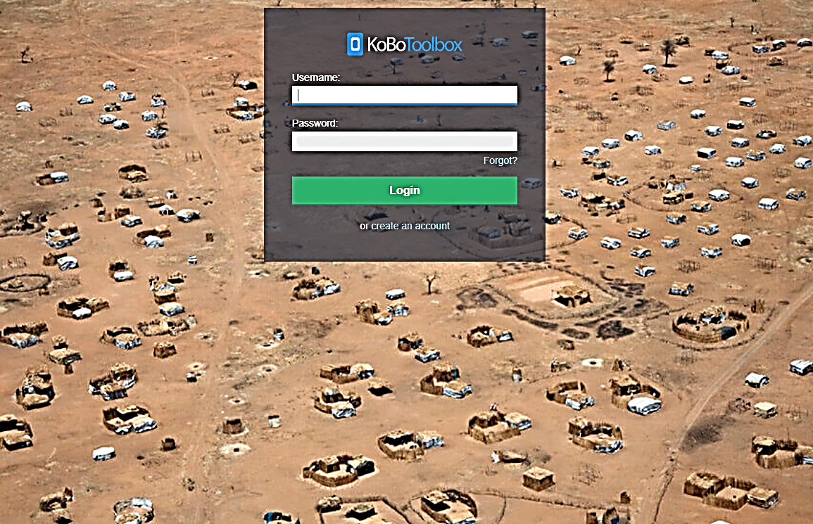
Step 2. Next, select “New”
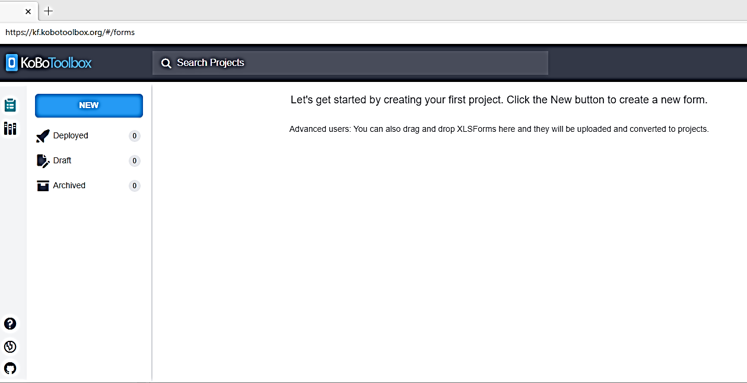
…and then “Upload an XLSForm.”
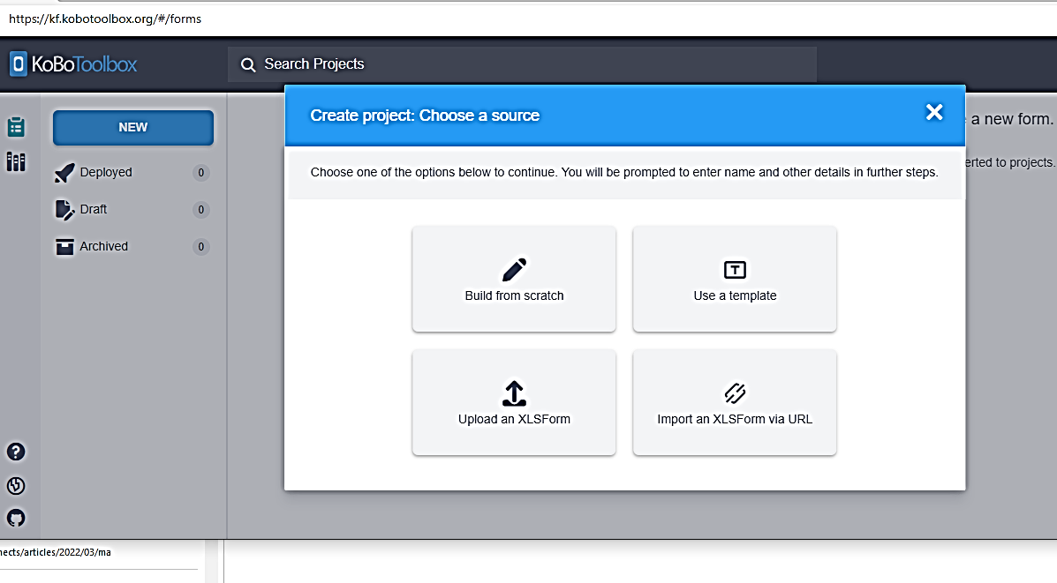
Step 3. Copy the Excel file from the toolkit that contains the KoBo format for the survey you are using (survey 1 or 2) onto your desktop. The files are named: “Excel Input File Questionnaire 1,” and “Excel Input File Questionnaire 2.” When you see the next screen, (below), you upload the file into the box, either by dragging the file or by clicking on the XLS icon and then selecting the Excel file from your desktop. This will create your electronic version of the survey questionnaire. This file does not have any survey data in it. It is just a formatting file that automatically programs KoBo to created your questionnaire.
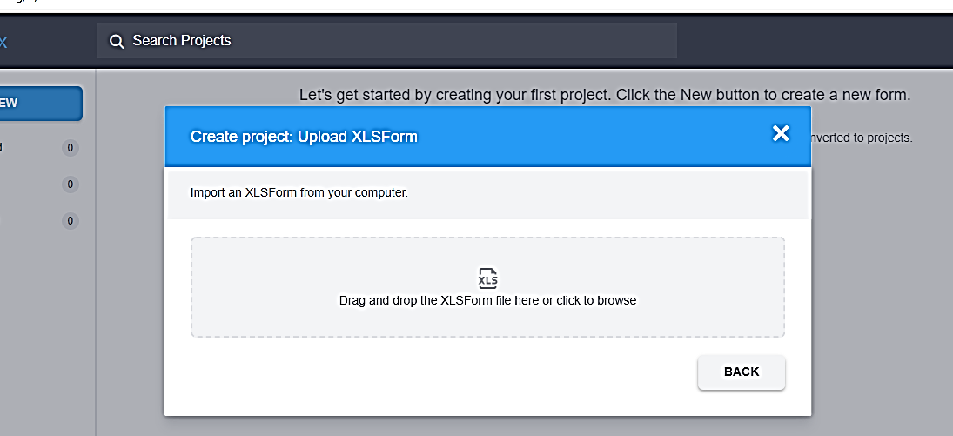
Step 4. You will see the screen below. In the upper right corner, select the icon that is shaped like an eye, and this will allow you to preview the survey. If there are any errors in the formatting of the survey, you will get an error message. If this happens, you will need to edit the format Excel file and then upload it again [is there a link in the guidance on editing this file? ] The Excel file formats provided in the toolkit have been tested, and there should not be any errors.
Once you have checked the “preview” you will close that viewing tab by looking up at the top ribbon and closing the tab by clicking on the “x.” Then you should see this screen again.
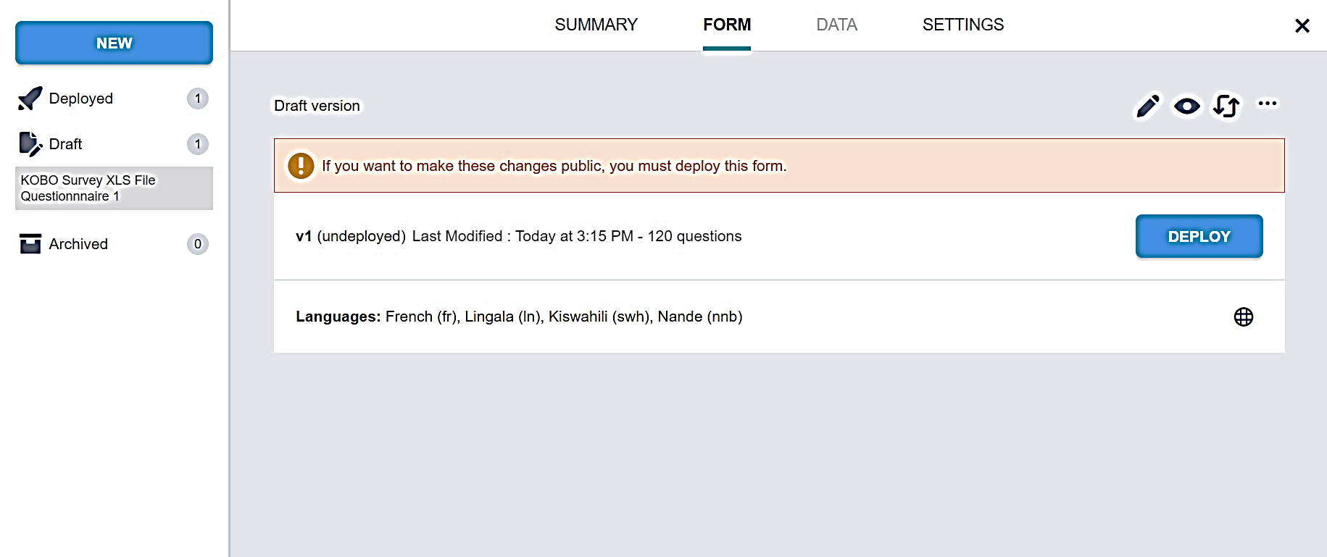
Step 5. Next, click on the “deploy” button. If the survey deploys correctly, there will be a brief message at the bottom of your screen saying, “survey has deployed.” Then you will see this screen:
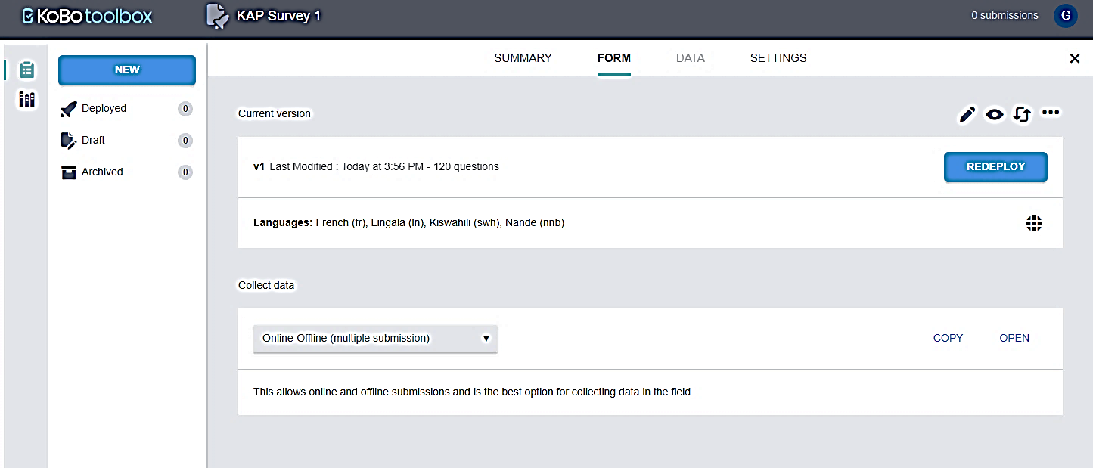
Step 6. On the right lower side of the screen, you will see the “open” button. If you click on this you can start entering data into the empty dataset. If you are setting this survey up in KoBo in order to enter data from paper questionnaires, you can open the file this way. If you want to access the dataset from a tablet or a different computer, you will select the “copy” button. This will copy a link to the dataset that you can then send to anyone that you want to access your dataset. Here you will also make sure the option for “online/offline” data entry is selected, so that data collectors can use the form even when there is no internet. The main file will update whenever the tablet is back in an area with wifi. Please note: using this method, only one person will set up an account for the whole team, and then data collectors will send data to that single account using the internet link. Data collectors don’t need to set up KoBo accounts themselves.
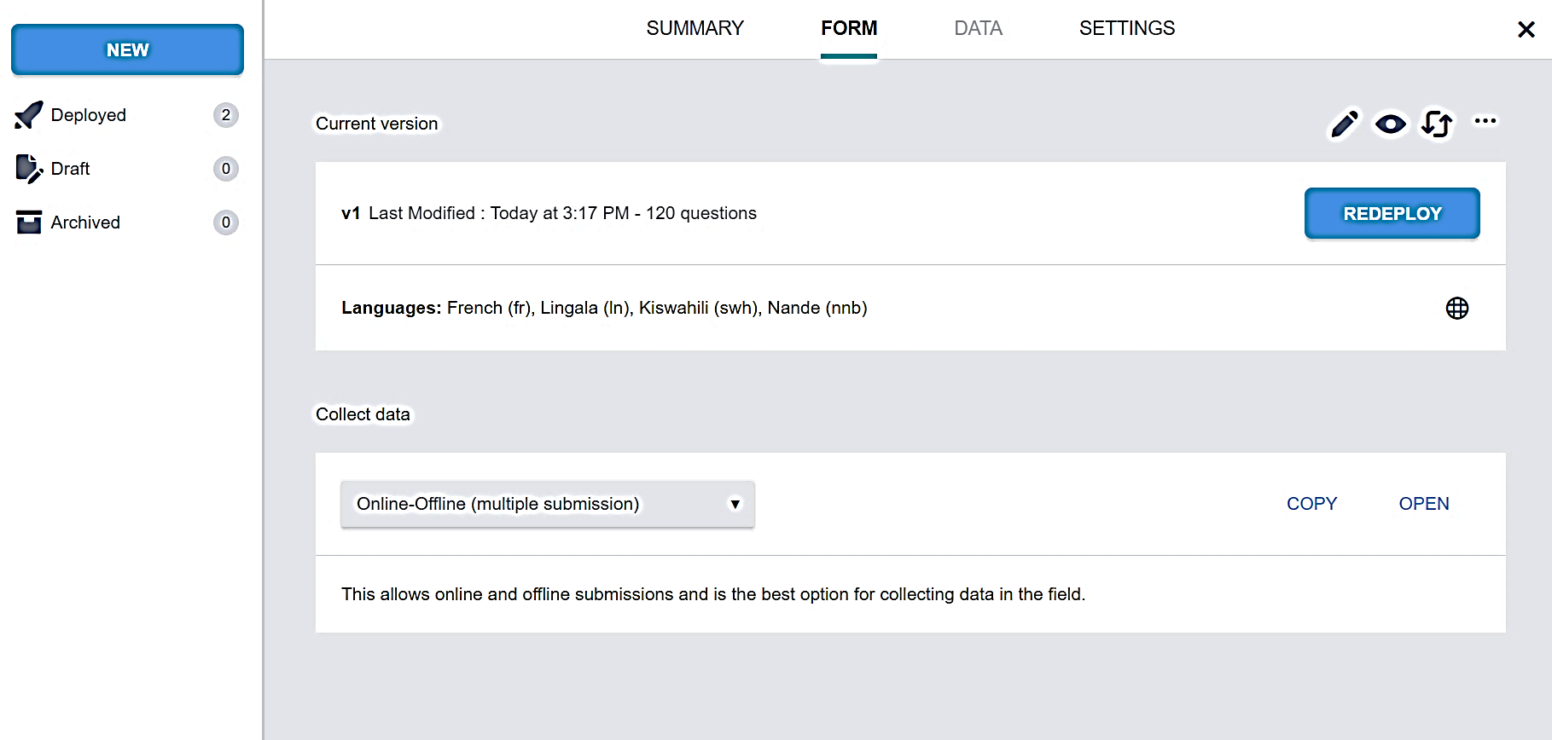
Step 7. When you are in the tablet, open the survey, and then select “bookmark” or “favorite” from your browser’s options. This makes it possible to easily open the survey as needed in the future.
NOTE: If you are using the paper surveys, open this same survey to perform manual entry of the data from the paper forms.

6 Sampling KAP survey participants
One of most important steps in conducting a KAP survey is deciding how you will select your KAP survey sample of participants. If you want to use the survey to provide information about the entire geographic area, then you will need to select a sufficiently large sample and select your sample randomly from that area. Samples in which people are not randomly selected are sometimes used (called “convenience samples” and “intercept interviews”), however using this approach should not be used for a KAP survey.
If you feel you need to collect information with a small sample size or using a convenience sample, you can administer a Rapid Assessment, by collecting a brief version of either of the surveys with a small sample from whoever you can find in the community (with local interviewers), followed by sharing that information with focus groups or other naturally occurring groups within the community, to reflect on the results, to add other points of view, and to compensate for the fact that your sample is most likely not representative of the whole community. You would not conduct statistical analysis on this type of data.

6.1 Key concepts of KAP survey sampling
Before providing specific guidance for estimating sample size and sampling participants, it will be helpful to read a brief review of some basic sampling concepts.
Estimating sample size – Because of known mathematical relationships between the size of the general population, the size of a survey sample, and an acceptable margin of error, you can estimate your sample size using a formula. The other elements that go into the formula have commonly used values that we can use here to keep it as simple as possible. (For a more in-depth explanation, follow this link: https://www.wikihow.com/Calculate-Sample-Size.) Past experience in DRC has shown that a sample size of 400-500 interviews provides sufficient power for most analyses. In the example provided below, we estimate a sample size of 600 (300 women and 300 men), so that results can be displayed separately by sex. In the section below, we will work through an example of how to calculate a sufficiently large sample size for your needs. In some cases, donors will specify the sample size, or budget may determine how many can be included in the survey. Security considerations may also affect where surveys can be administered. If you have to cover a large area and can only sample certain villages or neighborhoods, you can use cluster sampling methods. This is outside the scope of this guide, but guidance is available on-line (https://www.voxco.com/fr/blog/echantillonnage-en-grappes/).
Before making this calculation (using an online sample size calculator application, for example, Stat Trek Sample Size Calculator: https://stattrek.com/survey-sampling/sample-size-calculator.aspx), it is important to think about what your primary objectives are for the survey. Some important things to think about are:
- Who is in the population of interest (e.g., just adults or also children)?
- Are you interested in describing frequencies for the entire sample, or is it more important to keep groups separate to compare them?
- What about other subsets of the population such as ethnic or religious groups?

The simplest methods of estimating sample size assume you are trying to provide response frequencies that are generalizable to the entire population of interest. These are called descriptive statistics. If you also want to be able to stratify results by gender or by other characteristics, the sample size will need to be larger. One mistake people often make is that they estimate a sample size only large enough for basic descriptive statistics and then they try to stratify results by other variables or compare groups. If you do this, your sample will not be large enough for you to be confident in your results.
If you plan to stratify your results by gender, age, or other demographics, you will need to increase the sample size. This will be illustrated below when we suggest a specific sampling plan for the general population surveys using the two model questionnaires.
Sampling methods – Once you have calculated the survey sample size, you will also need to devise methods to number, select, and recruit respondents. Ideally, selecting participants is done by obtaining a list of everyone in the population of interest and then randomly selecting participants from this list. Contact the local public health office to obtain a list of all homes in the area of interest.
Once you have a list of all residents in the population of interest, identifying individuals to be recruited for interview is a simple matter of randomly selecting from the list. You have several options:
- You can assign a number to each individual and then use a random number generator such as this one (Stat Trek Sample Size Calculator: https://stattrek.com/survey-sampling/sample-size-calculator.aspx) to randomly select individuals.
- In more remote environments, you can simply put all the numbers in a bowl and select them randomly.
If it is not possible to obtain or create a list of every member of the population, alternative methods such as stratified sampling (sometimes also called representative sampling) can be used.
Stratified random sampling – When random sampling of the entire population is not possible, we can use alternative methods, such as randomly selecting villages, then neighborhoods within villages, houses within neighborhoods, and then individuals within selected households. As long as selections are made randomly throughout the process, this is also an acceptable method for respondent selection. This method also enables you to ensure that certain characteristics of your sample are consistent with the underlying population. For example, if 30% of the general population lives in rural villages, we can select 30% of our sample from rural villages.
In Section 6.2 below, we will provide an example of representative sampling for a general population KAP survey by first determining the proportion of the general population living in rural, small urban, and large urban locales. Then we will sample a proportionate number of villages of each type, then neighborhoods. Finally, houses, and individual respondents will be selected by data collectors while in each selected neighborhood. This is not the only way to do the sampling but provides an example.

6.2 Applying sampling concepts to a general population KAP survey
Sampling one health zone at a time – For your general population surveys, you will first need to determine the sample sizes for each health zone.
- If you are conducting a survey in a single health zone where the outbreak began, you will only sample that health zone.
- If you want to make comparisons between multiple health zones, you will need to calculate the sample size for each health zone separately.
With either of these strategies, follow these additional steps if you plan to analyze the data by sex:
- If you want to display findings for women and men separately on a range of frequencies, you will need to calculate a sample for women and men separately.
- However, if you sample men and women separately and then want to display frequencies for the entire population (not stratified by sex), you will need to weight the frequencies for men and from women according to the proportion of men and of women in your population of interest.
Begin by estimating sample size – For the example below, (using Beni health zone in eastern Democratic Republic of the Congo [DRC]), we will calculate a sample size for men and women separately so that survey response frequencies can be displayed separately. These separate frequencies will allow us to tailor community awareness efforts and organize community activities to meet the needs of men and women separately.
For this example, we will use population estimates found online in July 2020. You should work with your local Ministry of Health and local universities to obtain population estimates for the geographic area that you wish to survey. At a minimum, you will need: total population, percentage of women, percentage of the population who are children, and percentages of the entire population living in rural areas, in small towns/cities, and in large cities. This will allow you to make all the calculations you need for the sampling. While it is important that you have all of this information, keep in mind that you can use estimates.

Table 7. Information you will need to calculate sample size and to sample by small, medium, and large village/city using Beni Health Zone, DRC as an example
 | Total N (%) | Men N (%) | Women N (%)
Beni health zone population | 260,000 (100%) | 127,400 (100%) | 132,600 (100%)
City of Beni population (urban population) | 120,640 (46%) | 59,114 (46%) | 61,526 (46%)
Medium sized villages population | 91,978 (35%) | 32,192 (35%) | 46,909 (35%)
Small village population | 45,989 (18%) | 22,535 (18%) | 23,454 (18%)

We estimated the numbers in the table above from four numbers obtained online:
- The population of the Beni health zone: (https://www.watercharity.org/book/beni-biosand-training-democratic-republic-of-congo-2/)
- The percentage of the total DRC population who are women and the percentage who are children under 15: https://africa.unwomen.org/en/where-we-are/west-and-central-africa/democratic-republic-of-congo)
- The population of the city of Beni, the only major urban center in the health zone: (https://www.cidrap.umn.edu/news-perspective/2018/07/news-scan-jul-31-2018#:~:text=The%20DRC%27s%20health%20ministry%20urged%20health%20workers%20to,Beni%2C%20which%20has%20a%20population%20of%20about%20232%2C000.)
You will notice looking at these estimates that they are not precise. For example, ideally, we would want the proportion of children under 18 years, and we would want the proportion of the population that is female for Beni, not for all of DRC. However, if you are not able to access these precise figures, it is acceptable to make a rough estimate. Also, for this example, we calculated the percentage of the population living in urban areas by dividing the population of Beni City by the estimated population of the entire health zone. We assumed that twice as many people live in medium sized villages as in small villages. Creating a table with the best available information will help you both with the sample size estimation and the sampling planning.
Estimating the survey sample size for women – To start the process of sample size estimation for the women’s sample, we can go to an online sample size estimator such as Stat Trek Sample Size Calculator (https://stattrek.com/survey-sampling/sample-size-calculator.aspx) and follow it step by step. 1. First, we will estimate the sample size for women. Here is an example of the first screen you will see:
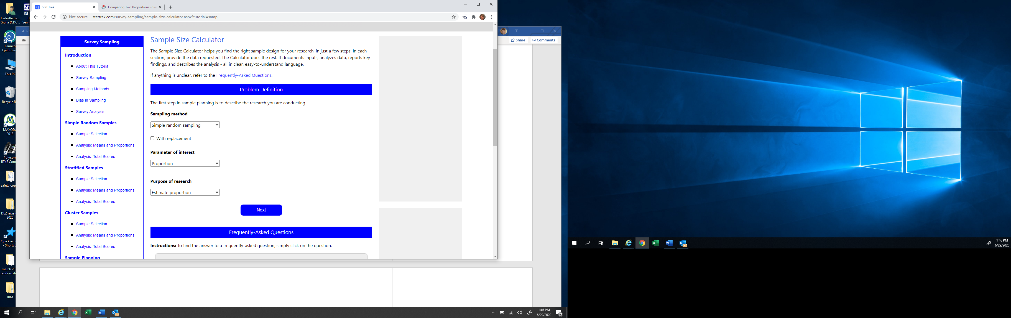
The options shown above are the ones you should select:
  - Sampling method: "Simple Random Sampling" (leave “with replacement” box blank)
  - Parameter of interest: “Proportion” – This means our results will be percentages and not numerical values in the form of means
  - Purpose of research: “Estimate proportion” – This means you are attempting to estimate values that represent the underlying population values rather than testing a hypothesis.
  - Select: “Next”
The next screen will be:
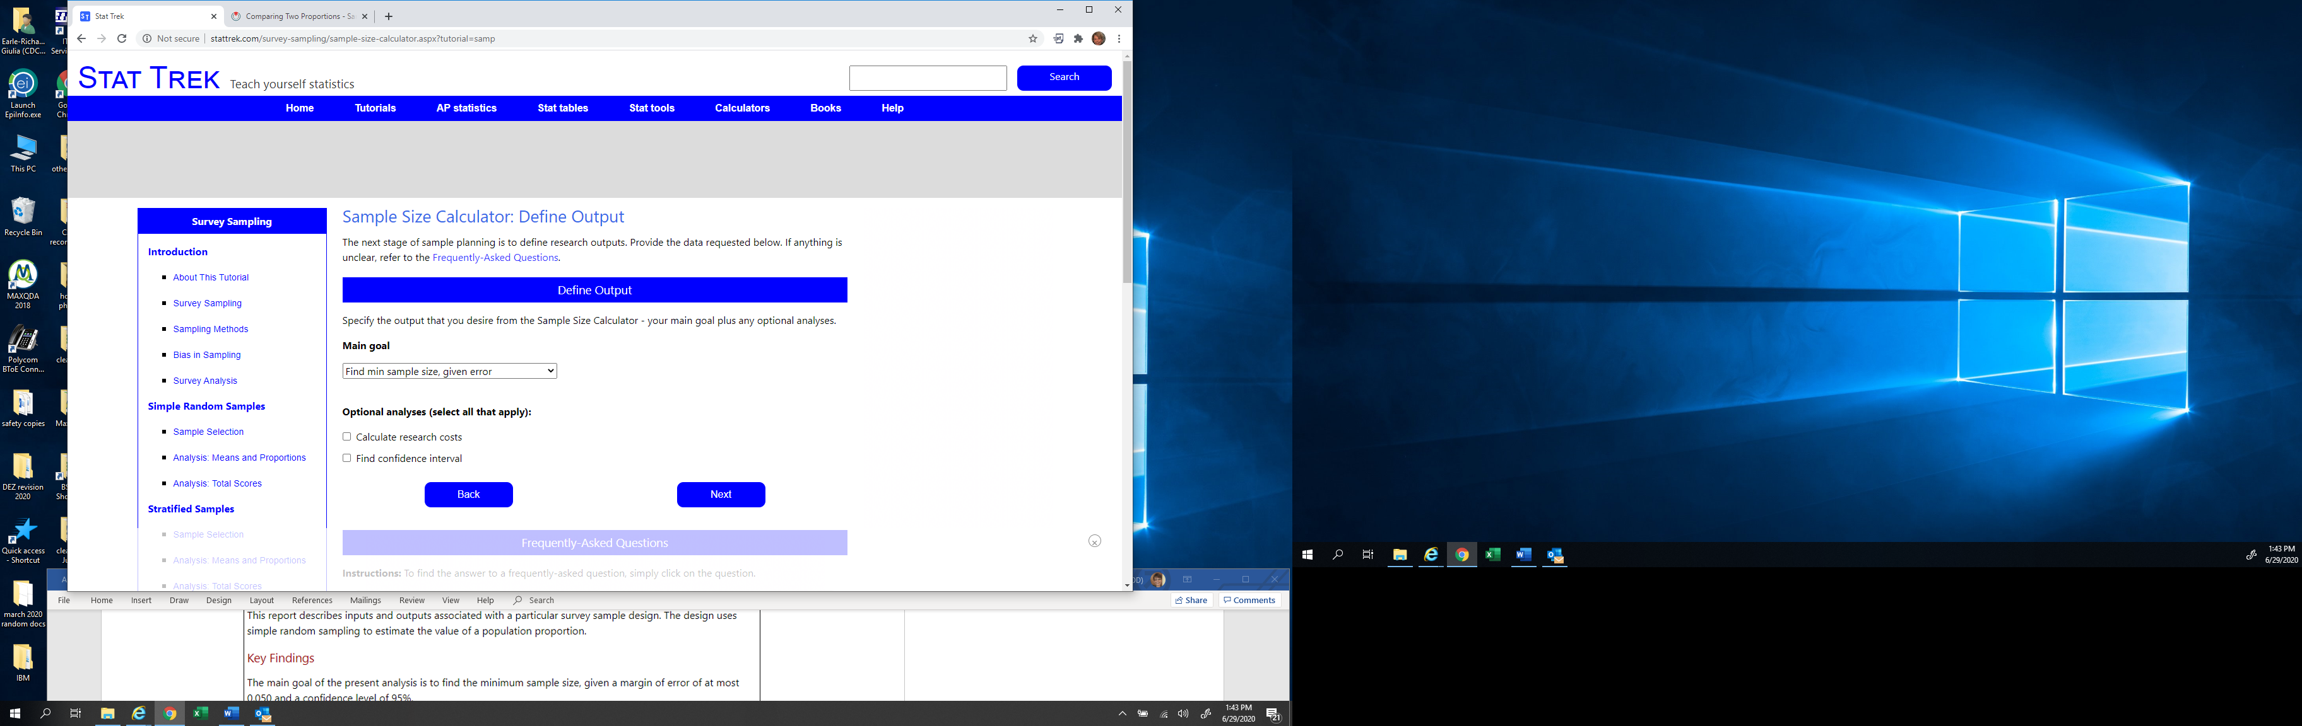
Select the following option:
Main goal: “Find minimum sample size, given error”
Select: “Next”

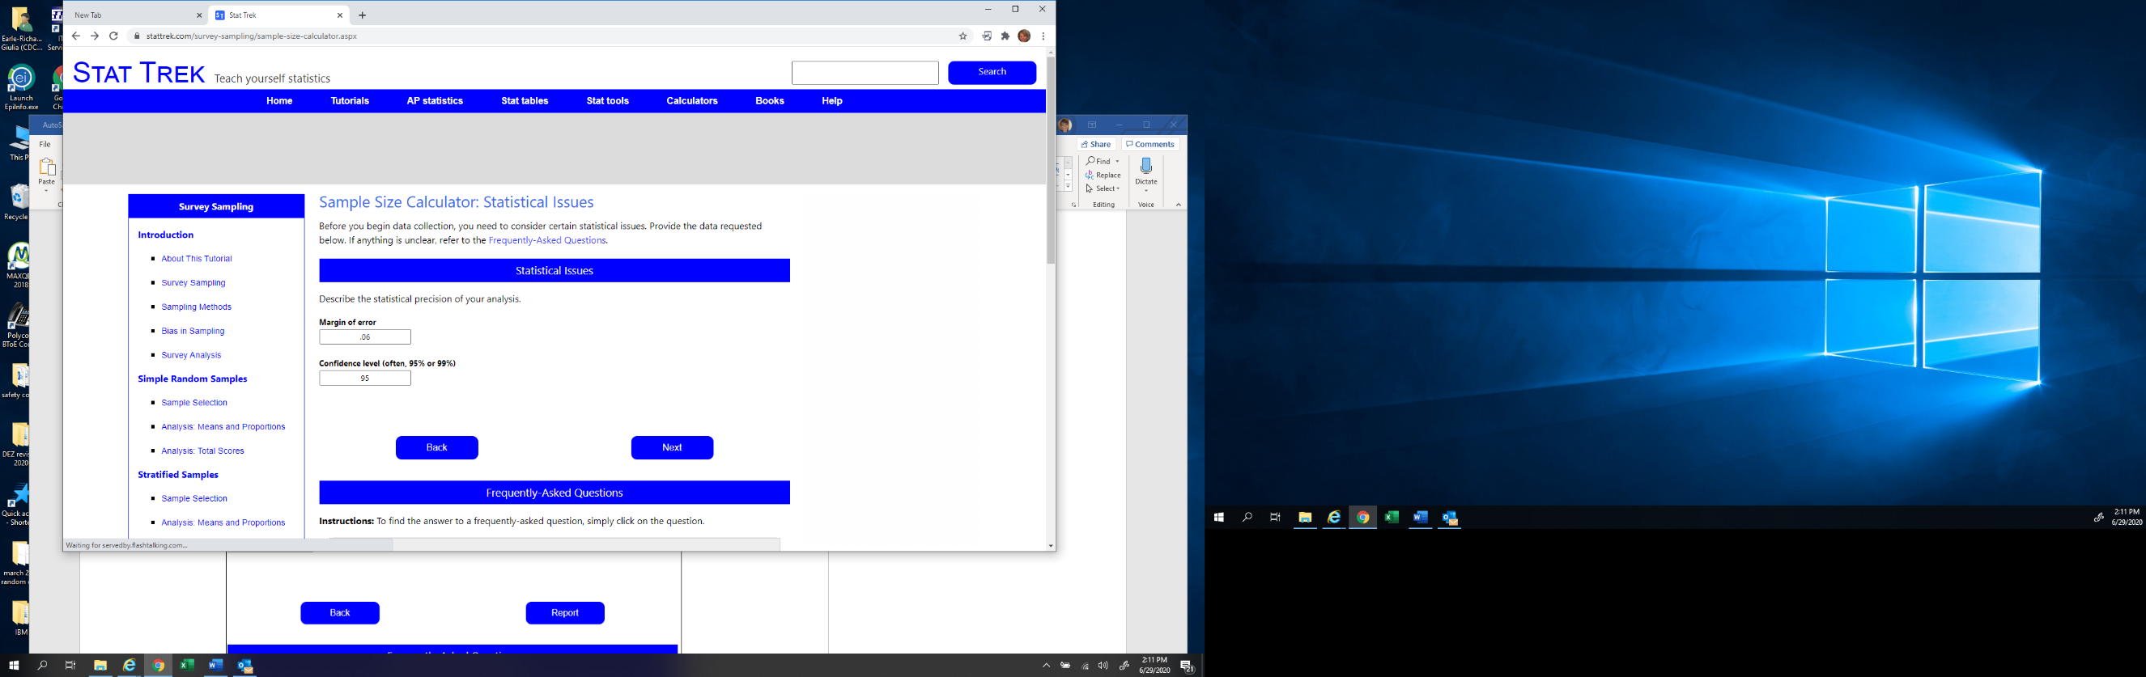
The next screen will be:

Here you see that we are entering “.06” for the margin of error. This means that your results, which will be in percentages, will have a margin of error of 6%. So you will say “the frequency is x% plus or minus 6%.” This is a relatively small margin of error because we want to have the ability to compare percentages for women versus percentages for men. However, you can adjust the margin of error that you want, keeping in mind that a smaller margin of error will require a larger sample size.

Fill in the above screen as is shown. The next screen will be:
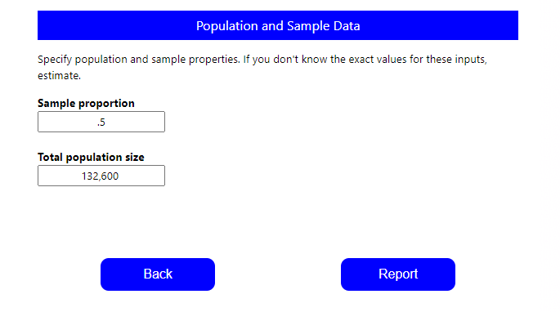

Here, it first asks for the sample proportion. The value 0.5 means that you estimate that your sample size will be based on a question for which 50% of respondents answer “yes.” For reasons we won’t go into here, this is the best value to use when you don’t have an actual estimate of the expected frequency of your most important survey responses because it yields the largest sample size. This means that with the resulting sample size, you can be sure you have a large enough sample to do all of your analyses, regardless of what the actual frequencies turn out to be.
Next, it asks for the total population size. Referring back to Table 7 above, we see that the best available estimate for the adult female population of Beni health zone is 132,600. You will of course need to replace this value with an estimate of the total female population in the health zone that you are surveying. Then select “Report.”

The report will look like this:
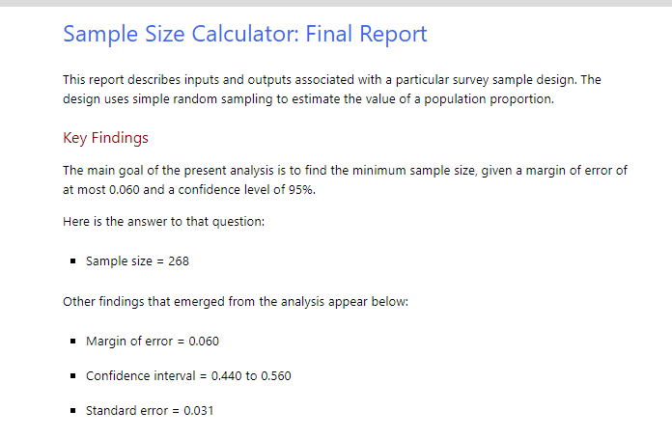

In the above report, you see that the total sample of women is 268. That is the target number of women you would like to have complete your survey. Keeping in mind that there may be some cases with the door-to-door sampling that may result in women not completing the survey, or loss of some cases while alternating between male and female respondents, we advise that you increase the sample to 300 (an extra 12% in the sample).
Estimating the survey sample size for men – Once you have completed this estimation process for the survey sample for women, you will do the same for men. You will use all of the same steps outlined above, except this time you will use the total estimated population of men in Beni: 127,400. Because this population estimate for men is very close to the estimate for women, the sample size comes out to be 300 also.

Comparisons of demographic groups may require oversampling – While the model sampling plan samples both men and women equally so that results can be stratified by sex, if you want to compare outcomes by language or ethnic group, by location, occupation, education or other grouping, you should be sure to have a large enough sample of every group (a minimum of 30 of every group being compared) in order to make comparisons.
You have now completed the step of estimating the sample size. Now we need to identify how 300 women and 300 men from Beni will be identified and recruited.
Selecting survey participants
Simple random sampling – If you are able to obtain a list of all residents (with phone numbers or home addresses) in the population of interest, then you can perform simple random sampling. This is easy to do if you use a random number generator (for example a formula in Excel: "= randbetween (1; 10000)") or print numbers and select the numbers from a bowl. One challenge with this method will be that if the surveys are administered in person, respondents are likely to be located across a very wide area. One way to overcome this challenge is to conduct interviews by phone.
Representative sampling – If it is not possible to do simple random sampling, then you can select a random sample through different geographic groupings within the health zone or other area. The following series of steps illustrates how to conduct representative random sampling using villages, neighborhoods, and households.
Steps
- For the purposes of this sampling process, we will assume that for each sampled health zone, we will sample 25 villages of different sizes. The proportion of those 25 villages that are small, medium, or large (by “large villages” we mean cities) will be different in each health zone.
- To sample small, medium, and large villages, we need to estimate the proportion of the total population living in each size category. It is much more accurate to establish proportionate sampling based on what proportion of the population live in small, medium, and large villages than it is to use the number of villages of each type to create the proportions. This is because by definition, large cities contain many more people than small villages. If you sample based on the number of villages of each type, you will vastly over-sample rural respondents and under-sample urban respondents. This will make your sample a poor representation of the population.
- Using the estimation table above, we know that small, medium, and large villages account for the following proportions of the population:
  - Small: 18% of the total population, so 18% of the sample of 300 or 54 women
  - Medium: 35% of the total population, 35% x 300 or 105 women
  - Large: 46% of the total population, or 46% x 300 or 138 women
(Due to rounding we have a total of 297 women, so we can add one more woman to each group to reach 300.)
- Next, using 25 as the total number of villages, we will calculate the number of villages that will be sampled in each size category using the proportions calculated in step 3.
- Small villages: 18% x 25 or 5 small villages (54 women)
- Medium villages: 35% x 25 or 9 medium villages (105 women)
- Large cities: 46% x 25 or 11 cities (138 women)

One challenge that becomes apparent using this process is that depending on your definition of a large city, there may not be 11 different cities to sample. As you recall, we estimated the urban proportion of the sample just from the city of Beni alone. The important thing is that Beni is an urban setting, and the neighborhoods across the city should be randomly selected. Within the city of Beni, there are four large subdivisions, or communes: Beni, Bungulu, Ruwenzori, Muhekera. For this example, will use these fours subdivisions for sampling, and they will represent large cities. So our large city row now becomes:
- Large cities: 4 communes of Beni city (138 women)
Depending on the area you are sampling in, this adaptation may not be necessary, but it is a good example of how to adapt the general sampling model to your setting.
5. At this point, it is helpful to consider that you are sampling two populations, women and men, from the same populations and with identical sample sizes for each. For this reason, the most efficient data collection method may be to alternate between men and women when conducting door-to-door interviews. Combining the male sample and the female sample, we have:
- Small villages: 5 (55 women, 55 men)
- Medium villages: 9 villages (106 women, 106 men)
- Large cities: 4 communes of Beni city (139 women, 139 men)

- The next step will be to randomly select 5 small villages and 9 large villages. This will require a list of all of the small and large villages in your geographic area. If you have the lists of small and medium sized villages on an Excel spreadsheet (numbered), you can use the formula "= randbetween (1; 10000)" in Excel to generate the numbers of selected villages. For each sample drawn, select 3-5 additional replacement villages in case some reason arises (for example, insecurity or difficult access) that makes any selected village not possible for surveying.
- Within villages and communes, you will need to decide whether it is more feasible to identify different neighborhoods and then randomly select them as well, or if the village is small enough to select households directly from the entire village.
  - Small villages: (55 women, 55 men), a total of 110 households across 5 villages, or 11 households per village (with 3 possible replacement villages)
  - Medium villages: (106 women, 106 men), a total of 212 households across 9 villages, or 24 households per village (with five replacement villages identified)
  - Large cities: (139 women, 139 men), a total of 278 households across 4 communes, or 70 households per commune. (If possible, further randomize by neighborhood so that in 3 of your communes, you have 25 households per neighborhood.).
- The next step is to randomly select houses while you are in each neighborhood.
Selection of the first household – In small villages and towns, begin by identifying the geographic center of the village (usually a school, religious center, or market). Follow these steps to select your first house to survey:
- Randomly identify a direction to walk in (either by spinning a bottle or throwing a pen into the air and seeing which way it is pointing when it ends).
- As you walk to the edge of the village in that direction, begin counting homes and assigning numbers.
- When you have finished assigning numbers to homes, put those numbers in a bowl and randomly select a number. Do the first survey at the house that was assigned that number.

The diagram below shows how this is done. In Figure 1, the data collector starts at the middle of the village, randomly selects a direction, then walks straight in that direction, passing six homes until reaching the edge of the village.

Figure 1. Randomly selecting the first home for a KAP survey in a rural village
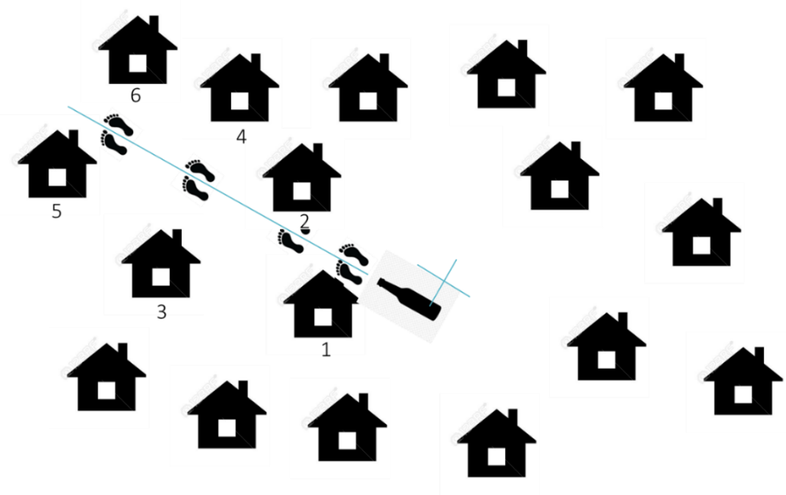
(This method is also used to begin random selection within randomly selected neighborhoods in larger villages and cities.)

Diagram credit: UNICEF présentation d’échantillonnage pour les CAPs élaborée par la CASS
(UNICEF) pendant la flambée d’Ebola en RDC de 2018.
After putting six numbers in a bowl, the data collector drew the number 5 (any method of random choice can be used) and conducted the first survey at house #5. As shown in Figure 2 below, the data collector spun the bottle again to find a new random direction. This time, the next interview was conducted at the next new house the data collector came to (houses #4 and #2 are passed by because they were already counted the first time).
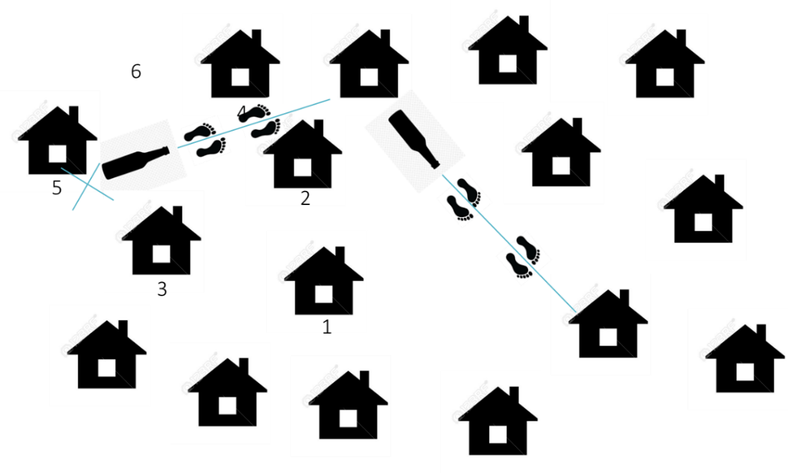
Figure 2. Randomly selecting the next home for KAP survey

Diagram credit: UNICEF présentation d’échantillonnage pour les CAPs élaborée par la CASS (UNICEF)
pendant la flambée d’Ebola en RDC de 2018.
When that survey is complete, the process is repeated until all the needed surveys are completed.
For large villages, you will have selected three neighborhoods at random within each commune, with five additional neighborhoods identified as back-ups in case any of the neighborhoods are not accessible. The selected neighborhoods should then be grouped geographically so that data collection teams can be assigned to neighborhoods as close together as possible. Then the process shown above in Figures 1 and 2 is repeated within each neighborhood to assure random selection of houses. Any neighborhood that is not visited due to security or other accessibility concerns should be noted and sent as a list to the project leader. As with refusals, inaccessible communities are part of the participation rate calculations, and should be recorded.
9. The next step is to select participants in households. If your strategy includes interviewing equal numbers of women and men, you can accomplish this by having each data collection team alternate between asking to interview a woman in one home and asking to interview a man in the next home. For this approach, it is most helpful to have one male and one female data collector so that surveys can be conducted by a data collector who is the same sex as the respondent as often as possible. If data collectors are visiting a household and need to interview a woman but no woman is present, they will continue to the next nearest household until a woman is home. It is important to respect the availability and wishes of participants. If the identified person cannot or does not want to participate in the survey, someone else must be sought, either in that household or elsewhere.

7 Recruiting survey data collectors
Data collectors should possess the following characteristics:
- They come from the communities to be surveyed. This will maximize cultural competency and strengthen their rapport with participants during interviews.
- They have experience conducting KAP surveys.
- They speak the local languages and French fluently.
- It is also important to hire a local supervisor who knows the community and has a good reputation.
It is also important to hire a local supervisor who knows the community and has a good reputation, and to partner with the local health authorities to select local data collectors.
The number of data collectors required will be determined by the geographic spread and size of the sample population to be interviewed. Generally speaking, you want to hire enough data collectors to have them go out into the community in teams of two (optimally one male and one female) and to be able to complete all of the surveys in approximately 1 week. The number of surveys that can be completed in 1 day will depend on how far apart the healthcare facilities (or other survey locales) are and how frequently respondents refuse to participate in the survey or terminate the survey in the middle. If you do not have a sense of the timing, you can send your team out to do 1 day of practice surveys, and you will see how many surveys can be accomplished in 1 day.

8 Training survey data collectors
For every KAP survey, training of high-quality data collectors is critical to maintaining scientific integrity. Even if a survey has been thoughtfully developed and validated, if it is poorly administered by a data collector who has not received adequate training, you will end up with biased and invalid data. Comprehensive data collection training needs to be conducted in a language understood fluently by all participants (preferably the language in which the survey will be administered) and should contain the following elements:
- Purpose of the survey
- Protocol for selecting respondents
- Informed consent process
- Review of the survey questions
- Handling and recording refusals
- Interpersonal communication
- Avoiding bias while asking questions
- Saving and transmitting data
- Role play
- Field testing

The following section reviews each of the training components and provides instructions on what should be presented and discussed.

8.1 Purpose of the survey
It is essential that all team members understand why the KAP survey is being undertaken and how the results will be used to assist with the Ebola responses. Data collectors can do a better job dealing with unexpected situations if they understand why they are conducting the survey. Data collectors also need to understand the purpose so they can explain the purpose to respondents.

8.2 Protocol for selecting houses and selecting respondents
Survey data collectors should understand the sampling protocol. All data collectors should have written and verbal guidance on how homes are selected and which individuals to interview. These materials should be developed and provided by the field supervisor. If the protocol includes alternating the interview of men and women, this should be discussed as well as plans for what to do if a male or female is not present when it is their turn to be asked to participate.

8.3 Informed consent process
Data collectors should be shown the introduction script for the survey, which they can read to quickly explain the purpose of the survey, how long it will take, that it is confidential, and that respondents can refuse to participate, decline to answer any question, and terminate the survey at any time without any negative consequences. Reading a script like this and obtaining consent can be done quickly and is required according to internationally accepted ethics principles.

8.4 Handling and recording refusals
If a survey respondent refuses or is unavailable to participate in the survey, this must be documented to calculate the participation rate. It will be important to review with data collectors how to record refusals on the questionnaire or in the tablet so that the number of “not at home” and “refused” participants is recorded. If data collectors are using paper surveys, you can give them a separate notebook to record whether someone refuses or is not at home. This will save paper because they will not need to use an entire paper survey with just “refused” or “no one at home” checked. If data collectors are using tablets, the data collection team will need to decide whether all data collectors will check “refused” and then leave the record in the data as a blank record, or if they will note the refusal in a separate logbook. You must have a way of counting the number of people who refused to participate, and if possible, to record the sex of each person who refuses. The survey questionnaires have a place to record refusals at the beginning. This will allow you to calculate the participation fraction among men and among women.

8.5 Questionnaire review
During the questionnaire review, each question should be read out loud together. During this step, the survey data collectors explain each question to the field coordinator to make sure they have understood the questions. At this point, the field coordinator and data collectors will develop an explanation (and any further clarifications) for each question. This document will be approved and finalized by the project lead. This information will be part of a survey guide for data collectors.
Note that this guide and information cannot be changed after the first round of data collection. For subsequent rounds, the meaning of the questions should be discussed using the guide that was developed by the pilot team.
Data collectors must also be trained on the different types of responses such as single choice, check-all-that-apply, and free text. Print out page 9 of this guide to share with data collectors and review the different possible response options. There also may be questions in which data collectors must not read the response options but rather listen to the respondent’s answer and mark the closest response option.
Finally, data collectors must understand the skip logic especially if the survey is administered on paper and the skip patterns are not automatically applied. When collecting data using the tablet, data collectors might not see the skip patterns, as they are programmed to occur automatically. You should train your data collectors using the method (paper or tablet) that will be used in your data collection.

8.6 Interpersonal communication
Data collectors should be instructed that good communication with respondents is key to avoiding biases that could affect the survey results. Data collectors should seek to build trust by being polite, respectful, and patient. Before starting an interview, they should:
- Introduce themselves with their name and agency
- Present the objectives of the survey and assure participants their responses will be anonymous and confidential
- Allow respondent to ask questions
- Obtain verbal consent from the participant and note it on the questionnaire
- Conduct the interview
In addition, data collectors should be advised that respondents are likely to answer questions differently depending on whether they are surrounded by other people who are listening to the answers they are giving. Every effort should be made to make it possible for the respondent to complete the survey in private.

8.7 Avoiding bias while asking questions
Make sure data collectors understand that they must ask questions in the order they are written. Note that any change in order, however small, may affect the responses.
Emphasize to data collectors the importance of not influencing people’s responses. For example, if the respondent is hesitant about a question, an answer should not be suggested. Explain that suggesting answers introduces a significant bias into the survey results. If the respondent refuses to answer a question, check “refuse to answer.”

8.8 Saving and transmitting data
Once data collectors are familiar with the questionnaire and how to record responses either on paper or electronically, they must understand how to save the data after completing an interview.
- For a paper survey, the questionnaire must be checked over to ensure all questions are answered, and it should be delivered to the supervisor at the end of the day.
- For an electronic survey, the data collector must have an opportunity to practice submitting records using the tablet.

8.9 Role play
As part of the training, data collectors should practice administering surveys in front of the group. This will allow supervisors to observe their performance and give feedback so they can improve their technique. The data collectors will each need to complete a survey by questioning a teammate in front of the group. This will help demonstrate effective surveying techniques while emphasizing interpersonal skills and communication.

8.10 Field testing
After the training, data collectors should each administer three practice interviews in the community. They will receive a list of areas that were not included in the survey sample to be investigated. Working in teams of two, they will conduct three interviews in the field.
After the practice interviews, data collectors should meet in a group with a facilitator to discuss difficulties they encountered in the field and strategies to manage them. This discussion is an opportunity for the data collectors to master their administration of the survey and is not an attempt to validate the survey. At this stage, the survey has already been finalized.

9 Final planning for data collection

9.1 Daily schedule
To plan daily data collection, a schedule should be developed for each team. Some considerations for planning include:
- The number of surveys that can be realistically conducted in a day given the field context (distance, accessibility, availability of transport) and length of the survey
- Assignment of interviews based on geographic proximity
- Movement of the team to maximize opportunities for supervision
- The familiarity of each team with the area to be surveyed (It is imperative to send data collectors who are familiar with communities and speak the local language.)

After determining the number of teams and their daily movements and activities, the plan should be summarized in a table to facilitate field supervision activities. An example can be found below.
Table 8. Example of a plan to collect data from the general population
Team | Health Zone | Village | Interviews (male) | Interviews (female)
Team 1 (person A, person B) | Katwa | Kihumulire | 4 | 4
Team 1 | Katwa | Matanda | 3 | 3
Team 2 (person C, person D) | Butembo | Bwinyole | 5 | 5
Etc... | Etc... | Etc... | Etc... | Etc...
It is possible that the official censuses and lists of health facilities will not be up to date. If it is discovered in the field that a sampled home no longer exists, data collectors will be instructed to survey one of the backup homes that were chosen for this purpose.

9.2 Number of survey data collectors
The number of data collectors required will be determined based on the geographic spread and number of units to be visited. (For example, if there are 10 neighborhoods to interview within a 3 km radius, it may take less time than surveying 3 neighborhoods within a 15 km radius.) In addition, the accessibility of households must be considered when determining the number of data collectors necessary to complete data collection within the specified time.
As noted earlier, if possible, plan to send the data collectors in teams of two or more. When assigning teams, it is wise to put a more experienced surveyor with one who is less experienced.

9.3 Survey data collector materials
Whether using tablets or paper surveys, the data collection process is largely the same. Data collectors will follow a written plan given to them by supervisor that tells them what areas to survey and provides specific instructions of how to select homes to survey and who to survey in each home. The list of places and homes to survey should have a place for interviewers to note where they visited and whether they were able to complete the survey. If using a paper survey, it will be very important to note all of the times a person refused to participate. With the tablet, you can note refused in the beginning of the survey and leave the rest of that entry blank. With paper surveys you should provide a logbook for noting refusals.
The data collection plan should also state how many interviews should be completed each day and include instructions for what to do with the forms or the tablets at the end of each day. You may want them to report the number of surveys completed each day so that you can be sure that the survey will be completed in the allotted time. You may want to store the forms and tablets at the project office. It is critically important that the completed survey data be kept safe and well organized.
Before starting data collection, field supervisors will give each data collector:
- A written schedule of what communities their team should visit each day and how many interviews to complete
- A document that provides instructions for getting to the team’s starting location, selecting the house and selecting the respondent
- A list of participant ID numbers assigned to each interviewer team. You can start each team’s number with a different initial number, so that no two participants will have the same number. For example:
  - Team 1: ID numbers -10001, 10002, 10003, etc.
  - Team 2: ID numbers – 20001, 20002, 20003, etc.
This assures that no participant will be assigned the same ID number as another participant. This number will be assigned to the individual when they start the interview and will be recorded on the survey. ID numbers help you keep your records in order and makes it easy to find the original paper questionnaires for a given participant if paper surveys are used.
- A log sheet or some other process for recording every refusal (you may want to include gender)
- The name and phone number of the field supervisors or other leader (at least two)
- Written instructions for administering the survey, including what to do if there are questions or concerns
- Paper questionnaires and pens or data collection tablet with charger
- Any other data collection materials, equipment, or gear that your project provides

9.4 Security planning
Planning for data collection must take into account the security situation. Prior to pilot testing or collecting the survey data, check with local health authorities as to the security situation, and determine what areas are safe for data collection. Meeting with local political leaders at the town, village or neighborhood level is also very important, both to obtain their support for data collection, and also to receive local-level information about the security situation. Security will also be enhanced by hiring local data collectors who know the community and who are known there.

10 Data collection

10.1 Data collection supervision
Data collection should be overseen by a team of field supervisors. They are essential for ensuring data quality. Their role is to:
- Provide daily supervision of survey data collectors. Supervisors observe the administration of one survey for each team daily to provide feedback and give them an opportunity to ask questions. They should also review the surveys or the tablet data at the end of each day for completeness and legibility.
- Be available in case of difficulty. If a team member encounters difficulties in the field, the supervisor is available to find solutions.
- Communicate with the field coordinator if there are significant changes or concerns. The field coordinator will develop a daily plan to observe and support each data collection team at least once during the data collection. It is important to be in the field continuously and to alternate between teams in order to provide as much support as possible.

The field coordinator will oversee the supervisors and will provide:
- Information containing the names and contact numbers for each team of data collectors as well as the teams for which each supervisor is responsible
- The daily data collection plan
- Additional health facilities or households to survey if necessary
- Support the field supervisors or data collectors in the event of a major problem
Field supervisors should accompany different groups of data collectors to observe their work, answer any questions, and to get a sense of how quickly the interviews are being completed. Ideally, field supervisors will alternate the survey teams they with every few hours.

10.2 Reviewing completed questionnaires and refusals logs
If the survey is using paper questionnaires, it is a good idea for the supervisor to collect them every day and review them to be sure that all of the questions were answered (no blanks except where there are skip patterns), and that responses are legible. It is important to do this daily in case the data collectors are making mistakes in their collection. Quickly identifying those mistakes and working with the data collector to correct them will prevent this error with the rest of the surveys. It may even be possible for the data collector to go back to the participant to collect missing information or to clarify a response.
If the survey is using tablets, it will be extremely important to check every day to make sure that completed surveys are being transmitted successfully to the main dataset. Any problems with uploading need to be identified quickly so as not to lose data. You may wish to provide interviewers with paper questionnaires even if they are using tablets in case there are problems with the tablets.
It is also important when collecting the surveys to follow your team’s procedure for collecting reports of refusals, so that at the end you can calculate the percentage of people who were invited to participate in the survey who accepted. You will want to report this with your results.
If the interview was terminated partway through the interview, you will need to discuss it with your team and decide if there is enough information in the interview to keep it in the dataset, or if it should be deleted.

11 Data entry, download and verification

11.1 Entering questionnaire data into KoBo
If you collected survey data by entering the data directly into a tablet or computer, you can skip this section and go to section 11.2. If you have collected the survey data by recording responses on paper questionnaires, you will need to enter the data from the paper forms into the KoBo survey form in order to use the cleaning and analysis tools.
If you have not already created an electronic dataset for your survey data, go to section 5.1 above, creating your online questionnaire form, and follow the directions for creating a KoBo account, and uploading the toolkit’s Excel sheet for survey #1 or #2 to create an online version of your survey. Once you have this created, you will be able to open the survey and manually enter your survey responses into the dataset.
The easiest way to enter the data is to log in to your account, select the survey that you have deployed, and then select “FORM” at the top of the screen, and then “OPEN” on the lower right of the screen as shown in the image below. Then you will see online version of the questionnaire, and you can enter the records from the paper forms easily.
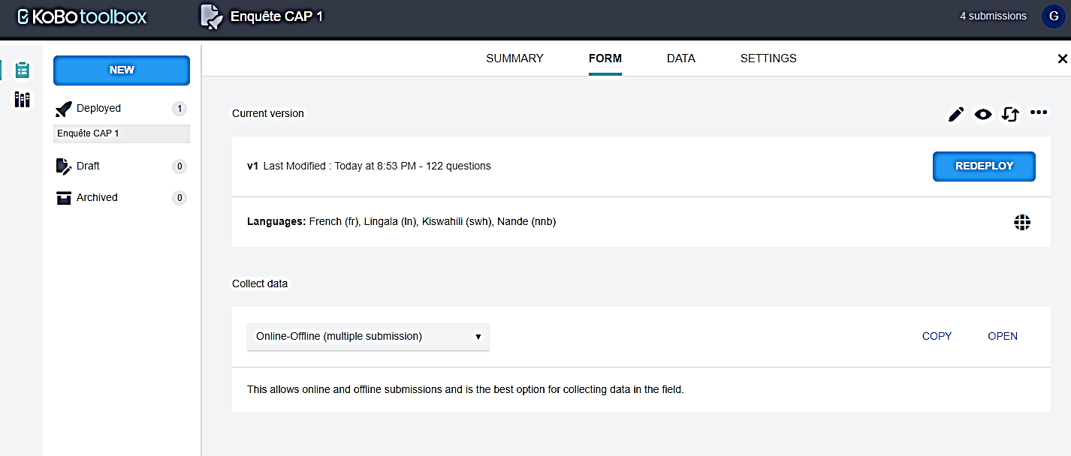
After the last question, you will have a choice between two buttons, “save” and “submit.” If you have access to the internet at that moment, you can “submit” the record and it should upload to the dataset within a few seconds. If your internet connection is slow or you do not have internet access at that moment, you may choose to “save” each record instead, and then submit the records later. We recommend trying this process with a few records until you have a system that works for you before you enter a large number of records.

11.2 Downloading your data from KoBo
Regardless of whether you collected the survey data on a tablet or using paper forms, the next step is to download the data to an Excel spreadsheet. Then you can view your data and check that everything worked properly and that there aren’t any errors.
You can view the completed dataset by logging in to your KoBo account, selecting your dataset (by selecting the name of the file), and then clicking on the “DATA” tab. To view survey responses in a spreadsheet-like format, select “Table.” Here you can view, edit, and/or delete individual survey responses and sort your data by individual columns using the descending or ascending options. If your data is entirely clean, it is possible to generate results table directly from this screen, however, we recommend simply downloading both a copy of your data collection form and your data in two separate Excel spreadsheets. Then you can manually review and clean your data.
Step 1: While in the dataset viewer in KoBo, select the “DATA” tab at the top, then the “Downloads” button on the left side. Then select the following options (see the image below):
- Export type: “XLS”
- Value and header format: “French (fr)” (This is the default).
- Click on “Advanced options,” then under “Export many questions as…”choose “Separate columns” This is what the screen should look like:
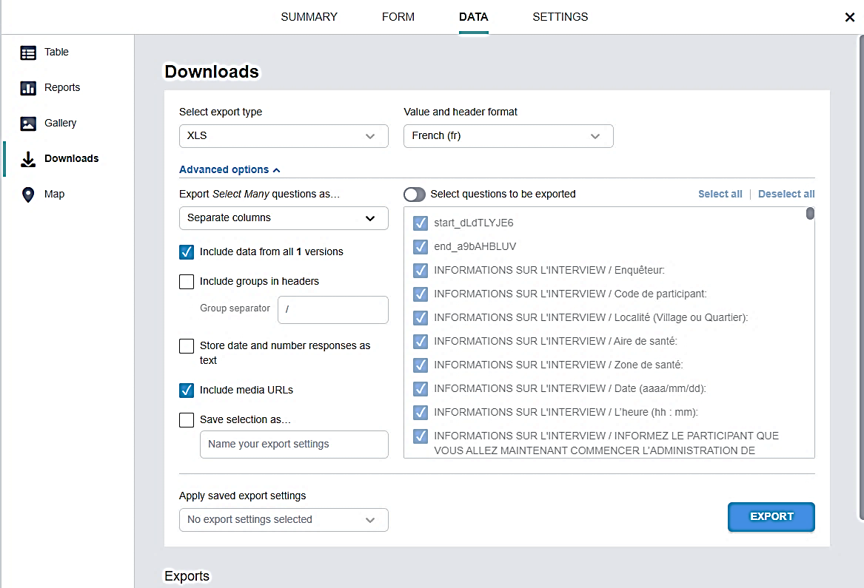

Then select “Export.” After you do this, a row will appear at the bottom of your screen (you may need to scroll down to see it.) At the far right of the row, select the “Download” button. Save this file as “survey data.”

11.3 Cleaning your data
The way that data is imported from KoBo is not suitable for analysis in a statistical analysis software, as it includes all free text sections of the survey as individual columns, and the variable names are too long. The following image is an example of what you will see:
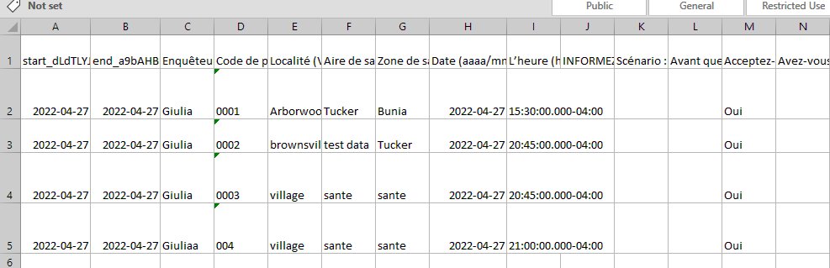
If you select the entire dataset, and then select “wrap text” this will allow you to see that row 1 contains the full text of every question. You will also see that certain columns are empty but contain a string of text in row one.
This is an example of how the spreadsheet will appear:
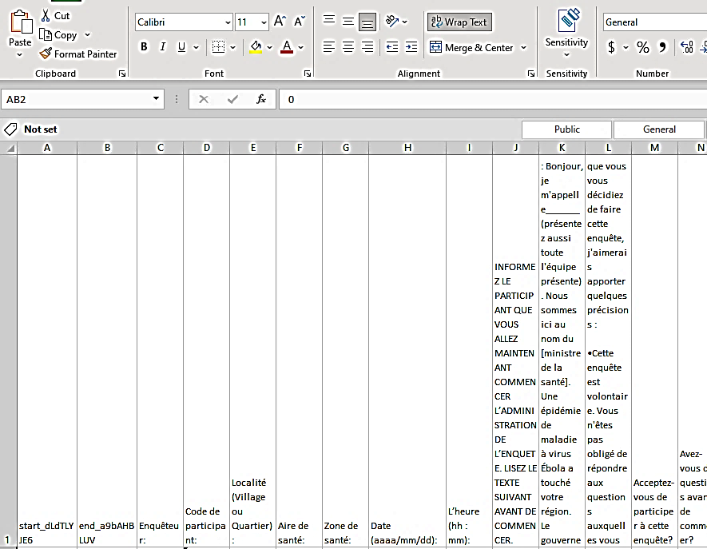
The first step in data cleaning will be to adjust the variable names directly in Excel and delete any unnecessary columns. The following sections will walk you through how to modify your dataset so that it can be analyzed using Epi Info.

Step 1. Copy and open dataset
Next, you will want to make a copy of the original dataset to modify, as you do not want to ever lose the original data. Open the dataset – each variable is represented as a column and the survey responses are represented in rows.

Step 2. Clean data of unnecessary columns
If you have included any descriptive text in your survey (e.g., explanatory text to read aloud to participant), these will upload as a separate column into your dataset. Go through your dataset and delete these columns. Below we have outlined which columns to clean out for Survey 1 and Survey 2. Note: the names of these columns will only correspond correctly if you are using the original survey provided without any changes.

Survey 1
Delete the following columns to clean your dataset:
- Columns J-L
- Column DR
- Column IQ
- Column LG
- Column LO-LP
- Column LU
- Columns MI-MR

Survey 2
Delete the following columns to clean your dataset:
- Columns J-L
- Column Q
- Column AT
- Column BI
- Column DC
- Column FH
- Column GW
- Column IA
- Column JD
- Columns JR-KC

Additional guidance – Cleaning a modified survey
If you have a modified version of the survey, these columns will not be the correct ones to delete. To identify the columns you want to delete, manually go through your dataset and identify columns that only contain the script read during the survey. You will also want to delete the variables _id, _uuid, _submission_time, _validation_status, _notes, _status, _submitted_by, _tags, and _index. These variables will be at the end of your dataset.
See example of the columns that correspond to a script read during the survey that you will want to delete below in columns J, K, and L:
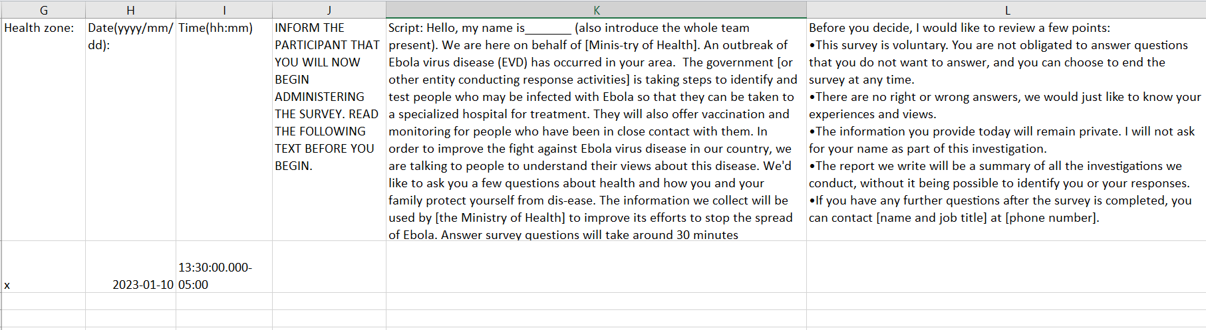

Step 3. Create codebook
Once you have cleared the dataset of all unnecessary columns, you will want to create a codebook, or file that documents what each variable in your dataset represents. Two codebooks have been provided for you – “Survey 1 codebook.xlsx” and “Survey 2 codebook.xlsx”. If you are using the original surveys with no modifications, you can use these are your codebook. If you have made any changes to the survey, you will need to either modify the codebooks provided or create your own using these as an example.
Your codebook will serve as a guide for understanding your dataset. It should include the following: Variable, Name of variable, Description of variable, and Code used to provide information on the variable. When naming variables, the names should be relatively short and intuitive. In addition, the name should not include any special characters (e.g., &, !, $, #, @, etc.), it should not have any spaces, and should not start with a number.
In the example provided, we have included the following columns:
- Variable: The name of the variable to refer to.
- Name: The name of the variable used in the dataset.
- Corresponding question: This is the corresponding question in the survey that the variable records the respondent’s answer.
- Further description: This is further detail on the variable to understand what this variable logged. For select all that apply questions, KoBo exports the data by having one variable list in text all options selected and an individual variable for every answer option. In the case of these questions, the answer option that the variable corresponds to has been logged here.
- Code: This represents what the survey response options that the participant has selected/entered.
See example below of what a codebook looks like:
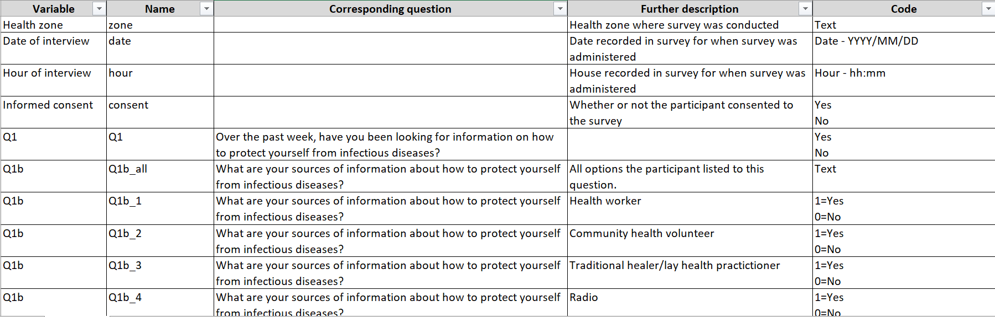

Additional information – Changing the codebooks we have provided
We highly recommend that you work off of the sample codebook we have provided to save time and ensure you are using the correct format. If you have adapted the survey, you will need to modify the codebook to reflect these changes. A few notes for making modifications to the survey:
- If you have added an additional question that allows the respondent to select only 1 option, you will only need to add 1 row (See above example for Q1).
- If you have added an additional question that allows respondents to select multiple options, you will need to add 1 row to log all responses and 1 row per individual response option (See above example for Q1b).
- If you ever include an option for “Other: please specify” where the interviewer can write in details, you will need to add an additional row that will log this free text entry, regardless of question type.

Step 4. Rename variables in dataset
Once you have deleted all descriptive text columns from your dataset and have a codebook with the new names the variables in the dataset should be assigned, you can proceed to renaming all variables in your dataset. You can do this in a statistical software or directly in Excel. For this example, we will do this directly in Excel.
If you have deleted all columns that are not included in your codebook and generated a codebook with all variable names in the same order that the survey was administered, you can use the following method to quickly change all variable names. You will want to highlight all variable names in your codebook in the column titled “Name” (Column B), right click and select “Copy”. From there, you will then open your dataset, click on the first variable name listed in Row 1, Column A. Go to the top left corner of the ribbon where the “Paste” icon is. Click the small arrow below this and select the icon with the two arrows to transpose the column to your row of variable names in your dataset (see circled icon below). Once this has selected, all variable names should be replaced with the new variables. It is very important to make sure to check that the variables have copied over properly and the variable names are corresponding to the correct columns.
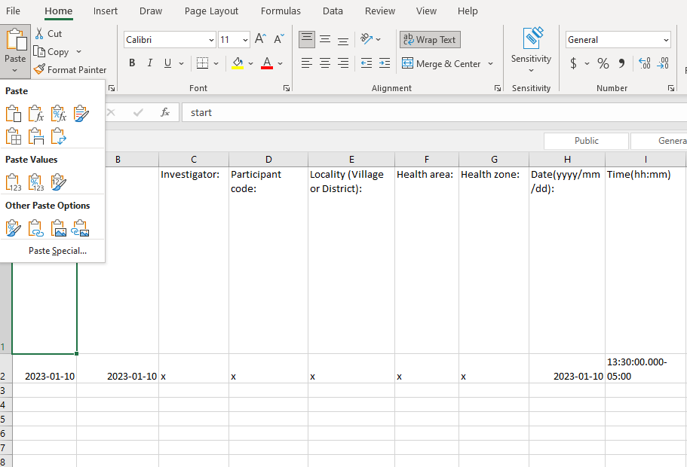

Step 5. Verify your data
At this point, your dataset should be readable, all unnecessary columns are cleaned, and you have a corresponding codebook. Below are some simple steps you can take to check for any problems in the data recording and downloading.

Paper questionnaires only: checking data entry accuracy
You will compare the data in a randomly selected group of paper questionnaires to the corresponding records in the Excel dataset to assure that data entry and transfer were successful. We recommend checking at least 5% of the surveys, so if you have 600 surveys, you would compare the paper surveys to the dataset entry for at least 30 surveys. If you see data entry errors, correct them, and increase the number of paper surveys that you are checking.

Ensuring the dataset is complete
To ensure that all of the records were transmitted successfully, compare the total number of records in the survey data file to the number of completed interviews reported by each data collection team. Each team should also provide the number of refusals they received, by sex (for example, X female and Y male refusals).

Ensuring there are no completely duplicated records in the dataset
To ensure that you do not have duplicated records, sort the dataset by participant ID number. You can quickly review the dataset to be sure that all of the ID numbers are unique. If there are records with the same ID number, check that the entire record is the same, or if there were two different records given the same ID number. If it is a large dataset, you can also use the “data,” “remove duplicates” command in Excel, however it is a good idea to make a back-up copy of the dataset before using this function in case you want to see which files were duplicates, since the program will delete them without showing them to you.

Ensuring that every record has an ID number
It will be important for your analysis that every record has an ID number (in the sample codebook, this is variable “pcode” or the Participant Code). This can be easily checked in the dataset by either sorting by ID (blank cells will appear as “0”), or by selecting the entire sheet (if you select the upper left-hand corner of the sheet, it selects the entire sheet), and then selecting “data” “filter.” This will create small selection boxes in each of the column names. When you select it, it shows the contents of the column. If you select the box on the “Participant” column, you will see if “blank” is listed in the contents. If so, you can filter the dataset to only show the records with blank Participant numbers. Then you can look at those records and investigate the problem.
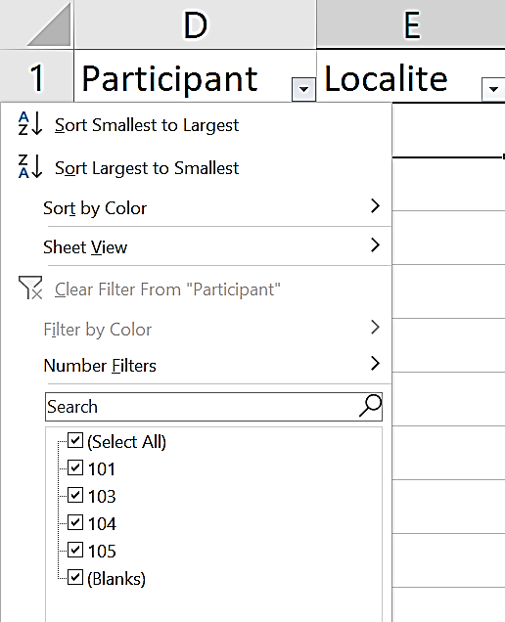
To see only the records with blank ID numbers, first click “(Select All)” which will uncheck all the response options. Then click “(Blanks),” you will now only see surveys that do not have a participant ID.

Being aware that data for some questions are in a single column, but data for other questions are in multiple columns
As previously mentioned, when creating the codebook, KoBo handles data different depending on the type of variable question. It is important to understand that data for question responses are structured in two different ways:
- For questions where the respondent can only choose one answer, there will only be one response column. A blank cell in that column means that there is missing data
- For questions where the respondent can choose more than one response, each possible response has its own column. Each column has a “1” if the respondent selected that response option, and a “0” if they did not. Here is an example (question 17) of what this looks like in the dataset:
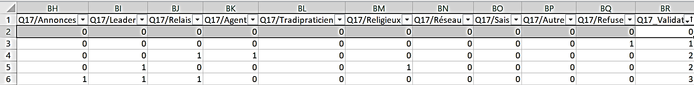
It is important to understand this difference both for verifying your data and for later on when you analyze the data.

Ensuring that there are no unexpected missing data
For most questions, there should not be any empty cells unless a previous question included a “skip pattern,” meaning that certain responses required the interviewer to skip the next question. Check to be sure there are not any missing data for questions that are not part of a skip pattern. You can use the same process described in section 11.3.4 to quickly review all the responses to each question, while looking at a copy of your questionnaire to identify which questions could be skipped. This will help you quickly identify whether there are any places in your dataset that have missing data but that should not have.
You can also use a formula to check for individual records with many missing data points. This could indicate that something went wrong with the data upload, or that the individual terminated the interview. To do this, go to the last column in the spreadsheet and enter the following formula in row 2: =COUNTIF (A2:AA2, "<>") where A2 is the first question in the survey and AA2 is the last question in the survey. Then copy this formula down to the entire survey, this will give you the number of responses with non-blank answers.
Another strategy that can be very helpful for questions in which the respondent could choose more than one response (“B” in the section 11.3.5. above). It is helpful to look at the example using question 17 again. Here, question 17 allows the respondent to select more than one response, therefore each possible response is its own column. In the column, the dataset shows a “1” if the respondent selected that response and a “0” if they did not.

Since we would expect the respondent to have selected at least one of the response options (even if that response was “don’t know” or “refuse,”) we can check for question non-response by looking at whether there is at least one “1” across all of the response options for a given question. To quickly determine whether this is true, you can insert a column following each set of columns for multiple response question as we have done in the example (column BR, “Q17_Validation), and then insert a formula that sums up all of the columns containing responses for the question (in the example, this includes column BH2 through BQ2). Once you have inserted this formula, copy it, and then paste it down all of the rows. Any row where the value in the cell = 0 has missing data.

Correcting, deleting or isolating errors and missing data cells
When you find missing or incorrect data, you have some options as to how to address them:
- If you used paper survey questionnaires, the first step should be to go back to questionnaire and determine if there was a data entry error. If so, correct the error in the database.
- If that is not the problem (or if you used the tablet to collect survey data), your team will need to decide whether to:
  - Delete the illegal response, and add it to the missing responses, leaving the dataset with some missing responses
  - Delete the entire record
  - Create a unique code not used anywhere in the survey (for example, 999), entering this everywhere there is missing data, so that you can separate and quantify these data

Recoding “other” responses
One thing that happens frequently when collecting survey data is that a response will get recorded as “other” when in reality the response could have been coded using one of the existing response options. This is simply an error of interpretation and in can happen if the data collector is not sure about whether the response fits in the existing category. In order to be cautious, the data collector selects “other” and then writes out the free text response. This is not a problem; actually it is good for the data collector to be cautious. However, because of this, you will need to review all of the free text responses for each question in which someone has chose “other” and then where the next column has something written in free text. For example, is this example table from question 2 in questionnaire #1, 4 men and 8 women selected “other” as one of their responses:
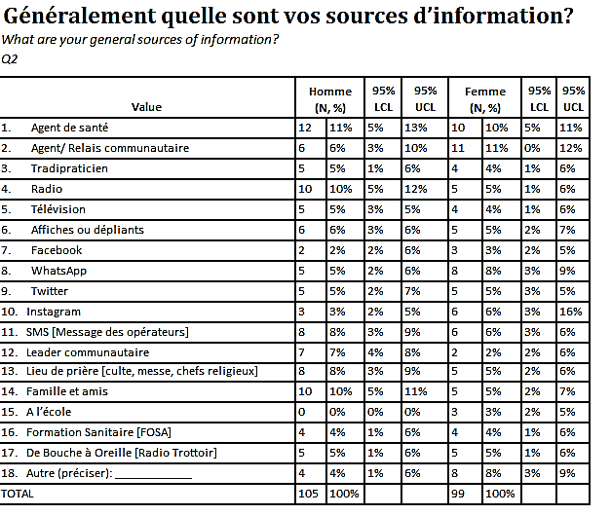
In this example, the following free text responses were found in the next column, “other, describe”:
- Mother
- Teacher
- Doctor
“mother” clearly belongs with “14. Family and friends” and “teacher” clearly belongs with “15. At school.” For these two responses, you should find those records in the dataset and change the responses to “14 family and friends” and “15. At school,” and remove the free text in “other, describe.” This can be somewhat time consuming, but it is very important because it will affect the frequencies shown in your results.
In the case of the response, “doctor,” you will need to make a decision with your team as to whether “doctor” fits under the category of “1. Health agent” or “health facility,” or if you want to create an additional category specifically for “doctor.” If you make a new category, keep in mind that some responses for “doctor” may have been categorized already as “health agent,” or “health facility.” This should be discussed with your data collectors. If you decide to make a new category for “doctor,” you can add it as “#19 doctor” to the question (on a paper copy of the survey and in your data dictionary that you make as part of your analysis), and remove the “other” entry and the “other, describe” free text. Doing this for all of your questions is an important part of “cleaning” your data.
Note: The above list does not contain every possible issue you may find while cleaning or verifying data. In addition, there are multiple ways to accomplish the same things within Excel so the verification steps provided are merely suggestions. If you have other preferred ways (including using a different analytic software such as R, SAS, EpiInfo or SPSS) to verify your data please feel free to use those.

12 Preparing the data for analysis
Once your dataset has been cleaned and a codebook has been created, you can import it into any statistical analysis software for data analysis. While KoBo has the capability to display survey results stratified by sex, we recommend using a data analysis application, such as R, SAS, Epi Info, SPSS or another program to produce frequency tables and 95% confidence intervals. If you do not have access to any type of data analysis software, frequencies can be tabulated manually within Excel, however, this is very time-consuming, and we do not recommend doing it this way.
In this guide, we provide a program for a sample dataset to analyze in Epi Info, as well as guidance on how to analyze your data using this software.

12.1 Extra steps for analysis if you are using Epi Info
The next sections outline specific tasks needed to prepare your dataset and to analyze your data appropriately in Epi Info (https://www.cdc.gov/epiinfo/support/downloads.html). This is a free program that you can download. If you are not using Epi Info and have a different preferred analytic software, you may briefly review this section but choose not to use this guidance.

12.1.1 Creating an age variable
Given that date variables can be hard to manipulate in statistical software programming, we recommend you create the variable for age in years prior to importing your dataset. First, ensure all entries for date of birth have two digits for the month, two digits for the day, and four digits for the year (i.e., MM/DD/YYYY). If an observation is missing the year, you will need to recode this as missing. If the observation is missing the month and day, you can use January 1 (01/01).
Once you have ensured all observations are valid and complete, convert all these entries to type “Date”. To do this, highlight all observations in that column, right click, and select “Format cells”. From there, you will select the Date option in the categories listed.
Now that the data is prepared, insert a column to the right of this variable and label it “AGE”. Then, paste the following Excel formula into the first observation:
=ROUNDDOWN (YEARFRAC(A2, TODAY(), 1), 0)
Once you have pasted this in, change the “A2” to the corresponding cell that has the date of birth for that observation and hit enter. The cell should now accurately reflect the age for that participant. To quickly do this in all cells, simply click and drag the bottom right corner down to the last observation.

12.1.2 Missing data
It is important to have all missing data coded correctly so that it is analyzed appropriately in your statistical software. For questions that are skipped due to skip patterns in the survey, the cells are left blank. However, if you have coded your missing data under a unique code (i.e., 999) and would like to quantify the percentage of data that is missing for each variable and are using Epi Info, be sure to modify these to be blank entries. Epi Info recognizes a blank entry as missing. Otherwise, this will be read in as a valid option.

12.1.3 Split dataset
If you use Epi Info, you will need to split the survey dataset for survey #1 and for survey #2 each into two parts. This is because Epi Info can only analyze a maximum of 255 variables, and the surveys contain more than 255 variables.
To read the dataset into Epi Info, the statistical software we will use to analyze the dataset, you will need to split the dataset into two. This is because Epi Info cannot handle datasets with more than 255 variables (or columns). Thus, you will want to split each dataset into two, making sure that both part have the first 11 variables (survey data collection information), participant sex, and weighting variables (if applicable). Before deleting any variables, make sure to make two copies of the entire dataset. When you are finished with this process, you will have three datasets of the same data: 1 that will be the complete dataset and 2 that will be the split versions of the same datasets.

12.1.3.1 Survey 1 - To use the Epi Info program provided with this guide, you will split Survey 1 into two datasets: the first dataset will include the first 11 variables (Columns A-K), Questions 1 through Question 22b (Columns L-FM), and Question 44 (Column LO). Delete all other variables. Save this dataset with “_1” at the end of the name as an .xls file. The second dataset will include the first 11 variables (Columns A-K) and Questions 22c through Question 50 (Columns FN-LZ). Delete all other variables. Save this datasets with “_2” at the end of the name as an .xls file.

12.1.3.2 Survey 2 - To use the Epi Info program provided with this guide, you will split Survey 2 into two datasets. The first dataset will include the first 11 variables (Columns A-K), Questions 1 through Question 29 (Columns L-EZ), and Question 53 (Column IV). Delete all other variables. Save this dataset with “_1” at the end of the name as an .xls file. The second dataset will include the first 11 variables (Columns A-K) and Questions 30 through Question 59 (Columns FA-JG). Delete all other variables. Save this datasets with “_2” at the end of the name as an .xls file.

12.1.3.3 If you have significantly modified the surveys – If you have significantly modified the survey and the above guidance does not apply to your dataset, follow this guidance on how to modify your dataset for analysis in Epi Info: First count the number of variables in your cleaned dataset. From there, you will need to divide your dataset into two datasets with less than 255 variables. Each dataset will need to include the survey start time, end time, interviewer name, participant code, locality, health area, health zone, date of survey, hour of survey, consent to survey, and any participant questions (the first 11 variables in your dataset). Then, split your dataset into two and make sure that the sex variable is in both datasets.

12.1.4 – Adding variables to both datasets for stratifying
If you are interested in stratifying your data by other variables (for example, age or city), you will need to make sure these variables are in both datasets, as you did with the sex variable. This will require more variables in your dataset, so double-check here that each dataset is still only 255 variables. If the first dataset is larger than that when you add more variables, split the dataset differently (for example, only include questions 1-19 in your first dataset instead of questions 1-22b).

13 Data analysis and reporting

13.1 Install and open Epi Info
To install Epi Info, following the guidance in this link: Windows | Epi Info™ | CDC
Once you have installed Epi Info onto your computer, you will want to open the classic view for analyzing data (see below).
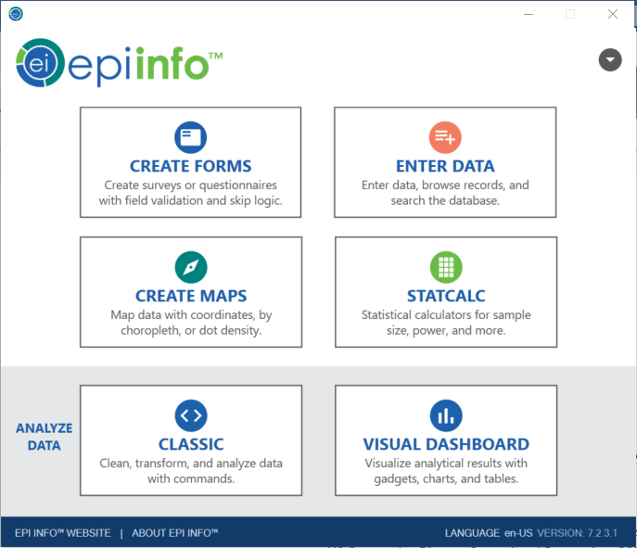

13.1 Run the programs provided with this guide
We have provided Epi Info programs that will produce the frequencies and percentages for a dataset that has been cleaned and prepared as we outlined in Sections 11 and 12.1. For survey 1, there are two programs named “Survey 1 Code_Q1-Q22.pgm7” and “Survey 1 Code_Q22b-Q50.pgm7”. For survey 2, there are two programs named “Survey 2 Code_Q1-Q29.pgm7” and “Survey 2 Code_Q30-Q59.pgm7”. Please follow the guidance below on how to open and run these programs.

13.1.1 Open the program in Epi Info
To open the program in Epi Info, you will need to be in “Classic Analysis” mode. Then, in the Program Editor you will click “Open Pgm” (see screenshot below).
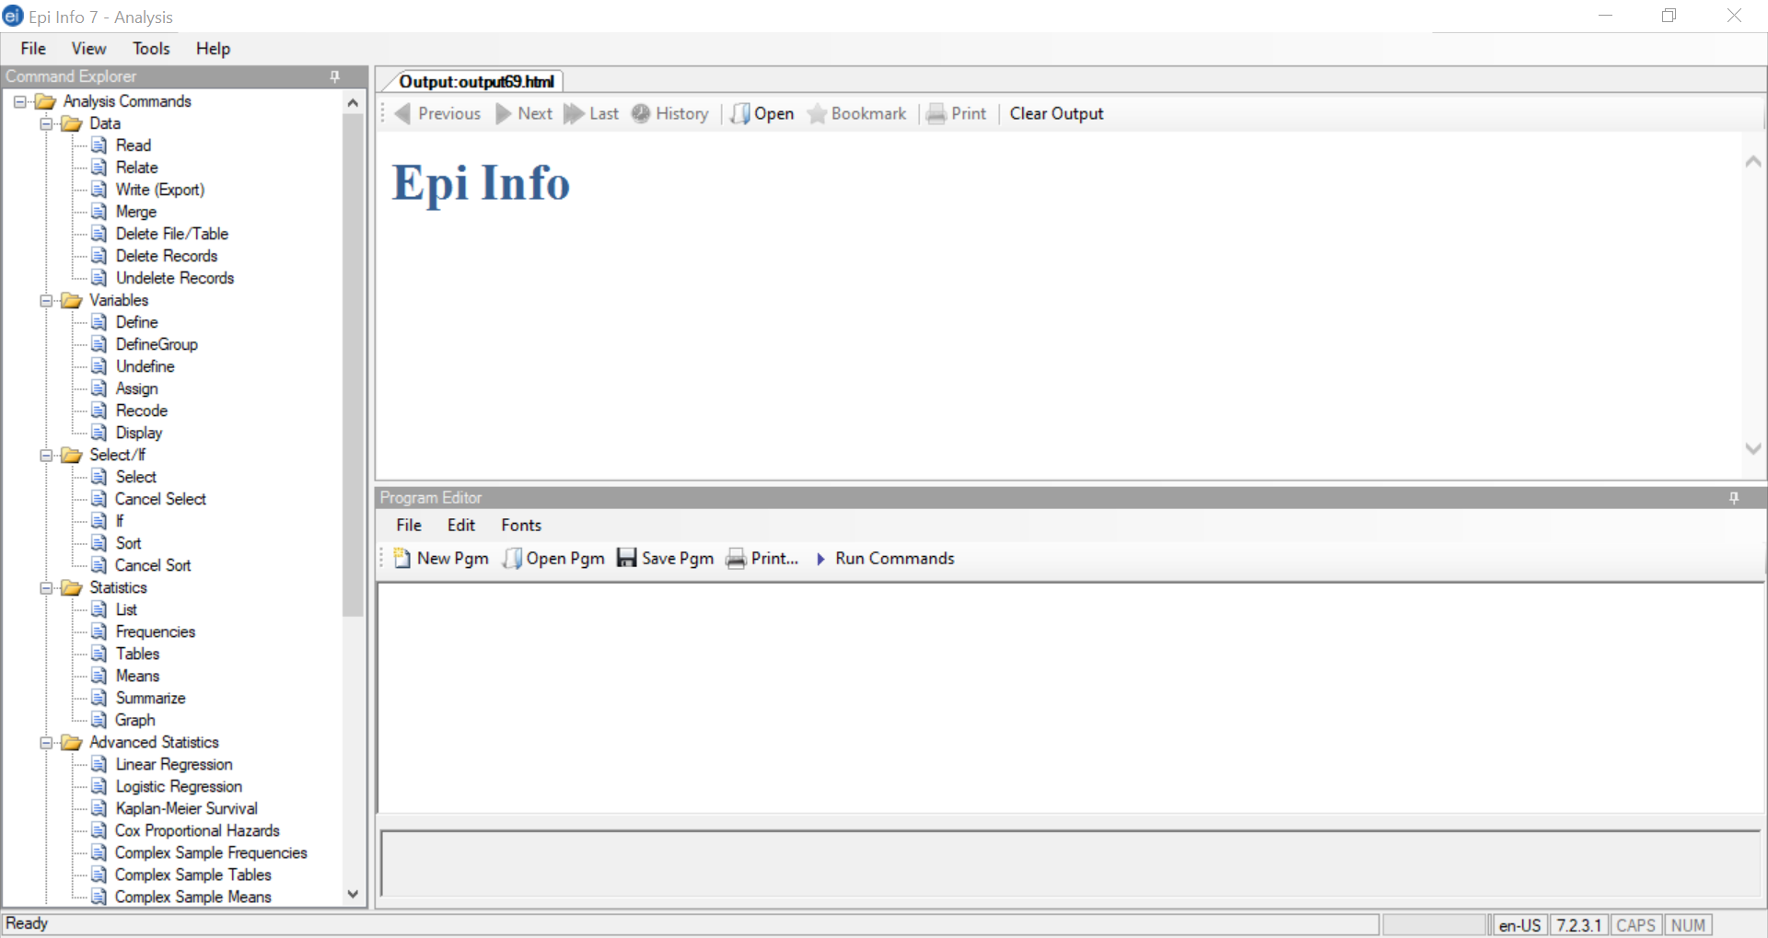
Then, a window will open where you will be prompted to select the program file. Click “Text File” in the bottom left corner, which will open the file finder. See screenshot below:
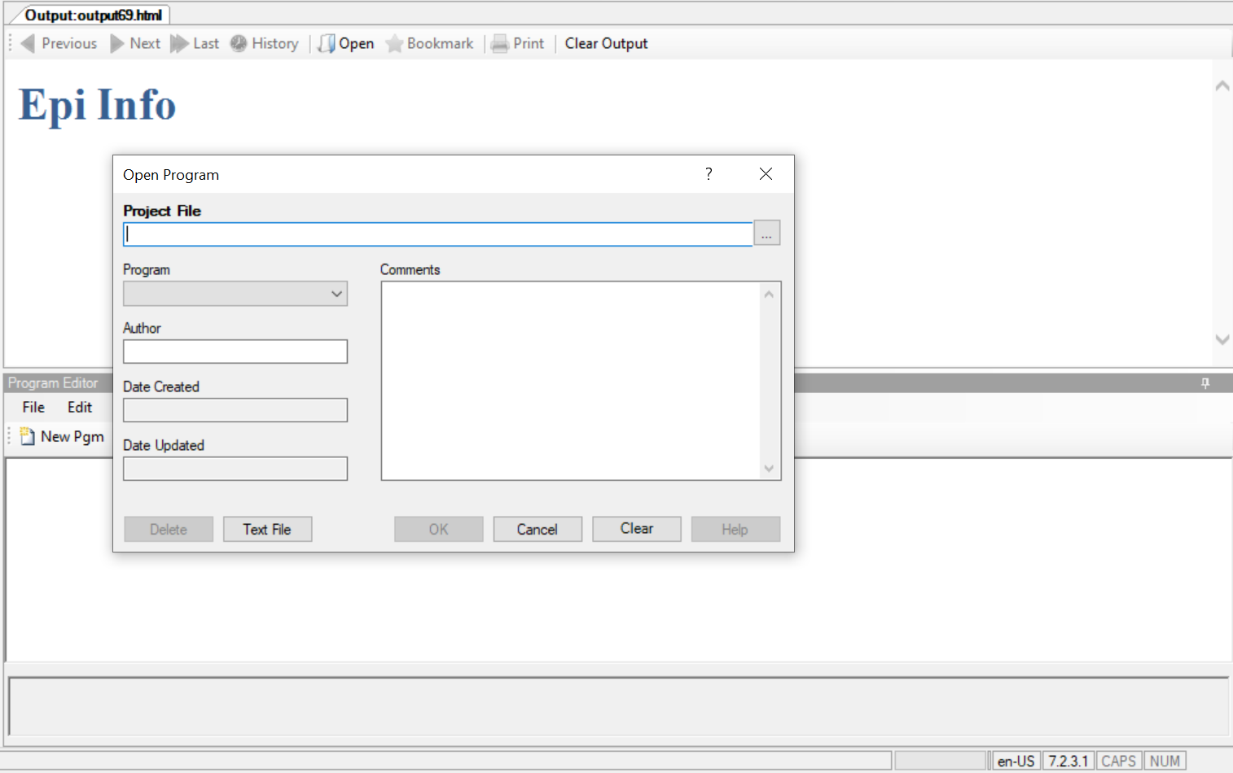
From there, you can select the program wherever you have it saved. Once you’ve selected this, you can click OK and it will open the program code, and the script should be in the bottom “Program Editor” box.

13.1.2 Change the file path
The first line of the program script will read the dataset in. You will need to adjust this so that Epi Info reads the correct file path for where your dataset is saved in your computer. For example, the first line of code in Survey Code 1_Q1-Q22.pgm7 reads as follows:
READ {C:\Users\toj0\Desktop\Data\testset1_s1_1.xls}:[Enquête CAP 1 - English incl###$]
You will need to modify the file path (highlighted in red) to route to where your dataset for Survey 1 Questions 1 through 22 is saved. If you have changed the name of the Excel sheet in your dataset, you will need to change the text highlighted in purple to the new sheet name.

How to find and replace the file path
The file path is where you dataset is saved. To get the written file path for your dataset, open the dataset in Excel. Make sure this is the dataset that corresponds to the correct .pgm7 file. Once you have opened your dataset, go to the top left corner of the screen and click “File” (see below).
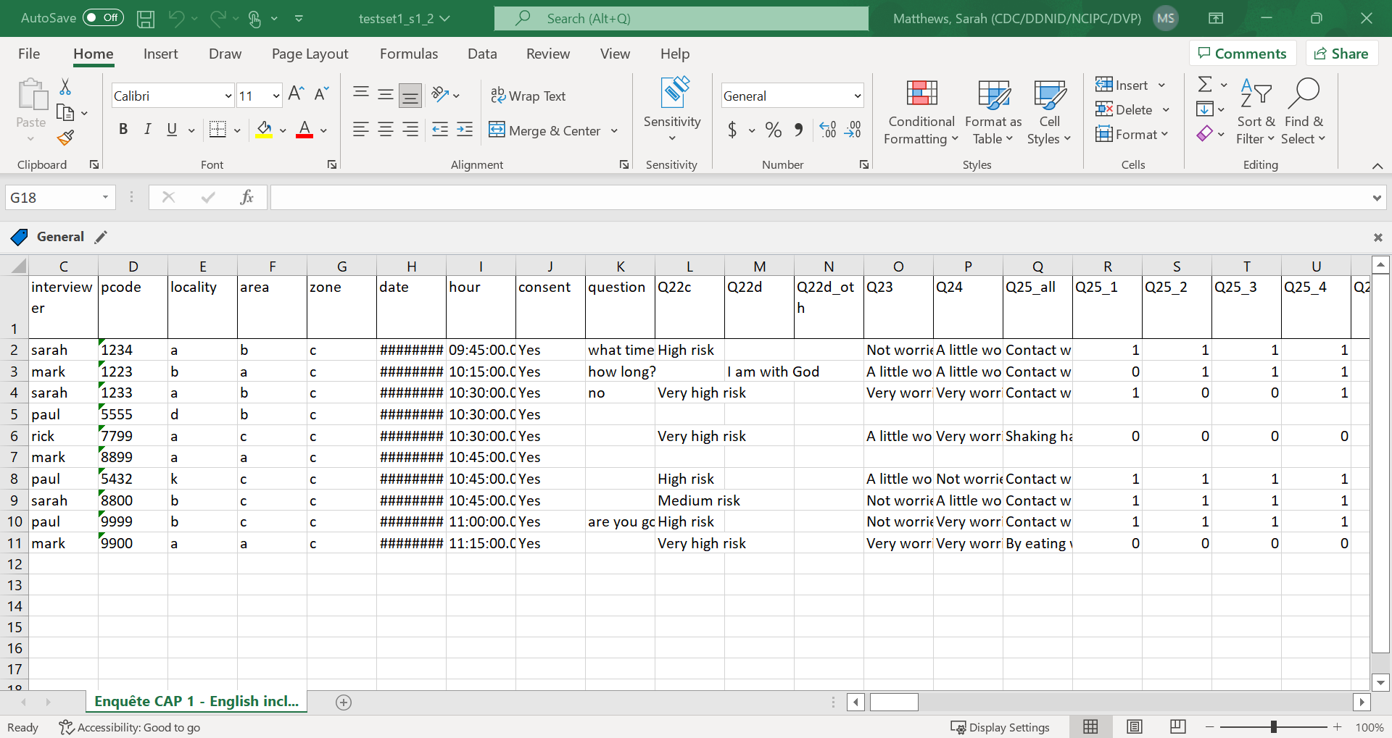
You will see the screen below. Click on “Info” (see below).
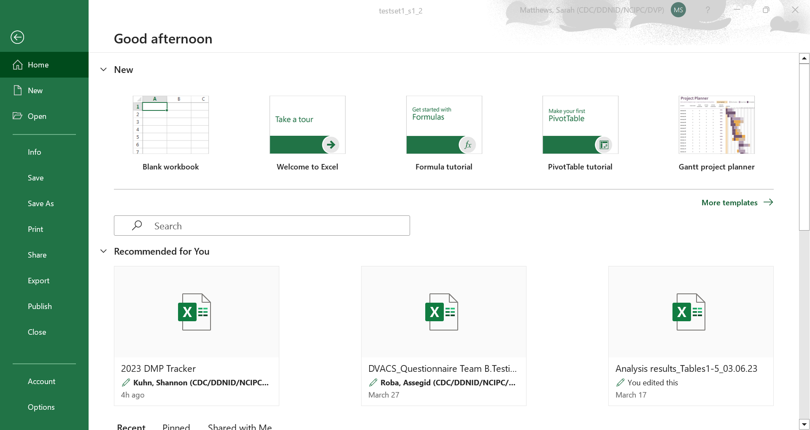
You will then see the following screen. Click the button “Copy path” (see below).
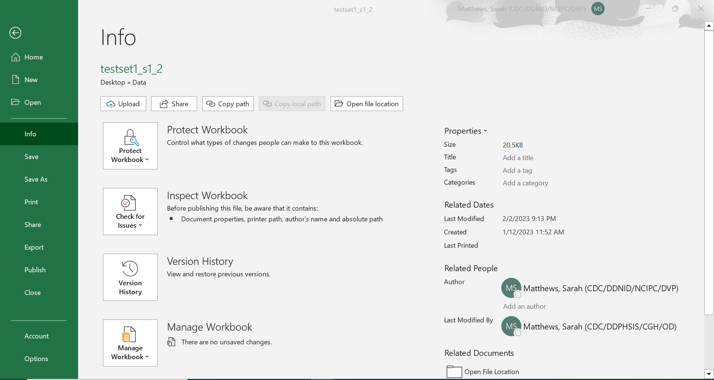
Once you have copied the file path, return to your .pgm7 file. The first line in this file will be the read statement. You will erase the file path that is in the first set of brackets (highlighted in red) and paste the new file path into your .pgm7 file. EpiInfo will include quotation marks around this – make sure to delete the quotation marks around the file path before running the commands.
READ {C:\Users\toj0\Desktop\Data\testset1_s1_1.xls}:[Enquête CAP 1 - English incl###$]

How to find and replace the sheet name
The sheet name is the next set of information you will need to read in your dataset. To find your sheet name, open your dataset and look at the name of the sheet (see below).
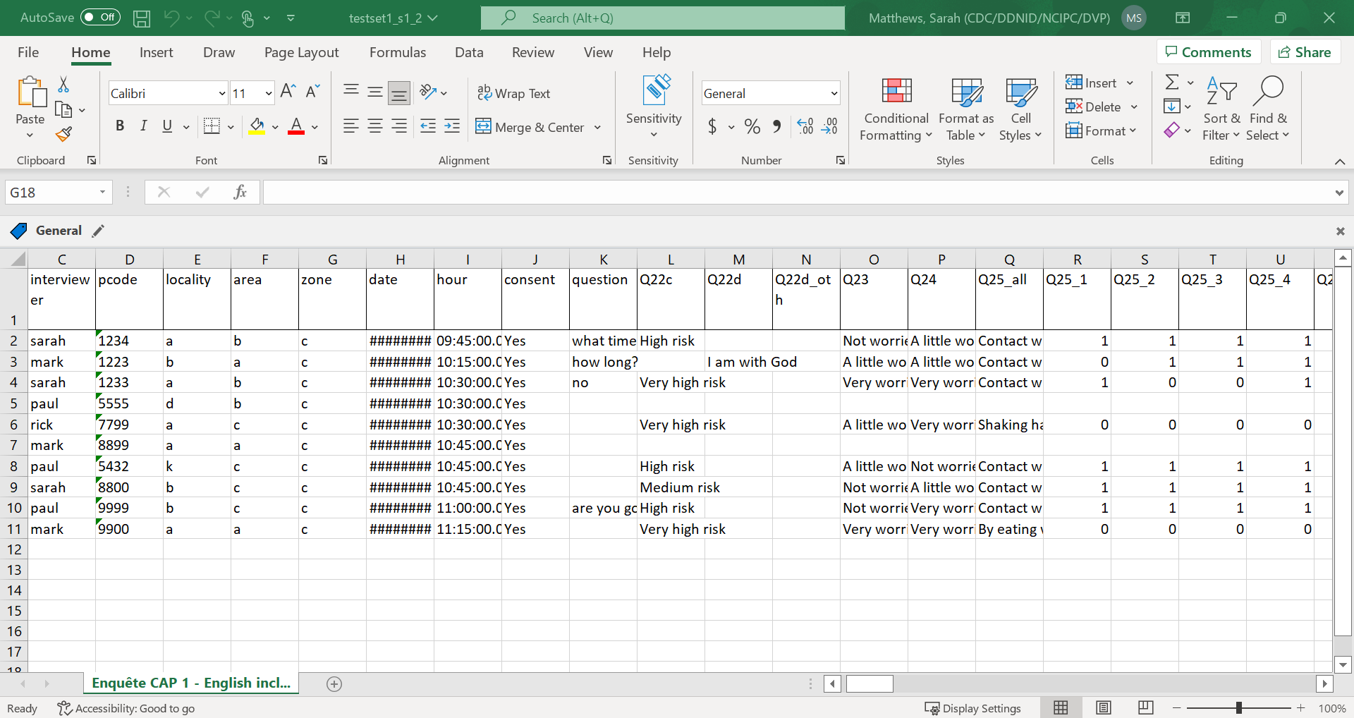
Type this name exactly as written into the second set of brackets in your read statement (see text in purple below).
READ {C:\Users\toj0\Desktop\Data\testset1_s1_1.xls}:[Enquête CAP 1 - English incl###$]
Once you have finished modifying your read statement, make sure to close your dataset before running the commands.

13.1.3. Running the program
To run the entire program, you will click the “Run Commands” button in the program editor. This will run a frequency of every survey question in your dataset in numerical order, excluding the first 11 variables (these are only survey description variables, not survey answers).

13.2 Entering results into the template spreadsheets
Once you have analyzed your data and you have all the frequencies, you can use the survey results templates to organize your results by topic and then to create charts for each question.
For each questionnaire, the toolbox contains two results template spreadsheets: CDC Ebola survey #1 results template and CDC Ebola survey #2 results template. Both template files are organized in the same way, with the first worksheet, “survey questions” listing all the questions on the questionnaire and showing which topical worksheet corresponds to each question. For example, Questions 1 through 4 appear on the worksheet, “Sources of health info” (“Sources d’informations santé”). Below we have outlined how to interpret the data analyzed in Epi Info for the two types of questions you have analyzed.

Select one option questions
For questions where the participant is only allowed to select one option, Epi Info will output two tables: one for females and one for males. It will provide the frequencies for each question option in the table and the percentage of female or male participants who selected that option. Below the table Epi Info outlines the 95% confidence intervals for the frequencies and percentages in the table. See the example for Question 1 output below:
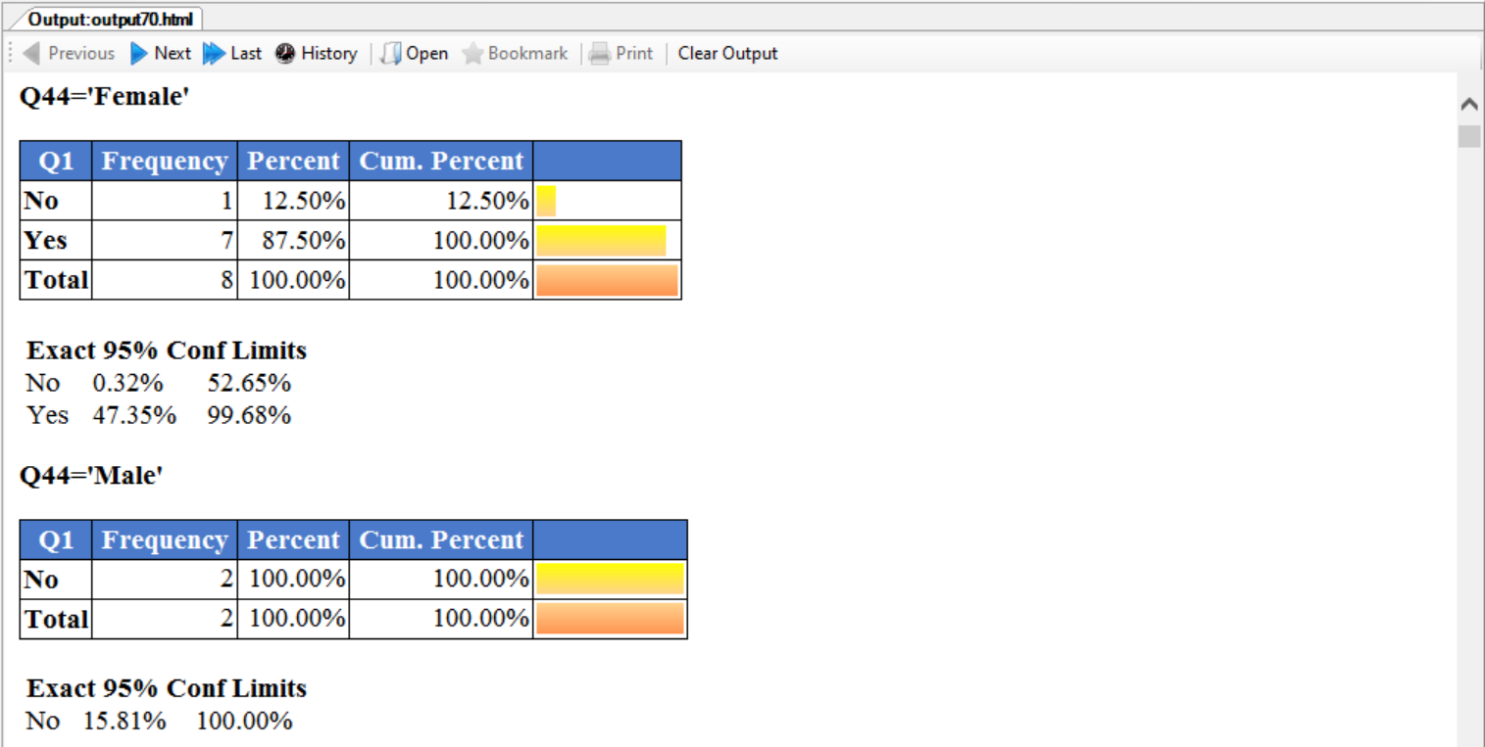
For this example, you would enter this data into the table at the very left of the sheet below Q1 where the data is highlighted in red. This table shows how you would input the information shown above in Epi Info.
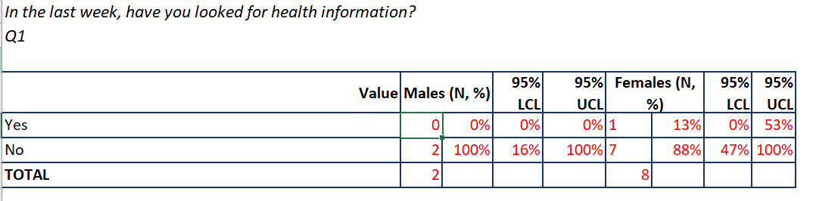
For this table, you would interpret that all male participants (2) selected “No” for this question. For females, 1 selected “Yes” (13%) and 7 selected “No” (88%).

Choose all that apply questions
For choose all that apply questions, each option in that question is displayed as an individual question. Each frequency will be the percentage of respondents who selected that option among all respondents who answered this question. To fill out the survey results template for Q2 “What are your general sources of information?”, you will need to view the results of every response option (Q2_1 through Q2_20). Using the provided script, Epi Info will display the results for Q2_1 through Q2_20 for Females first, then the results for Males after. Below is example output for Females:
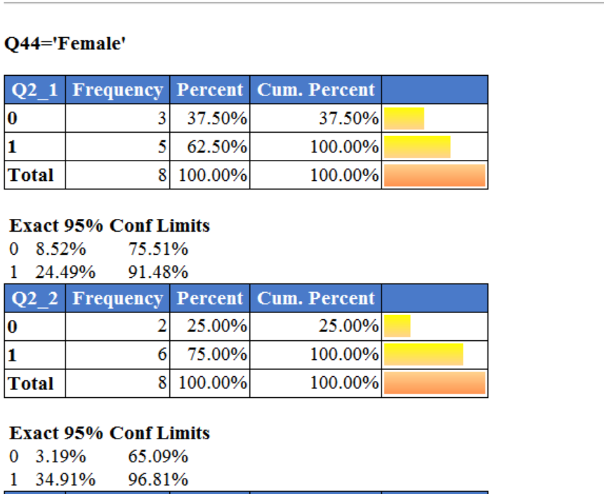
We have highlighted in red the data that would be entered into the provided table. This data would be entered as such into the table provided in the spreadsheet template:
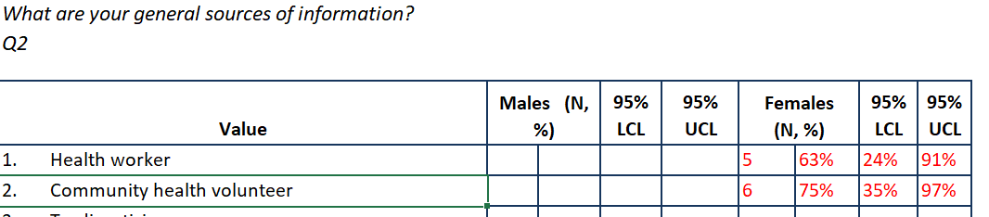
Since respondents can answer more than one question, you should not have a cumulative percentage for this question in your TOTAL line as this would add up to over 100%.

Other information in the template spreadsheets
In addition to the table shown above that you will populate with your own numbers, there is a second table that will automatically update when you add numbers to the first table. This table looks like this:
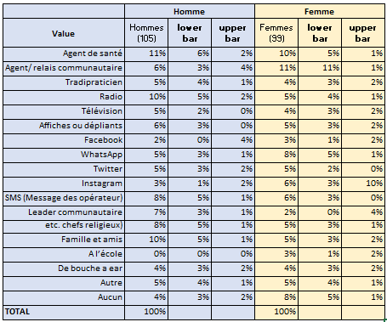
You cannot enter data into this table. It is linked to the first table, and it will automatically update when you enter data in first table. (If they do not update automatically, go to the top ribbon o of the worksheet, select “data” and then “refresh all” to make sure that the numbers update.) This table has been created to format your frequency data in way that Excel can read it to make charts. Once you complete this chart, the chart to the right of the table should update also and look like this:
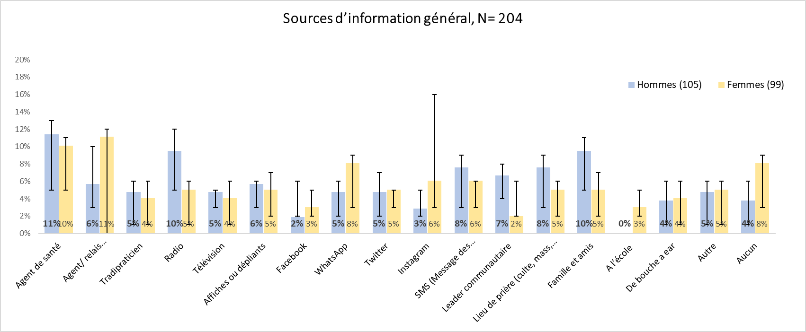
You can then use these charts to view your results and make your interpretations. We strongly recommend that after you create each chart, you use the space to the right of the chart to write a sentence or two about what the chart shows, and how this contributes to answering your original analytic questions. It will be helpful to also note whether you consider this information to be high, medium or low priority. This will help you when you put together your presentation or report, because you will want to present the high priority results in each section of your presentation first, and consider not showing charts for the lowest priority information at all. Presenting too much information at one time can actually reduce the effectiveness of your presentation.

13.3 Additional information – Running your dataset manually
If the program we have provided for your use needs to be modified or you would like to run your own analyses, we have provided guidance on how to use certain Epi Info functions for analysis.

13.3.1 How to import data into Epi Info
To read your dataset into EpiInfo, go to the Command Explorer on the left-hand side of the screen and click “Read” under the “Data” folder. First, select your dataset type. If you have used Microsoft Excel to create your dataset, click the option “(.xls). From there, you will select “Browse”, and it will open another window. Make sure that this window has the box checked for “First row contains header information”. Then, select “Browse” on this window and it will open your computer’s file storage. Navigate to where you have saved your datasets. To start, click on your first dataset (labelled _1). It will bring you back to your original Read window, where you will select the dataset (it will be the name of the Excel sheet that the data is saved in in your Excel file) in the Data Source Explorer. Once you have selected your dataset, click OK.
A note from here onward: The process of analyzing your datasets will be the same. The only difference is if you want to produce frequencies for any questions in the second half of your dataset, you will need to repeat the above process and select your second dataset (labelled _2).

13.3.2 Calculating frequencies in Epi Info
Once you have read in your dataset you can begin analysis. Find the statistics folder (in the left hand command explorer box), and under that locate “frequencies.” A box will appear, with the symbol “*” prefilled in the “Frequency of” box. The symbol “*”, tells Epi Info to produce a frequency statistic for every variable in your dataset. Click “OK”. (Note: to look at just one variable, click the arrow and select the variable from the list.) Your output for variables will look like this:
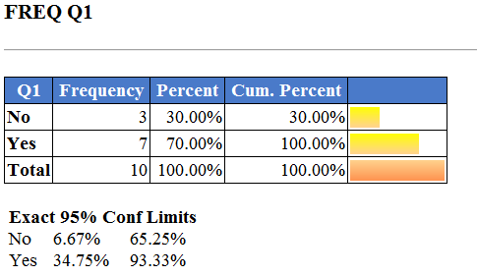
Note that this output is for the entire sample. If you would like to stratify the results, in the Frequencies window you will click the drop-down menu of “Stratify by” and select the variable you would like to stratify by (e.g., gender – Q44 in our example dataset). Your output will then be presented by gender (see example below):
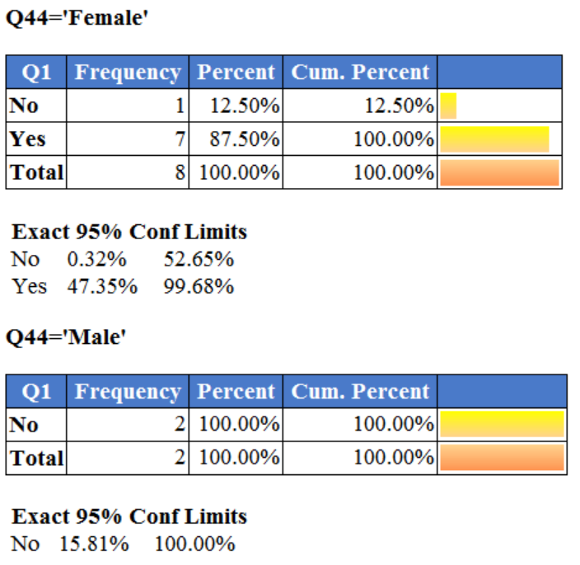

Additional information - Show percentage missing for each variable
If you are interested in including missing data in your frequencies, you will need to modify Epi Info’s programming to show missing data. To do so, click “Set” under the Options folder in the Command Explorer. Click the box “Include Missing Values” and click OK. Now, when you produce a frequency there will be a row for missing data. It is important to note how much data is missing in your dataset. However, when we calculate percentages, it is common practice not to include missing data in those percentages. Thus, before entering your data into the results template, be sure to repeat this step and uncheck the “Include Missing Values” box.

13.3.3 Grouping variables for analysis
In the survey results template, we have grouped the numeric variable Age into different categories. The following guidance will walk you through how to recode a numeric variable into separate categories in Epi Info using the example of the variable Age.
First, you need to define a new variable in Epi Info that will represent the age variable categorized. To do this, click “Define” under the Variables folder in the Command Explorer. Enter the variable name (following the guidance above) and select the variable type (“Text” is recommended for a categorized variable), then select OK. For example, we define the variable AGECAT as a Text variable. Once you define your new variable, you will select “Recode” under the Variables folder. Select the numeric variable you’d like to group in the “From” drop-down list and select the new variable in the “To” drop-down list. Enter the range of values you would like to create in your age groups in “Value” and “To Value”. Then, name this group in the “Recoded Value” column. See example below:
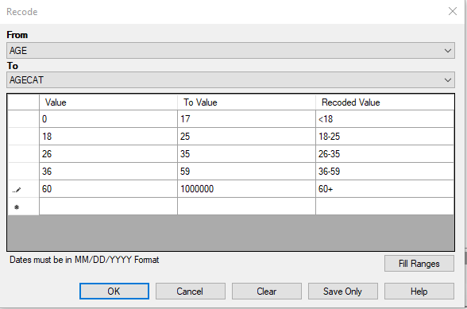
Once you have this set up, click OK and you are now able to run a frequency on this new variable.

13.3.4 Saving a new program code
If you have made modifications to one of these program codes or have created your own, to save this first click “Save Pgm” in the Program Editor. You will want to save this code as a text file, so click Text File in the bottom left corner. Once you have done this, it will open the file finder and you can enter the name you would like to save this program code under and click Save.

13.3.5 Entering your data into the template spreadsheet
If you have run your own program, follow the guidance in Section 12.3.4 on how to enter the data into the spreadsheets provided for results.

14 Documentation and storage
As you go through the process of developing your questionnaire, and planning and implementing your survey, keep copies of all the documents you use throughout the process. This will help you describe your work later. Archiving also could be very useful for future social science work. For each KAP survey, be sure to save the following documents in the appropriate electronic folder:
- The questionnaire (MS Word or KoBo file)
- Raw database (Excel)
- Cleaned database (Excel)
- Analysis results (Excel)
- General report and PowerPoint presentation

15 Authors and acknowledgements
The primary authors of the guide and associated materials are: Giulia Earle-Richardson, Ciara Nestor, Henriette Bulambo, and Christine Prue. The following individuals made significant contributions to the development and evaluation of the survey questionnaires, the guide or the Excel templates: Djeneba Coulibaly-Traore, Arlette Lembou, Prince Kimpanga, Grace Kesereka, Joel Kahehero, Jennifer Hemingway-Foday, Anne-Lyne Verella, Daiva Yee, Vishakha Ramakrishnan, Brooke Aksnes, Amber Robinson, Kate Meehan and Norbert Gnakub Soke. We also acknowledge the Harvard Humanitarian Initiative, Phuong Pham and Patrick Vinck, for early testing of questions for questionnaire #2.

16 Appendices

Appendix A. KAP toolkit

Appendix A.1. Survey #1 Questionnaire (English)
EBOLA KAP SURVEY 1: GENERAL POPULATION (DRC-SPECIFIC VERSION)
Interview Information
(Register investigator and participant code)  Investigator: ______________  Participant Code: _____________ | (Register locality, health zone, date of interview)  Locality (Village or District): _________  Health Area: ____  Health Zone: __________  Date (dd/mm/aaaa) : ___ ___ /___ ___ /___ ___ ___ ___  Time (hh: mm): ___ ___ : ___ ___

(Inform the participant that you will now begin administering the survey. Read the following text before you begin.)
Script: Hello, my name is_______ (also introduce the whole team present). We are here on behalf of [Ministry of Health]. An outbreak of Ebola has occurred in your area. The government [or other entity conducting response activities] is taking steps to identify and test people who may be infected with Ebola so that they can be taken to a specialized hospital for treatment. They will also offer vaccination and monitoring for people who have been in close contact with them. In order to improve the fight against Ebola virus disease (EVD) in our country, we are talking to people to understand their views about this disease. We'd like to ask you a few questions about health and how you and your family protect yourself from disease. The information we collect will be used by [the Ministry of Health] to improve its efforts to stop the spread of Ebola. Answer survey questions will take around 30 minutes.

Before you decide, I would like to review a few points:
- This survey is voluntary. You are not obligated to answer questions that you do not want to answer, and you can choose to end the survey at any time.
- There are no right or wrong answers, we would just like to know your experiences and views.
- The information you provide today will remain private. I will not ask for your name as part of this investigation.
- The report we write will be a summary of all the investigations we conduct, without it being possible to identify you or your responses.
- If you have any further questions after the survey is completed, you can contact [name and job title] at [phone number].

Do you agree to participate in this survey? Yes or no
(Note the verbal consent to participate here; if you refuse to participate, thank them for their time and end the survey).)

Do you have any questions before you start? (Save questions here)

Text of the question | Response options
Sources of health information
- Over the past week, have you been looking for information on how to protect yourself from infectious diseases? | (Unless noted otherwise, for all questions, read all answer choices to the respondent, and check the one answer that they provide.)  - Yes  - No go to Q.2  - Refuse (Do not read)
1.b. What are your sources of information about how to protect yourself from infectious diseases? | (Do not read answer choices. Check all the answers provided by the participant.)  - Health worker  - Community health volunteer  - Traditional healer / lay health practitioner  - Radio  - Television  - Online or print news  - Posters or leaflets  - Facebook  - WhatsApp  - Twitter  - Instagram  - SMS [Message from operators]  - Community Leader  - Place of prayer [worship, mass, religious leaders]  - Family and friends  - At school  - Health facility  - Word of Mouth [Sidewalk Radio]  - Other (specify): _____________  - None  - Refuse
- What are your sources of general information, for things like events, news and topics than interest you? | (Do not read answer choices. Check all the answers provided by the participant.)  - Health worker  - Community health volunteer  - Traditional healer / lay health practitioner  - Radio  - Television  - Online or print news  - Posters or leaflets  - Facebook  - WhatsApp  - Twitter  - Instagram  - Websites  - SMS [Message from operators]  - Community Leader  - Place of prayer [worship, mass, religious leaders]  - Family and friends  - At school  - Health Facility  - Word of Mouth [Sidewalk Radio]  - Other (specify): _____________  - None  - Refuse
2b. What are your sources of health information? | (Do not read answer choices. Check all the answers provided by the participant.)  - Health worker  - Community health volunteer  - Traditional healer / lay health practitioner  - Radio  - Television  - Posters or leaflets  - Facebook  - WhatsApp  - Twitter  - Instagram  - SMS [Message from operators]  - Community Leader  - Place of prayer [worship, mass, religious leaders]  - Family and friends  - At school  - Health facility  - Word of Mouth [Sidewalk Radio]  - Other (specify): _____________  - None  - Refuse
- The last time you searched for health information, was this for ... | (Read all answer choices. Check all the answers listed.)  - Yourself (respondent)  - Another person you care for (for example, a spouse, child, parent, relative or friend)  - Other (specify): _____________  - Refuse (Do not read)
TRUST in health information
- In general, how much do you trust health workers for health information? | - A lot  - Moderately  - A little  - Not at all  - I have no opinion  - I don't know  - Refuse (Do not read)
- In general, how much do you trust community health volunteers for health information? | - A lot  - Moderately  - A little  - Not at all  - I have no opinion  - I don't know  - Refuse (Do not read)
- In general, how much do you trust traditional healers / lay health practitioners for health information? | - A lot  - Moderately  - A little  - Not at all  - I have no opinion  - I don't know  - Refuse (Do not read)
- In general, how much do you trust radio for health information? | - A lot  - Moderately  - A little  - Not at all  - I have no opinion  - I don't know  - Refuse (Do not read)
- In general, how much do you trust television for health information? | - A lot  - Moderately  - A little  - Not at all  - I have no opinion  - I don't know  - Refuse (Do not read)
- In general, how much do you trust posters or leaflets for health information? | - A lot  - Moderately  - A little  - Not at all  - I have no opinion  - I don't know  - Refuse (Do not read)
- In general, how much do you trust social media (e.g., Facebook, WhatsApp, Twitter, Instagram) for health information? | - A lot  - Moderately  - A little  - Not at all  - I have no opinion  - I don't know  - Refuse (Do not read)
- In general, how much do you trust community leaders (e.g., local chiefs) for health information? | - A lot  - Moderately  - A little  - Not at all  - I have no opinion  - I don't know  - Refuse (Do not read)
- In general, how much do you trust religious leaders for health information? | - A lot  - Moderately  - A little  - Not at all  - I have no opinion  - I don't know  - Refuse (Do not read)
- In general, how much do you trust family members for health information? | - A lot  - Moderately  - A little  - Not at all  - I have no opinion  - I don't know  - Refuse (Do not read)
13b. In general, how much do you trust friends for health information? | - A lot  - Moderately  - A little  - Not at all  - I have no opinion  - I don't know  - Refuse (Do not read)
13c. In general, how much do you trust school for health information? | - A lot  - Moderately  - A little  - Not at all  - I have no opinion  - I don't know  - Refuse (Do not read)
13d. how much do you trust “sidewalk radio” (word of mouth) for health information? | - A lot  - Moderately  - A little  - Not at all  - I have no opinion  - I don't know  - Refuse (Do not read)
13e. In general, how much do you trust health facilities (clinics, health centers, hospitals) for health information? | - A lot  - Moderately  - A little  - Not at all  - I have no opinion  - I don't know  - Refuse (Do not read)
13f. In general, how much do you trust SMS (message from mobile phone networks) for health information? | - A lot  - Moderately  - A little  - Not at all  - I have no opinion  - I don't know  - Refuse (Do not read))
Main health concerns in the community
- What do you think are the most common diseases in your community? | Read all answer choices. Check all the answers listed.  - Ebola virus disease  - COVID-19  - Malaria  - Tuberculosis  - VIH  - STD  - Cholera  - Measles  - Typhoid  - Influenza  - Acute respiratory tract infection  - Diarrhea  - Other (specify): _____________  - Refuse (Do not read)
Knowledge and concerns about Ebola Virus Disease (EVD)
- Have you ever heard of Ebola Virus Disease (EVD)? | - Yes  - No à read the script below to the respondent, then proceed to Q.43  Script: The signs and symptoms of Ebola Virus Disease (EVD) are similar to those of other diseases, and usually include fever, headache or body aches, vomiting, and diarrhea. After several days, symptoms may include bleeding gums or other hemorrhaging. People most at risk of EVD are those who have been close to other people who are sick or have died from EVD or an unknown cause. [Also include any relevant updates regarding the EVD outbreak in the community.] proceed to Q.43  - Refuse (Do not read)
- What have you heard about EVD? | - (Free text) :____________________________________________  - I don't know  - Refuse (Do not read)
- From whom did you last hear about EVD? | Read all answer choices. Check all the answers listed.  - Public announcements (megaphone or crier)  - Community leader  - Community health volunteer  - Health worker  - Traditional healer / lay health practitioner  - Religious leader: church / mosque / other  - Personal network: relatives / friends  - I don't know  - Other (specify): _____________  - Refuse (Do not read)
- From what source did you last see, hear or read something about EVD ? | Read all answer choices. Check all the answers listed.  - Health worker  - Community health volunteer  - Traditional healer / lay health practitioner  - Radio  - Television  - Online or print news  - Posters or leaflets  - Facebook  - WhatsApp  - Twitter  - Instagram  - Websites  - SMS [Message from operators]  - Community Leader  - Place of prayer [worship, mass, religious leaders]  - Family and friends  - At school  - Health Facility  - Word of Mouth [Sidewalk Radio]  - Other (specify): _____________  - None  - Refuse
- Do you think the EVD epidemic in your community is real? | - Yes  - No go to Q.21  - I don't know go to Q.21  - Refuse (Do not read)
- If you think the EVD outbreak is real, what do you think is the cause of the epidemic? | (Do not read answer choices. Check all the answers indicated by the participant)  - A person being near an infected animal, dead or alive  - Introduced by cases imported from outside the community  - Intentionally introduced for profit ["Ebola business"]  - Introduced by politicians  - Introduced by foreigners  - Witchcraft [mystical/magical source]  - I don't know  - Other (specify): _____________  - Refuses (Do not read)
20a. What do you think are the causes of the spread? | - Lack of information  - People taking care of people who are sick with EVD  - Touching infected animals  - Other (specify): ____________________________________  - Refuse (Do not read)
- If you don't believe the EVD outbreak is real, why do you think the people employed in the EVD response are here? | (Do not read answer choices. Check all the answers indicated by the participant)  - To make money ["Ebola business"]  - For political purposes  - To oppress an ethnic group  - To exterminate an ethnic group  - Didn't see anyone in the community working to finish the EVD outbreak  - Other (specify): _____________  - Refuse (Do not read)
- Do most people in your community believe that there is an EVD outbreak in the community right now? | - Yes  - Not  - I don't know  - Refuse (Do not read)
22a. Do you think you can get infected or become sick with EVD? | - Yes  - No go to Q.22c  - I don't know go to Q.23  - Refuse (Do not read)
22b. If you think you can get or get sick with EVD, how high would you say your risk is for getting sick? | - Very high risk  - High risk  - Medium risk  - Low risk  - Very low risk  - Refuse (Do not read)
22c. If you think you can't get sick or get EVD, why? | - I am with God  - I am vaccinated  - I don't handle bushmeat or wild animals  - I protect myself by rituals (amulets)  - Other (specify): ____________________________________________  - Refuse (Do not read)
- How worried are most people in your community about getting sick with EVD? | - Not worried  - A little worried  - Very worried  - I don't know  - Refuse (Do not read)
- How worried are you about getting sick with EVD? | - Not worried  - A little worried  - Very worried  - I don't know  - Refuse (Do not read)

Ebola virus disease (eVD) Transmission
- How can EVD be transmitted from person to another? | (Do not read answer choices. Check all the answers provided by the participant.)  - Contact with body fluids (urine, saliva, sweat, feces, vomit, breast milk, vaginal secretions and semen) of a person with EVD  - Contact with body fluids of a person who died of EVD  - Contact with objects contaminated with body fluids of a person who is sick or deceased from EVD  - Sexual intercourse with a person infected with EVD  - Sexual intercourse with an EVD survivor  - Shaking hands with people  - By eating wild animals  - Airborne transmission  - By a curse or witchcraft  - Other (specify): __________________________________  - I don't know  - Refuse (Do not read)
EVD Protective measures
- What are the ways to protect against EVD? | (Do not read answer choices. Check all the answers provided by the participant.)  - Wash your hands regularly with soap  - Get vaccinated with the EVD vaccine  - Do not touch the body of a person who has died of EVD  - Do not attend funerals of people who died from EVD  - Wear gloves before caring for a sick person  - Wear gloves before cleaning vomit or other liquids of a sick person,  - Using a condom when having sex with someone infected with EVD  - Using a condom when having sex with someone who has survived EVD  - Avoid going to a clinic, health center or hospital  - Avoid consulting a traditional healer / lay health practitioner  - Accept disinfection of the house if needed  - It’s impossible to protect against EVD  - Other (specify): ______________________________________  - I don't know  - Refuse (Do not read)
- Have you taken any steps to avoid being infected with EVD? | - Yes  - No àgo to Q.29  - Refuse (Do not read)
- What steps have you taken to avoid being infected with EVD? | (Do not read answer choices. Check all the answers provided by the participant.)  - I wash my hands regularly with soap  - I received the EVD vaccine  - I avoid touching the body of someone who has died from EVD  - I would not attend the funeral of someone who has died from EVD  - I wear gloves when touching or caring for a sick person  - I wear gloves when cleaning vomit or other liquids of a sick person  - I use a condom when having sex with someone infected with EVD  - I use a condom when having sex with someone who has survived EVD  - I avoid going to clinics, health centers or hospitals  - I avoid visiting traditional practitioners / lay health practitioner  - I have authorized the disinfection of my house  - Other (specify): ____________________________________  - I don't know  - Refuse (Do not read)
- Have you encountered any obstacles in trying to protect yourself against EVD? | - Yes  - No go to Q.31  - I don't know go to Q.31  - Refuse (Do not read)
- What are the obstacles you have faced in trying to protect yourself against EVD? | (Do not read answer choices. Check all the answers provided by the participant.)  - Cost of supplies (gloves, soap, etc.)  - Availability of supplies (gloves, soap, etc.)  - Lack of access to clean water  - No access to the vaccine  - No room to isolate a sick person in the house  - No way to avoid risky behaviors (care for the sick, participation in funerals, etc.)  - The community does not approve of these changes in behaviour  - Other (specify): __________________________________  - Refuse (Do not read)
Signs and symptoms
- Can you describe the signs that a person may have EVD? | (Do not read answer choices. Check all the answers provided by the participant.)  - Fever  - Headaches  - Body pain  - Vomiting  - Diarrhea  - Bleeding gums or other bleeding  - Generalized weakness and fatigue  - Other (specify): ________________________________________  - I don't know  - Refuse (Do not read)
Read the following to the participant: The most common signs and symptoms of Ebola virus disease (EVD) are similar to those of other infectious diseases and include fever, headache or body aches, vomiting, diarrhea, and generalized weakness and fatigue. After several days, they may include bleeding gums or other hemorrhaging. People most at risk of EVD are those who have been close to other people who are sick or have died from EVD or an unknown cause. The next questions will focus on what you would do if you or others show signs of EVD.
- What would you do if you had EVD symptoms? | (Do not read answer choices. Check all the answers provided by the participant.)  - Call the local alert number  - Inform the authorities [specify to refer to the appropriate point of contact in the context of the investigation]  - Inform response personnel [specify to refer to the appropriate point of contact for the investigation]  - Go to a public health center for treatment  - Go to a private health facility for treatment  - Go to an Ebola transit center  - Go to an Ebola Treatment Centre (ETC) for treatment  - Go to a traditional practitioner for treatment  - Go to a pharmacy to get medication  - Stay at home and recover  - Stay away from others  - Continue daily activities  - Contact a religious leader  - Pray  - Other (specify): _________________________________________  - I don't know  - Refuses (Do not read)
- What would you do if a family member had EVD symptoms? | (Do not read answer choices. Check all the answers provided by the participant.)  - Call the local alert number  - Inform the authorities [specify to refer to the appropriate point of contact in the context of the investigation]  - Inform response personnel [specify to refer to the appropriate point of contact for the investigation]  - Take the person to a public health center for treatment  - Take the person to a private care facility for treatment  - Take the person to an Ebola transit center  - Take the person to an Ebola Treatment Center (ETC)  - Take the person to a traditional practitioner lay health practitioner  - Go to a pharmacy to get medication  - Take care of the person at home  - Keep the person away from other people  - Contact a religious leader  - Pray  - Do nothing  - Other (specify): _________________________________________  - I don't know  - Refuse (Do not read)
- What would you do if a member of your community is suspected of having EVD? | (Do not read answer choices. Check all the answers provided by the participant.)  - Call the local alert number  - Inform the authorities [specify to refer to the appropriate point of contact in the context of the investigation]  - Inform response personnel [specify to refer to the appropriate point of contact for the investigation]  - Notify a local community leader  - Encourage the person to seek treatment in an Ebola treatment center  - Encourage the person to get tested at an Ebola transit center  - Do nothing  - Pray  - Avoid contact with the suspicious person  - Other (specify): ___________________________________________  - I don't know  - Refuse (Do not read)
- What would you do if a member of your community died of EVD or an unknown cause? | (Do not read answer choices. Check all the answers provided by the participant.)  - Do not touch or wash the corpse  - Call the local alert number  - Inform the authorities or response personnel [specify to refer to the appropriate point of contact in the context of the investigation]  - Notify a local community leader  - Notifying a religious leader  - Notify a traditional practitioner  - Notify the local health facility  - Don't tell anyone  - Don't be alarmed  - Hold a funeral in secret  - Other (specify): _________________________________________  - I don't know  - Refuse (Do not read)
Community involvement in the response
Read the following to the participant: I am also interested in the leaders in your community and the people you think should be involved in ending the EVD outbreak.
- Who are the trusted leaders in your community that you could contact for EVD information? | - Leaders Name (Free Text): _________________________________  - I don't know go to Q.38  - Refuse (Do not read) go to Q.38
- Would you be willing to share their name, phone number, and physical address? | - Yes Note name, phone number and physical address:  __________________________________________________  - No  - Refuse (Do not read)
- Are there other people in your community who you think should be involved in the response? | - Yes  - Nogo to Q.40  - I don't know go to Q.40  - Refuse (Do not read)
- Would you be willing to share their name, phone number and physical address? | - Yes, write down their names, phone number and physical address:  ______________________________________________  - No  - Refuse (Do not read)
Perceptions of response [Include this section only if EVD response activities are underway and you want to understand community perceptions. Perceptions of response are covered in more detail in survey 2].
Read the following to the participant: There are already many organizations and individuals working to end the EVD outbreak. These are called "response teams" and you may have encountered them in your community. These response teams carry out a number of activities, for example, they provide contact tracing, vaccination, medical care and case management for possible EVD cases, and safe and dignified burial.
- Have you seen anyone from the response team in your community during the current outbreak? | - Yes  - No  - I don't know  - Refuse (Do not read)
- Are you satisfied with the way the response teams work with community members? | - Yes  - No go to Q.42b  - I don't go to Q.43  - Refuse (Do not read) go to Q.43
- If so, why are you satisfied? | - (Free text) ______________________________________________  - Refuse (Do not read)
42b. If not, why are you dissatisfied? | - (Free text) _________________________________________________  - Refuse (Do not read)
DemographICS
(Read the following text to the participant): Thank you for taking the time to participate in our survey. Before I conclude, I'd like to ask you a few questions so we can understand your journey a little better.
- What is your date of birth? | Date (mm/dd/yyyy): ___ ___ / ___ ___ / ___ ___ ___ ___
- [Note the gender of the participant] | - Male  - Female
- What is your highest level of education? | - None  - Primary school  - High school  - Secondary school diploma  - University degree (including graduate degree)  - Technical or vocational school  - Refuse (Do not read)
- What type of activity do you engage in to generate the majority of your income? | - No activity  - Agriculture, livestock, forestry, and fisheries  - Extractive activities  - Manufacturing activities  - Production and distribution of electricity, gas and water  - Building construction and civil engineering  - Accommodation and catering activities  - Transportation and storage  - Postal and telecommunications activities  - Financial and insurance activities  - Professional, scientific and technical activities  - Real estate activities and administrative and support services  - Public administration, defense and compulsory social security  - Education  - Health and social work  - Arts, entertainment, and recreation  - Handyman/ laborer  - Businessperson  - Small business  - Other (specify): ___________________________________________  - Refuse (Do not read)
- What is your main spoken language ? | - French  - Lingala  - English  - Kinande  - Other (specify): ___________________________________________  - Refuses (Do not read)
- What is your dialect (spoken language of the tribe?) | - [Language 1]  - [Language 2]  - [Language 3]  - Other (specify): ___________________________________________  - Refuses (Do not read)
- In which of the following languages would you prefer to receive information about EVD? | - [Language 1]  - [Language 2]  - [Language 3]  - Other (specify): ___________________________________________  - Refuses (Do not read)
- What is your religion? | - Protestant  - Catholic  - Evangelical  - Muslim  - Kimbanguistes  - Atheist  - Other (specify): ______________________________________  - Refuse (Do not read)
Read the following text to the participant: Thank you, this marks the end of our survey. Do you have any questions to ask us before finish?

This material was produced through a cooperation agreement (no. 1 NU2HGH000047-01-00) between the US Centers for Disease Control and Prevention and Control (US CDC) and RTI International, 2022. It is offered free of charge for use in community analysis and research. Please credit US CDC and RTI International. For more information, contact GEarle-Richardson@cdc.gov.
The contents and format of this questionnaire are the responsibility of the authors and do not necessarily represent the official position of the CDC.

Appendix A.2. KoBo Survey XLS File Questionnaire 1
This is an Excel file, “KOBO Survey XLS File Questionnaire 1” attached separately that formats questionnaire #1 for uploading to KoBo online survey tool.

Appendix A.3. CDC Ebola survey #1 results template
This is an Excel file, “CDC Ebola survey #1 results template,” attached separately that provides a template for organizing survey #1 results frequency tables and automatically creates results charts.

Appendix A.4. Survey #2 Questionnaire (English)

GENERAL POPULATION SURVEY 2 (DRC-SPECIFIC VERSION)
Interview Information
(Register Investigator and Participant Code)  Investigator: ______________  Participant Code: ___________ | (Record Location and date /Time of the interview)  Locality (village or neighborhood): ___________  Health area: _________  Health zone: __________  Date (mm/dd/yyyy) : ___ ___ / ___ ___ / ___ ____ ___ ___  Time (hh: mm): ____ ____ : ____ ____
(Introductory text: Read the following text before starting QUESTIONNAIRE 2)
Hello, my name is _______ (also introduce the entire team present). We are here on behalf of [Ministry of Health/agency name]. An outbreak of Ebola virus disease has affected your area. The government [or any other entity conducting response actions] is taking steps to identify and test people who may be infected with Ebola for care in a specialized hospital, and to provide vaccination and monitoring for people who have been in close contact with them. Today, I want to ask you some questions to understand what you think about this disease and about Ebola response activities in your community. The information we collect will be used by [ Ministry of Health/agency name] to improve efforts to stop the spread of Ebola virus disease. Answering the questions should take around 30 minutes.
Before you decide whether you will participate, I'd like to go over a few points:
- This survey is voluntary. You are not required to answer every question, and you can choose to end the survey at any time.
- There are no right or wrong answers. I am interested in your opinion. If you don't understand the question, let me know.
- The information you provide today will remain confidential. I will not ask for your name as part of this investigation.
- The report we are writing will be a summary of all investigations and it will not be possible to identify you or what questions you have answered.
- If at the end of this survey you want to ask questions, you can contact ___ (name)______ at ___________
Would you like to participate?
[Write down the verbal consent to participate in the investigation; if not, thank the person for their time and close the investigation.
_______Verbal consent ________ [Every refusal should be recorded in a daily logbook.]

Before we begin, do you have any questions for me?

Text of the question | Response options
- Have you been informed of any cases of Ebola in your [village/town]? | - Yes  - Not  - I don't know  - Refuse (Do not read)
- Have you seen an Ebola stakeholder in your locality/village/city/city | - Yes  - Not  - I don't know  - Refuse (Do not read)
Read for Q3: EVD usually manifests as fever, vomiting, diarrhea, muscle pain, and bleeding gums or other bleeding.
3. If a family member showed signs of Ebola virus disease, what would you do? | (Don't read answer choices, check everything that applies)  - You alert the Ebola Response Team  - You alert other local authorities [Determine which authorities would be considered in the local context [would Ebola response teams be listed separately?)]  - You take care of him at home as usual  - You take care of him at home, but you try to keep him away from other people as much as possible  - You take him to the nearest health facility  - You take him to an Ebola treatment center  - You take him to a traditional healer / lay health practitioner  - You go to the pharmacy to buy medicines  - You don't do anything  - Other (specify): _____________  - I don't know  - Refuse (Do not read)
- If a member of your community was suspected of being infected with Ebola, what would you do? | (Don't read answer choices, check everything that applies)  - You alert local authorities [Determine which authorities would be considered in the local context (would Ebola response teams be listed separately?)]  - You inform a local community leader of this situation  - You encourage the community member to participate in contact tracing  - You encourage close contacts to participate in contact tracing  - You encourage him to seek treatment in a health facility  - You encourage him to seek treatment in a private health facility  - You encourage him to seek treatment from a Traditional healer / lay health practitioner  - You don't do anything  - Other (specify): ________________________________________________  - I don't know  - Refuse (Do not read)
Ebola CASE Surveillance
- Are you aware of the search for people who may be infected with Ebola cases by response teams in your locality/village/city/city? | - Yes  - No – (Read the script below.)  - I don't know (Read the script below.)  (SCRIPT): the Ebola case surveillance team searches for people who may be infected with Ebola virus disease and helps them get tested and treated quickly. This gives the person the best chance of recovering, and also lowers the chances that other people will become infected. These activities are referred to as "Ebola case surveillance." When a person in the community who may be infected with Ebola is reported, this is called an "alert." GO TO Q.9  - Refuse (Do not read)
- Have you ever seen or spoken to a member of the Ebola Response Team in your local area? | - Yes  - No à go to Q.9  - I don't know à go to Q.9  - Refuse (Do not read)
- If so, how would you describe this experience? | - Very good experience  - experience  - Bad experience à go to Q.8b  - Very bad experience à go to Q.8b  - Refuse (Do not read)
8. You describe this experience as good. Could you tell me more about that? What was the reason? | Free text (write what was said):  GO TO Q.9
8b. You call this experience bad. Could you tell me more about that? What was the reason? | Free text (write what was said):
- What is the opinion of other members of your community about the Ebola Response Team? | (Don't read answer choices, check everything that applies)  - They say it's a good thing  - They say they do it for money  - They say they are infecting people with the Ebola virus  - They say response teams designate every sick person as having Ebola.  - I don't know  - They don't say anything  - Other (specify): ____________  - Refuse (Do not read)
Ebola Treatment Center
(Read the script): When a person is identified as possibly being infected with Ebola, the response team will take that person for testing and treatment at a specialized hospital called the Ebola Treatment Center or "ETC."
- Do you know of an Ebola Treatment Centre (ETC) in your locality/village/city/city? | - Yes  - No go to Q.17  - I don't know go to Q.17  - Refuse (Do not read)
- If so, have you been to the ETC? | - Yes  - No go to Q.15  - I don't know go to Q.15  - Refuse (Do not read)
- Why did you go to the ETC? | (Check all relevant answers)  - I attended a community visit or open house at the ETC  - I visited a family member or friend at the ETC  - I was present as a speaker or volunteer at the ETC  - I was a patient with Ebola  - Other (specify): ____________  - Refuse (Do not read)
- As you have already been to the ETC, how would you describe this experience? | - A good experience  - A bad experience  - Neither good nor bad/ Refuse (Do not read)
- You qualify this experience as [good/bad]. Could you tell me more about that? What was the cause/reason? | Free text (write what was said):
- What is the opinion of other members of your community about the Ebola Treatment Centre? | (Don't read answer choices, check everything that applies)  - They say it's a good thing  - They say no one comes out alive  - They say staff hurt people  - They say staff provide food  - They say that if you cooperate, you are corrupt  - They say staff are making money  - They say staff are infecting people with Ebola  - They don't say anything  - Other (specify): ____________  - I don't know  - Refuse (Do not read)
- If you or a family member showed signs of EVD, where would you most likely go for treatment? | - I would treat the symptoms at home  - I would go to an Ebola treatment center to go to Q. 18  - I would go to a public health facility (e.g., health facility, health center, general referral hospital, provincial hospital)  - I would go to a private health facility (e.g., dispensary, medical center, polyclinic/clinic)  - I would pray or go to a place of prayer  - I would go to a traditional healer / lay health practitioner  - Other (specify)______________________________________________  - I don't know  - Refuse (Do not read)
- Why would you prefer this place for treatment rather than using an ETC? | (Don't read answer choices, check everything that applies)  - The ETC is too far away  - I don't know where to find an ETC  - ETC staff are not qualified  - ETC staff are foreigners  - People are mistreated by ETC staff  - Everyone who goes to an ETC dies  - People are infected with Ebola due to unsanitary conditions in ETCs  - People who visit an ETC are voluntarily infected with Ebola by ETC staff  - Patients cannot receive visitors to the ETC  - We don't know what's going on in ETCs  - My community would disagree  - My family would disagree  - Other (specify)__________  - I don't know  - Refuse (Do not read)
Contact tracing
- Have you heard of contact tracing? [Use a different local term if it is more common] | - Yes  - No (Read the script below.)  3. I don't know (Read the script below.).  (SCRIPT): Contact tracing describes when Ebola response personnel collect the names of all people who have been very close to a person with Ebola virus disease. Then they visit or talk with all these people every day for 21 days so that if they get sick with Ebola virus disease, they can get them into treatment right away, which increases their chance of survival. Go to Q.25  - Refuse (Do not read)
- Is contact tracing done in your community? | - Yes  - No  - I don't know  - Refuse (Do not read)
19b. Have you ever been identified by the Ebola Response Team as a "contact" after being near someone with Ebola? | - Yes  - No go to Q.24  - I don't know go to Q.24  - Refuse (Do not read)
- When you were identified as a contact, did you consent to someone coming to your home every day for 21 days to check your temperature and ask if you had any Ebola symptoms? | - Yes  - No go to Q.23  - I don't know go to Q.24  - Refuse (Do not read)
- How did this experience go? | - A good experience  - A bad experience go to Q.22b  - Neither good nor bad/ Refuse (Do not read)
- You describe this experience as good. Could you tell me more about that? What was the reason? | Free text (Write down what is said):  GO TO Q.24
22b. You call this experience bad. Could you tell me more about that? What was the reason? | Free text (Write down what is said):
- If you didn't consent, what was the reason? | (Don't read answer choices, check everything that applies)  - I don't understand the purpose of contact tracing  - 21 days is too long  - I don't want my community members to know that I'm a contact  - I don't know who does contact tracking  - I don't trust people who do the contact tracing  - People who do the contact tracing spread the disease  - People who follow up on contacts try to make money from people  - Those who do the contact tracing don't treat people well  - Other (specify)__________  - I don't know  - Refuse (Do not read)
- What do other members of your community say about contact tracing? | (Don't read answer choices, check everything that applies)  - They say it's a good thing  - They say that the people in charge of contact tracing are corrupt  - They say they don't understand what the people in charge of contact tracing are doing  - They say that people in charge of contact tracing do not show up or come late  - They say people in charge of contact tracing are spreading the disease  - They say that people in charge of contact tracing don't take care of people well  - They don't say anything  - Other (specify)___________________________________________________  - I don't know  - Refuse (Do not read)
- If you happen to be identified as a potential contact in the future, would you accept someone coming to your home every day for 21 days to make sure you don't get sick? | - Yes go to Q.27  - Not  - Not sure go to Q.27  - Refuse (Do not read)
- If not, why not? | (Don't read answer choices, check everything that applies)  - I don't understand the purpose of contact tracing  - 21 days is too long  - I don't want my community members to know that I'm a contact  - I don't know the people who do contact tracing in my community  - People who do contact tracing spread the disease  - People who contact tracing try to make money from people  - Other (specify)__________  - I don't know  - Refuse (Do not read)
- If you happen to have symptoms of EVD, would you agree to give the names of the people you have been in contact with? | - Yes go to Q.29  - Not  - I don't know  - Refuse (Do not read)
- If not, why not? | (Don't read answer choices, check everything that applies)  - I don't understand the purpose of contact tracing  - I wouldn't want my community members to know that I have contracted Ebola virus disease.  - I don't know the people who track contacts in my community  - People who follow up on contacts in my contacts spread the disease  - People who follow up on contacts in my community try to make money from people  - I don't know what the people in charge of contact tracing in my contacts would do with this information  - Other (specify)__________  - I don't know  - Refuse (Do not read)
Vaccination against the Ebola virus
- Have you heard of the Ebola vaccine? | - Yes  - No (Read the script below.), I don't know (Read the script below.)  (script): A vaccine to protect against Ebola is offered to people who have been in close contact with people with Ebola (family, friends and health professionals). Go to Q. 40  - Refuse (Do not read)
- Have you ever been offered an Ebola vaccine? | - Yes  - No go to Q.40  - I don't know go to Q.40  - Refuse (Do not read)
- If so, have you consented to be vaccinated? | - Yes  - No go to Q.38  - I don't know go to Q.38  - Refuse (Do not read)
- In which city did you receive the vaccine? | - Beni  - Butembo  - Goma  - Other (specify)______________________________________________  - Refuse (Do not read)
32b. If you consented to be vaccinated, how many injections did you receive? | - I received an injection go to Q.34  - I received two injections go to to Q.34  - I received 3 injections go to Q.34  - None, I didn't get a vaccine  - Refuse (Do not read)
- If you consented but were never vaccinated, why were you not vaccinated? | (Don't read answer choices, check everything that applies)  - I changed my mind  - The place of vaccination was too far away  - The time of vaccination did not suit me  - Vaccinators didn't vaccinate me  - Vaccinators asked me for money  - I had to wait too long at the vaccination site  - Other (specify)________________________________________  - Je don't know  - Refuse (Do not read)  ALL ANSWER CHOICES, GO TO QUESTION 41
- As you have been vaccinated, how would you describe the experience of the first administration of the vaccine? | - A good experience  - A bad experience go to Q.35b  - Refuse (Do not read)
- You describe this experience as good. Could you tell me more about that? What was the reason? | Free text [write down what was said]:  Go TO QUESTION 36
35b. You call this experience bad. Could you tell me more about that? What was the reason? | Free text [write down what was said]:
- Since you have been vaccinated a second time, how would you describe this experience? | - A good experience  - A bad experience switch to Q.37b  - Did not receive the second dose of vaccine upgrade to Q.41  - Neither good nor bad/ Refuse (Do not read)
- You describe this experience as good. Could you tell me more about that? What was the cause/reason? | Free text:  Go to question 41
37b. You call this experience bad. Could you tell me more about that? What was the reason? | Free text [write down what was said]:
- If you didn't agree to get vaccinated, what was the reason? | (Don't read answer choices, check everything that applies)  NOT USEFUL  - Ebola is not real  - I don't think I'm at risk of contracting Ebola  INEFFECTIVE  - I don't think the vaccine is effective  DANGEROUS  - I believe the vaccine transmits the Ebola virus  - Vaccine leads to death  - The vaccine has harmful side effects  TOO DIFFICULT TO RECEIVE  - I was offered it, but I was told I was not eligible  - The vaccination center is too far away  - Vaccination takes too long  - I don't know how to get vaccinated  OTHER  - Other (specify)__________  - I don't know  - Refuse (Do not read)
- If you hadn't agreed to get vaccinated, would you change your mind if you were offered it now? | - Yes  - Not  - I don't know  - Refuse (Do not read)  All answer choices, Go to question 41
- If you have never been offered an Ebola vaccine before, would you agree to do so if you were offered it now? | - Yes  - Not  - I don't know  - Refuse (Do not read)
safe and Dignified burials
- Have you heard of dignified and safe burials (SDB)? | - Yes  - No (Read the script below.),  - I don't know (Read the script below.)  (script): Safe dignified and burial is the practice of burying a loved one in accordance with customs and practices using special protective equipment and procedures to protect all people from EVD transmitted through the deceased's body fluids. The burial team works with the family to carry out, where possible, a burial in accordance with local traditions. Go to Q.45.  - Refuse (Do not read)
- Have you ever attended the safe and dignified burial of a community member? | - Yes  - No go to Q.45  - I don't know go to Q.45  - Refuse (Do not read)
- Since you attended a safe and dignified burial, how would you describe this practice? | - Good practice  - A bad practice go to Q.44b  - Neither good nor bad/ Refuse (Do not read)
- You describe this practice as good. Could you tell me more about that? What was the cause/reason? | Free text [write down what was said]:  GO TO QUESTION 45
44b. You describe this practice as bad. Could you tell me more about that? What was the cause/reason? | Free text [write down what was said]:
- If a family member were to die from a disease that may be caused by Ebola, would you agree to have them buried following SDB practices? | - Yes go to Q.47  - Not  - I don't know go to Q.47  - Refuse (Do not read)
- If not, why? | (Don't read answer choices, check everything that applies)  - I don't understand the purpose of SDB  - DHSs do not respect the standards and burial practices of our culture  - I want to be able to attend the burial and the SDB does not allow it  - I don't know the people who deal with SDB  - I don't trust the people in charge of SDB  - The people who carry out the SDB do not belong to our community  - I don't trust people who make SDB  - A member of my family died from a cause other than EVD, so the application of this practice is useless  - Other (specify)__________  - Refuse (Do not read)
- If someone died of any cause during the Ebola outbreak in your community, would you agree to have them buried through SDB practices? | - Yes read the script below about the answer in general, then go to Q. 49  - Not  - I don't know  - Refuse (Do not read)
- Otherwise, why not? | (Don't read answer choices, check everything that applies)  - Deaths not suspected or not confirmed to have been caused by EVD should not comply with SDB  - I don't understand the purpose of SDB  - DHSs do not respect the standards and burial practices of our culture  - I want to be able to attend the burial and the SDB does not allow it  - I don't know the people who do the SDB  - The people who carry out the SDB do not belong to our community  - I don't trust people who make EDSDB  - Other (specify)__________  - Refuse (Do not read)
(Read the script): As noted, the Ebola response includes a number of actions within the community: early detection of Ebola cases and treatment of infected people, follow-up of contacts to manage them if they become ill, vaccination of contacts and health professionals to prevent them from getting sick, and safe and dignified burials to prevent the spread of the Ebola virus. I will now ask you a few questions about the of the Ebola response as a whole.
- Can you tell me what the benefits of the response you think might be? |  | (Don't read answer choices, check everything that applies)  - Stop or end Ebola  - Help us avoid getting sick  - Provide us with an Ebola treatment center  - Provide us with equipment to prevent Ebola virus disease (PPE) Personal protective equipment  - Building a laboratory  - Vaccinating us against the Ebola virus  - Providing many people with paid employment  - Providing contacts with food aid  - Other (specify)__________  - The intervention has no beneficial effects  - I don't know  - Refuse (Do not read)
- Can you tell me what the main drawbacks of the response are? | (Don't read answer choices, check everything that applies)  - All illnesses are thought to be due to Ebola  - Response staff are there to make money  - Ebola response hires foreigners  - Free healthcare leads to overburdening of the health center  - The quality of health care is worse  - Chefs receive bribes  - Health care workers receive bribes  - There are no harmful effects  - Other (specify)______________________________________________  - I don't know  - Refuse (Do not read)
- What can be improved in response in collaboration with the community? | Free text [write down what was said]:
DemographICS
(Read the script): Thank you for taking the time to participate in this survey. Before I conclude, I would like to ask you a few questions to allow us to know a little more about your demographic background.
- What is your date of birth? | Date (mm/dd/yyyy):___ ___ /___ ___ /___ ___ ___ ___
- [Note the gender of the participant] | - Male  - Female
- What is the highest level of education you have achieved? | - None  - Primary school  - Secondary school  - Secondary school diploma  - University degree (including graduate degree)  - Technical or vocational school  - Refuse (Do not read)
- What is the activity in which you generate the majority of your income? | - No activity  - Agriculture, livestock, forestry, and fisheries  - Extractive activities  - Manufacturing activities  - Production and distribution of electricity, gas and water  - Building construction and civil engineering  - Accommodation and catering activities  - Transportation and storage  - Postal and telecommunications activities  - Financial and insurance activities  - Professional, scientific and technical activities  - Real estate activities and administrative and support services  - Public administration, defense and social security  - Education  - Health and social work  - Arts, entertainment and recreation  - Handy man / laborer  - Businessperson  - Small business  - Other (specify)_________________________________________  - Refuse (Do not read)
- What is your main spoken language? | - French  - Lingala  - English  - Kinande  - Other (specify)__________  - Refuse (Do not read)
- What is your dialect (language of the tribe)? | - [Language 1]  - [Language 2]  - [Language 3]  - Other (specify)______________________________________  - Refuse (Do not read)
- In which of the following languages would you prefer to receive health information? | - [Language 1]  - [Language 2]  - [Language 3]  - Other (specify)_____________________________________  - Refuse (Do not read)
- What is your religion? | - Protestant  - Catholic  - Evangelical  - Muslim  - Kimbanguistes  - Atheist  - Other (specify)_____________________________________________  - Refuse (Do not read)
(Read the script): Thank you, this step marks the end of our interview. Do you have any questions for us before we leave?

This material was produced through a cooperation agreement (no. 1 NU2HGH000047-01-00) between the US Centers for Disease Control and Prevention and Control (US CDC) and RTI International, 2022. It is offered free of charge for use in community analysis and research. Please credit US CDC and RTI International. For more information, contact GEarle-Richardson@cdc.gov.
The contents and format of this questionnaire are the responsibility of the authors and do not necessarily represent the official position of the CDC.

Appendix A.5. KoBo Survey XLS File Questionnaire 2
This is an Excel file attached separately, “KOBO Survey XLS File Questionnaire 2” that formats questionnaire #2 for uploading to Kobo survey tool.

Appendix A.6. CDC Ebola survey #2 results template
This is an Excel file, “CDC Ebola survey #2 results template,” attached separately that provides a template for organizing survey #2 results frequency tables and automatically creates results charts.

Appendix A.7. CDC Data Dictionary for Ebola surveys #1 and #2
This is an Excel file, “Data dictionary,” attached separately that provides 2 data dictionaries (each on its own worksheet) for use in analyzing the surveys.

Appendix B. List of Published Ebola KAP Surveys

Abebe, T. B., Bhagavathula, A. S., Tefera, Y. G., Ahmad, A., Khan, M. U., Belachew, S. A., Brown, B., & Abegaz, T. M. (2016). Healthcare professionals’ awareness, knowledge, attitudes, perceptions and beliefs about Ebola at Gondar University Hospital, Northwest Ethiopia: A cross-sectional study. Journal of Public Health in Africa, 7(2). https://doi.org/10.4081/jphia.2016.570
Health Communication Capacity Collaborative, & Government of Liberia Ministry of Health. (2017). National knowledge, attitudes and practices (KAP) survey on Ebola virus disease in liberia. Johns Hopkins Center for Communication Programs.
Iliyasu, G., Ogoina, D., Otu, A. A., Dayyab, F. M., Ebenso, B., Otokpa, D., Rotifa, S., Olomo, W. T., & Habib, A. G. (2015). A multi-site knowledge attitude and practice survey of Ebola virus disease in nigeria. PLOS ONE, 10(8), e0135955. https://doi.org/10.1371/journal.pone.0135955
Jalloh, M. F., Li, W., Bunnell, R. E., Ethier, K. A., O’Leary, A., Hageman, K. M., Sengeh, P., Jalloh, M. B., Morgan, O., Hersey, S., Marston, B. J., Dafae, F., & Redd, J. T. (2018). Impact of Ebola experiences and risk perceptions on mental health in Sierra Leone, July 2015. BMJ Global Health, 3(2), e000471. https://doi.org/10.1136/bmjgh-2017-000471
Jalloh, M. F., Sengeh, P., Monasch, R., Jalloh, M. B., DeLuca, N., Dyson, M., Golfa, S., Sakurai, Y., Conteh, L., Sesay, S., Brown, V., Li, W., Mermin, J., & Bunnell, R. (2017). National survey of Ebola-related knowledge, attitudes and practices before the outbreak peak in Sierra Leone: August 2014. BMJ Global Health, 2(4), e000285. https://doi.org/10.1136/bmjgh-2017-000285
Jiang, H., Shi, G.-Q., Tu, W.-X., Zheng, C.-J., Lai, X.-H., Li, X.-X., Wei, Q., Li, M., Deng, L.-Q., Huo, X., Chen, M.-Q., Xu, F., Ye, L.-J., Bai, X.-C., Chen, T.-N., Yin, S.-H., Samba, T. T., & Liang, X.-F. (2016). Rapid assessment of knowledge, attitudes, practices, and risk perception related to the prevention and control of Ebola virus disease in three communities of Sierra Leone. Infectious Diseases of Poverty, 5(1), 53. https://doi.org/10.1186/s40249-016-0142-9
Nyakarahuka, L., Skjerve, E., Nabadda, D., Sitali, D. C., Mumba, C., Mwiine, F. N., Lutwama, J. J., Balinandi, S., Shoemaker, T., & Kankya, C. (2017). Knowledge and attitude towards Ebola and Marburg virus diseases in Uganda using quantitative and participatory epidemiology techniques. PLOS Neglected Tropical Diseases, 11(9), e0005907. https://doi.org/10.1371/journal.pntd.0005907
Olowookere, S. A., Abioye-Kuteyi, E. A., Adepoju, O. K., Esan, O. T., Adeolu, T. M., Adeoye, T. K., Adepoju, A. A., & Aderogba, A. T. (2015). Knowledge, attitude, and practice of health workers in a tertiary hospital in Ile-Ife, Nigeria, towards Ebola viral disease. Journal of Tropical Medicine, 2015, 1–6. https://doi.org/10.1155/2015/431317
Piţigoi, D., Săndulescu, O., Ionescu, T., Niţescu, B., Niţescu, M., Streinu-Cercel, A., & Streinu-Cercel, A. (2018). Assessment of knowledge, attitudes and perceptions regarding Ebola disease in healthcare workers from a tertiary care hospital in Romania. Public Health, 164, 7–15. https://doi.org/10.1016/j.puhe.2018.07.002
Prue, C. E., Williams, P. N., Joseph, H. A., Johnson, M., Wojno, A. E., Zulkiewicz, B. A., Macom, J., Alexander, J. P., Ray, S. E., & Southwell, B. G. (2019). Factors that mattered in helping travelers from countries with Ebola outbreaks participate in post-arrival monitoring during the 2014-2016 Ebola epidemic. INQUIRY: The Journal of Health Care Organization, Provision, and Financing, 56, 0046958019894795. https://doi.org/10.1177/0046958019894795
Raab, M., Pfadenhauer, L. M., Millimouno, T. J., Hoelscher, M., & Froeschl, G. (2020). Knowledge, attitudes and practices towards viral haemorrhagic fevers amongst healthcare workers in urban and rural public healthcare facilities in the N’zérékoré Prefecture, Guinea: A cross-sectional study. BMC Public Health, 20(1), 296. https://doi.org/10.1186/s12889-020-8433-2
Toure, A., A Traore, F., B Sako, F., Delamou, A., S Tonguino, F., Sylla, D., Bangoura, M., Barry, M., Cisse, M., & Vanhems, P. (2016). Knowledge, attitudes, and practices of health care workers on Ebola virus disease in Conakry, Guinea: A cross-sectional study. Journal of Public Health and Epidemiology, 8(2), 12–16. https://doi.org/10.5897/JPHE2015.0752
Wilken, J. A., Pordell, P., Goode, B., Jarteh, R., Miller, Z., Saygar, B. G., Maximore, L., Borbor, W. M., Carmue, M., Walker, G. W., & Yeiah, A. (2017). Knowledge, attitudes, and practices among members of households actively monitored or quarantined to prevent transmission of ebola virus disease — Margibi county, Liberia: February-march 2015. Prehospital and Disaster Medicine, 32(6), 673–678. https://doi.org/10.1017/S1049023X17006720

Appendix C. List of workshop participants

Appendix C. 1. List of participants at the KAP Ebola tools validation workshop in Kinshasa Democratic Republic of Congo (DRC)

No | NAMES – SURNAME | INSTITUTION | FUNCTION
1 | DR KEN KAYEMBE | AFENET | FIELCO
2 | DR ALAIN MAGAZANI | AFENET
3 | DR MARC YAMBAYAMBA | AFROHUN | MANAGER
4 | HENRIETTE BULAMBO | CDC | Scientiste
5 | JOELLE KABAMBA | CDC-RDC
6 | KALLY MALUKU | CR-RDC | DIRECTEUR
7 | DR YOKA EBENGO | DSE | CB
8 | ANNIE MUTOMBO TINDA | DSE | CB
9 | DR DOROTHEE BULEMFU | DSE | CB
10 | DR LUCETTE WOMBA | ESPK | EXPERTE COM /ASS
11 | ESAÏE KINDOMBE | INRB | SOCIAL SCIENT
12 | DR MATTHIEU KALEMAYI | JHU-CCP | GHSA
13 | DINANGA JEAN CLAUDE | JHU-CCP | GHSA/ASS
14 | TEDDY NTENDAYI | MEDD | DIRECTEUR
15 | GABRIEL NGIMBI | MIN COM MED | DIRECTEUR
16 | PATRICK MASWANGI | MINIPEL | EXPERT
17 | PAUL KALENGA | ONIP | EXPERT
18 | RAOUL KAMANDA | PNCPS | DIRECTEUR
19 | JULES ILAKA | PNCPS | CB /DAT
20 | LYDIE WEMA | PNCPS | CB/PLANIFICATION
21 | JACQUES TATY MWAKUPEMBA | PNCPS | PF/ANALYSTE
22 | MBIYA WALUBANDA | PNHF | CHARGE DE COMMUNICATION
23 | DR ANTOINETTE HAKONYANGE | PNLT | PMCS
24 | DR ANSELME MANYONG | RTI | DIRECTEUR PAYS
25 | DR BONAVENTURE NGOYI FUAMBA | RTI | SENIOR TECHNICAL MANAGER
26 | PR PRINCE KIMPANGA | RTI | CONSULTANT
27 | ARLETTE LEUMBOU | RTI | CONSULTANTE
28 | GRACE KASEREKA | RTI | CONSULTANT
29 | PR CELE MANIANGA | UNIKIN-UNICEF | ANTHROPOLOGUE

Appendix C. 2. List of participants at the KAP Ebola Tools Validation Workshop in Goma, DRC

No | NAMES – SURNAME | INSTITUTION
1 | HENRIETTE BULAMBO (EN LIGNE) | CDC
2 | VINCENT DE PAUL RUSHAGO | Croix-Rouge
3 | GUILLAIN LIFENDI | Croix-Rouge
4 | ERIC KISA KALOBERA | DIVISION DE LA COMMUNICATION ET MEDIA
5 | DEKA KABUNGA | DPS
6 | CHARLES MBULINYOLO | DPS
7 | FURAHA NYAMUNONGO | DPS
8 | DR GUY MUTOMBO | DPS
9 | DR IJIL YAM-KWAM (EN LIGNE) | OMS
10 | DR PALLAWO RAYMOND | OMS
11 | DESIRE BUYANA | PNCPS
12 | DAVID KALENDA (A REMPLACE EUGENE LUBULA MUMBERE) | Pole Institute
13 | DR HENRY MBUYI | RTI
14 | ARLETTE LEUMBOU | RTI
15 | PROF. PRINCE KIMPANGA | RTI
16 | JOSEPH KASEREKA | RTI
17 | JOEL PALUKU | RTI
18 | VE KOMI HOTOWOSSI (A REMPLACE GAFFAR GOMINA) | UNICEF
19 | FELICIEN MALYRA | UNICEF
20 | EMMANUEL LUNYERE | ZS GOMA
21 | SAMSON MUHINDO KIKWAMANI | ZS KARISIMBI
22 | ADOLPHE MASHUKANO | ZS NYIRAGONGO
23 | DR HITIMANA | UNIGOMA

Appendix C. 3. List of participants at the KAP Ebola Dissemination Workshop in Kinshasa, DRC

No | NAMES – SURNAME | INSTITUTION | SEX
1 | HENRIETTE BULAMBO | CDC | FEMALE
2 | MALUA MANKATU KALLY | CROIX ROUGE | MALE
3 | MUTOMBO TINDA ANNIE | DES | FEMALE
4 | GABRIEL NGIMBI | MIN COM | MALE
5 | MBIYA WALUBANDA | MSP/PNHE | MALE
6 | JULES ILAKA | PNCPS | MALE
7 | LYDIE WEMA | PNCPS | FEMALE
8 | ARLETTE LEUMBOU | RTI | FEMALE
9 | BONAVENTURE FUAMBA | RTI | MALE
10 | PRINCE KIMPANGA | RTI | MALE
11 | ANNE-LYNE VERELLA | RTI | FEMALE
12 | BENJAMIN MULEKA | RTI | MALE
13 | JUSTIN MATABARO | RTI | MALE
14 | CELE MANIANGA | UNIKIN | MALE

WHO (2018). Guidance for managing ethical issues in infectious disease outbreaks https://apps.who.int/iris/handle/10665/250580. French version available at: https://apps.who.int/iris/handle/10665/275799
Translators without Borders: https://translatorswithoutborders.org/

