Lockout-tagout posted procedure
ID Number: M21451 | Facility: Powder 2 |  | Location: Dryer 4
Created: 2/1/2011 | Description: West Front Chain Sweep M21451
Revised: 2/1/2011

Lockout Points | Lockout Application
1 | - Notify affected personnel. | - Properly shut down machine. | - Isolate all energy sources. | - Apply lockout devices, locks, and tags. | - Verify total  de-energization of all sources.

M21451 | West Front Chain Sweep Gear Motor
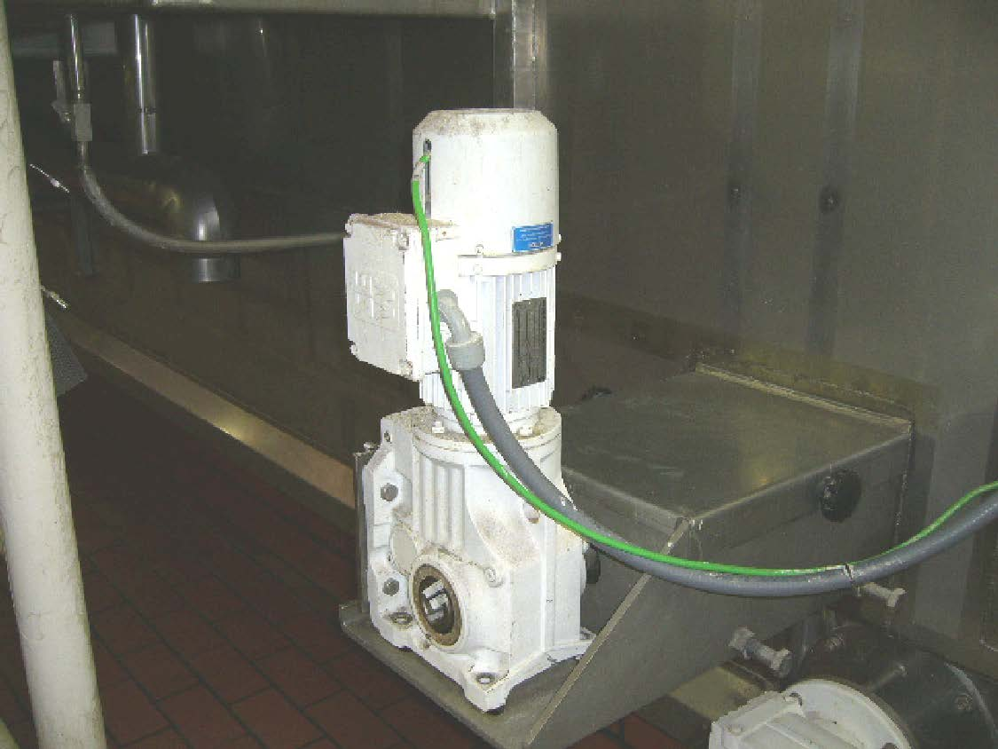 | 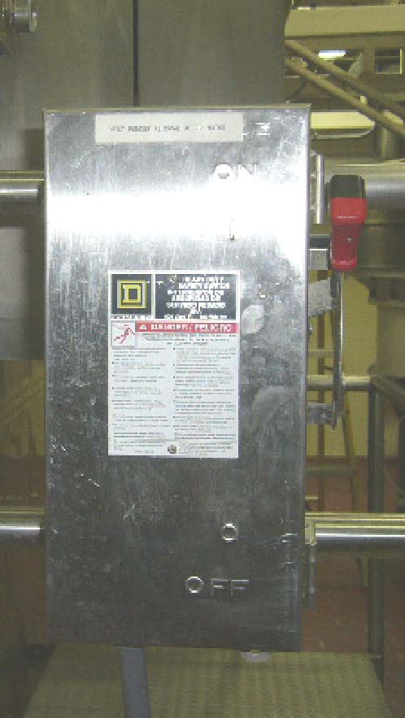

Energy Source | Location | Method | Test
  Electrical | Disconnect is located at the motor. | Turn Disconnect to the off position and apply lockout and tagout. | Attempt to start the equipment to verify  de-energization

Lockout Removal Process
- Ensure all tools and items have been removed. | - Confirm that all employees are safely located. | - Verify that controls  are in neutral. | - Remove lockout devices and reenergize machine. | - Notify affected employees that servicing is completed.

