PURPOSE of Lockout
From time to time, machinery and equipment need servicing or maintenance work. If machinery or equipment is not properly shut down and locked out before maintenance work is performed, it could be energized and cause injury to the servicing employee. This lockout program is designed to protect those employees who service, operate, and work near the machinery from the unexpected start-up of that machinery.

Employee Roles
- Authorized Employees are employees who maintain and service machinery or equipment, and are also employees who operate the machinery and lock it out when it needs servicing, i.e. maintenance workers, machine operators, etc.
- Affected Employees are employees who operate machinery or work in the area where lockout is being performed; i.e. machine operators.

Lockout Application
This lockout program will be used for servicing and maintaining equipment when:
- An employee is required to remove or bypass a guard or safety device.
- An employee is required to place any body part into an area on a machine or piece of equipment in order to perform maintenance or servicing work

Exception to 29 CFR 1910.147(a)(2)(ii)
Minor tool changes and adjustments, and other minor servicing activities, which take place during normal production operations, are not covered by this standard if they are routine, repetitive, and integral to the use of the equipment for production, provided that the work is performed using alternative measures which provide effective protection.
- In order for employees to safely unjam equipment and make minor adjustments during production, alternative measures must be used to provide effective protection, such as interlocked systems which fail to a safe state or detect failures and methods to verify that the alternative measures provide effective protection before making minor adjustments and services.
- This lockout program does not apply to those pieces of equipment that are cord and plug machinery when the cord is disconnected and is under the exclusive control of the authorized employee.

General Rules for Lockout
- Do not attempt to operate any switch, valve, etc. when a machine or piece of equipment is locked out or tagged out.
- Locks are the primary lockout device and should be accompanied by an identity tag at all times. However, never remove a tag by itself outside the lockout/tagout procedure requirements
- Identity tags have a picture and/or a name on them to indicate who is performing lockout. The identity tags are attached to the lockout device.
- Locks used for lockout cannot be used for any other purpose except to lockout machinery or equipment and must be identified as such by color or type.
- Enforce this policy and utilize disciplinary actions if these procedures are not followed.

Storage of Lockout Devices
Locks, tags and other lockout devices used exclusively for lockout are kept in lockout cabinets throughout the facility. The locks kept in the cabinets can be used by anyone who needs to lockout equipment. Employees who wish to have their own personal lock can request one from their supervisor.

Lockout Procedures
(Use the Machine Specific Lockout Procedure Form; located [specify location].)
- Identify which switches, valves, etc. need to be locked out.
- Notify all employees that a lockout is to be used, the reason for it, and the approximate time the lockout will be in effect.
- Go to the lockout cabinets and get as many locks and tags as needed.
- Shutdown the equipment using normal shut down procedures.
- Turn off the main power source to the equipment by pushing the stop button, turning switches, closing valves, etc.
- Apply the locks and identity tags. Remove the keys from the locks and place them in your pockets.
- Dissipate or restrain all potentially hazardous energy sources by repositioning, blocking, bleeding down, purging, neutralizing, etc.
- Verify that the machine has been shut off by trying to start it.
- Return all controls to the “Off” position once it is demonstrated that the machine is unable to start-up.
- Service or maintain the equipment or machinery.
- Check the area around the machine to make sure it is clear of work tools and other employees.
- Replace guards or safety devices that were removed during servicing.
- Remove all locks and identity tags from the machinery and put them back in the lockout cabinet.
- Notify affected employees that servicing is finished.
- Start up the machinery by normal procedures and observe that it works properly.

Temporary Removal of Locks
In situations when the lock must be temporarily removed for testing and positioning purposes, the employee who applied the lock shall remove it and follow these actions:
- Clear the machine of tools and materials.
- Remove employees from the machine area.
- Remove lockout devices.
- Startup machinery and proceed with testing and positioning.
- Shut off all systems and reapply the lock and tags.
The idea is to maintain control of the hazardous zone/machine/process.

Lockout Removal
(Use the Lock Removal Permit/Procedure; see Appendix F)
In situations where a lock must be removed and the employee who applied the lock is not there to remove it, the highest level of management on that shift adheres to the following:
- Verifies that the employee who affixed the lock is not at this facility.
- Makes all efforts to notify the employee that his/her lock was removed.
- Establish control of the area and find any employees working in that area hidden or otherwise. Be especially vigilant in noisy, confined, or low-light conditions
- Cuts off lock and throws the lock away.
- Verbally notifies the employee, when he or she returns to work, that the lock was cut off and the key shall be thrown away.
- Fill out the Lock Removal Permit (App F) and place it in a common file.

Shift or Personnel Changes
- When an authorized employee's shift is over and the machine is still in need of maintenance work, the authorized employee removes his/her lock and identity tag and applies a maintenance tag.
- If an authorized employee on a later shift is to finish servicing the machine, that employee applies a lock and identity tag to the machine and follows normal lockout procedures.
- When servicing is complete, the last authorized employee to work on the machine shall remove his/her lock, identity tag and the maintenance tag.

Group Lockout
When more than one authorized employee services the machinery, the lockout procedures defined in this program may be used as is or a lockbox can be utilized. To utilize a lockbox for group lockout, use the following procedures:
- One authorized employee applies all the needed locks to the machinery by following normal lockout procedures.
- That same authorized employee puts all of the keys to the locks in a lockbox.
- The same authorized employee places a lock and an identity tag to the lockbox.
- Every employee who works on the equipment also applies a lock and an identity tag to the lockbox.
- The last employee servicing the equipment removes his/her lock and identity tag, opens the lock box, removes the keys, and unlocks each lock on the equipment by following normal lockout procedures.

Contractor, Outside Personnel, etc.
- Whenever contractors are engaged in servicing or maintenance activities with (enter company name) employees, the outside personnel will adhere to this Lockout Program. Locks and tags will not be provided for outside personnel. Contractors and other outside personnel are to use their own lockout devices.
- Whenever contractors are working exclusively on a project, without (enter company name) employees, they must follow this Lockout Program or follow their own equally effective lockout program. All involved must be qualified, trained and knowledgeable on that specific equipment to perform lockout.

Lockout Training
- Authorized Employees are trained to recognize hazardous energy sources, the type and magnitude of energy available in this work place, and methods and means to perform lockout. Authorized employees will receive annual awareness training.
- Affected Employees are trained in the purpose and use of lockout.
- Initial and annual training on lockout procedures is recommended.
- Refresher training will be conducted when there is a change in the employee’s job assignment, a change in machines, equipment or processes that present a new hazard, or when there is a change in the lockout procedure.
- Refresher training is also conducted when the inspection reveals that employees are not properly locking out machinery. Inspection must occur at least annually, as required by 1910.147(c)(6)(i).

Inspection
(Use the Inspection Form; see Appendix D)
The E, H & S Rep and an authorized employee annually inspect the lockout procedures. This inspection is performed to make sure employees are using proper procedures when locking out machinery to maintain or service it.
- Every authorized employee, except for the one doing the inspection, locks out a machine.
- The E, H & S Rep and the authorized employee helping with the inspection check to make sure proper procedures were followed when the machine was locked out.
- The inspector and each authorized employee review the employee’s role in lockout.
- If proper procedures weren’t followed to lockout the machine, refresher training will be provided. Gross neglect to follow the procedures (such as removing a lock while someone is working) should be grounds for consideration for termination.
- All inspections are documented and maintained for three years.

For more information on Lockout
Review the Occupational Safety and Health Administration (OSHA), Control of Hazardous Energy (Lockout and Tagout), 29 Code of Federal Regulations 1910.147 and ANSI/ASSE Z244.1-2003 (R2008) Control of Hazardous Energy- Lockout and Tagout and Alternative Methods.

Appendices
A. Protective Materials and Hardware
B. Definitions
C. Annual Inspection
D. Annual Inspection Form
E. Machine-Specific Lockout Procedure Form
F. Lock Removal Permit/Procedure

APPENDIX A—Protective Materials and Hardware
Lockout devices are the primary means of isolating hazardous energy. Lockout devices and tags are:
- The only device(s) used for controlling energy
- Used for no other purposes than locking out machines or equipment.
- Capable of withstanding the environment to which they are exposed for the maximum period of time that exposure is expected.
- Standardized within the facility in at least one of the following criteria: color; shape; or size.
- Lockout devices are substantial enough to prevent removal without the use of excessive force or unusual techniques.
- Lockout devices and/or tags indicate the identity of the employee applying the device(s).

APPENDIX B—DEFINITIONS
Affected Employee – An employee whose job requires him/her to operate or use a machine or equipment on which servicing or maintenance is being performed under lockout or tagout, or whose job requires him/her to work in an area in which such servicing or maintenance is being performed.
Authorized Employee – A person who locks out or implements a tagout system procedure on machines or equipment to perform the servicing or maintenance on that machine or equipment. An authorized employee and an affected employee may be the same person when the affected employee’s duties also include performing maintenance or servicing on a machine or equipment when a lockout / tagout system must be implemented.
Capable of being locked out – An energy isolating device is considered to be capable of being locked out either if it is designed with a hasp or other attachment, or through which, a lock can be affixed, or if it has a locking mechanism built into it. Other energy isolating devices are considered to be capable of being locked out, if lockout can be achieved without the need to dismantle, rebuild, or replace the energy isolating device or permanently alter its energy control capability.
Energized – connected to an energy source or containing residual or stored energy.
Energy isolating device – A mechanical device that physically prevents the transmission or release of energy, including but not limited to the following: A manually operated electrical circuit breaker; a disconnect switch; a manually operated switch by which the conductors of a circuit can be disconnected from all ungrounded supply conductors and, in addition, no pole can be operated independently; a line valve; a block; and any similar device used to block or isolate energy. The term does not include a push button, selector switch, and other control circuit type devices.
Energy source – Any source of electrical, mechanical, hydraulic, pneumatic, chemical, thermal, or other energy.
Hot tap – A procedure used in the repair, maintenance, and service activities which involves welding on a piece of equipment (pipelines, vessels, or tanks) under pressure, in order to install connections or appurtenances. It is commonly used to replace or add sections of pipeline without the interruption of service for air, gas, water, steam, and petrochemical distribution systems.
Lockout – The placement of a lockout device on an energy isolating device, in accordance with an established procedure, ensuring that the energy isolating device and the equipment being controlled cannot be operated until the lockout device is removed.
Lockout device – A device that utilizes a positive means such as a lock, either key or combination type, to hold an energy isolating device in the safe position and prevent the energizing of a machine or equipment.
Normal production operations – The utilization of a machine or equipment to perform its intended production and function.
Qualified employee – Qualified employees are those whose work on energized equipment involves either direct contact or contact by means of tools or materials. Only qualified persons may work on electrical circuit parts or equipment that have not been de-energized. Employees may be considered qualified after receiving certified training to work on electrical sources or equipment.
Servicing and/or maintenance – Workplace activities, such as constructing, installing, setting up, adjusting, inspecting, modifying, and maintaining and/or servicing machines or equipment. These activities include lubrication, cleaning or unjamming of machines or equipment and making adjustments or tool changes, where the employee may be exposed to the unexpected energization or startup of the equipment or release of hazardous energy.
Setting up – Any work performed to prepare a machine or equipment to perform its normal production operation.
Tagout – The placement of a tagout device on an energy isolating device, in accordance with an established procedure, to indicate that the energy isolation device and the equipment being controlled may not be operated until the tagout device is removed.
Tagout device – A prominent warning device, such as a tag and a means of attachment, which can be securely fastened to an energy isolating device in accordance with an established procedure, to indicate that the energy isolating device and the equipment being controlled may not be operated until the tagout device is removed.

APPENDIX C—inspection
An inspection of the energy control procedures is conducted at least annually by the Environmental, Health and Safety Plant Representative and an authorized employee. The authorized employee assisting in the inspection is not the one utilizing the energy control procedure being inspected. The purpose of the inspection is to ensure that the procedure and requirements of the policy are being adhered to and to correct any deviations or inadequacies observed. The inspection includes a review, between the inspector and each authorized employee, of that employee’s responsibilities under the energy control procedure being inspected. All inspections are documented. The documentation identifies the machine or equipment on which the energy control procedure is being utilized, the date of the inspection, the employees included in the inspection, and the persons performing the inspection. The inspection documentation is maintained for three years.
To ensure that this program is being properly implemented, random inspections and planned visual observations are conducted to determine if the energy control procedures are adequate and what changes are needed. Refresher training is necessary if the inspections determine deviations from the written program.
Locks are the primary means for controlling hazardous energy. Only under very specific instances is tagout used without lockout. When tagout is used for energy control, the inspector checks if the tag is attached to the machine needing service; Regardless of whether used with a lock or not, tags are not removed without authorization; are never bypassed, ignored, or otherwise defeated; legible and understandable by all authorized and affected employees; able to withstand the environmental conditions; and securely attached to the equipment.

APPENDIX D—Lockout and Tagout Inspection Form

Lockout and Tagout Inspection Form
Date:
Machine Type: | Location:
Supervisor conducting the inspection:
Authorized employee assisting in the inspection:
Comments and recommendations:
Authorized employees involved in the lockout procedure that is being inspected:

APPENDIX E—Machine-specific lockout procedure

Machine-Specific Lockout Procedure
Machine type: | Location:
Manufacturer: | Model number:
Situations requiring lockout:
Does Electrical energy apply? | Is it lockable?
Description or location of the lockout mechanism:
Lockout Devices:
Does Hydraulic energy apply? | Is it lockable?
Description or location of the lockout mechanism:
Lockout devices:
Does Pneumatic energy apply? | Is it lockable?
Description or location of the lockout mechanism:
Lockout devices: | Is it lockable?
Description or location of the lockout mechanism:
Lockout devices:
Does Thermal energy apply? | Is it lockable?
Description or location of the lockout mechanism:
Lockout devices:
Does Chemical energy apply? | Is it lockable?
Description or location of the lockout mechanism:
Lockout devices:
Does Other energy apply? | Is it lockable?
Description or location of the lockout mechanism:
Lockout devices:
Do any other systems feed this device you are isolating? (Yes/No)
If yes, what systems are they and how are they being locked out or lines blanked?

Shut Down and Lockout Procedures:

1.

2.

3.

4.

5.

6.

7.

8.

9.

Means to verify non-operable status:

Special Precautions to be taken during start-up:

Other Comments:

Completed by: Date:

Approved by: Date:

APPENDIX F—Lockout and tagout lock removal permit and procedure
When lockout/tagout devices are removed by anyone other than the person who applied the devices, the following steps must be taken:
- Locks are removed only by the highest level of management on that shift.
- Verify that the authorized employee who applied the lock is not at the facility.
- Make every effort to contact the authorized employee and inform him/her that their lock has been removed.
- Cut off the lock and throw the lock away.
- Fill out this permit and place it in a common file.
- Upon returning to the facility and prior to resuming work, verbally notify the employee that the lock was cut off.
Lock Number: | Employee:
Lock removed by: | Authorized by:
Date:

APPENDIX G—machine-specific lockout PROCEDURES
[enter name]
The following is an example of the steps that should be taken when locking out machinery, such as the [Enter name of machine], to perform servicing or maintenance work.
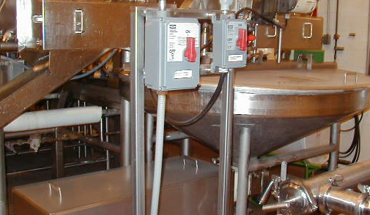
- To begin lockout, identify which switches, disconnects, valves, etc., need to be locked out. [Enter photo of your machine.]
Name of machine disconnect

- Notify all employees that a lockout is to be used to service the [Enter name of machine] and approximate time it will take.
- Get locks and identity tags from lockout cabinet.
- Shut down the [name of machine] using normal shutdown procedures.
- Isolate the main power source to the hopper pump by placing the [Enter name of machine] disconnect into the OFF position and apply the lock and your identity tag. (Put key to the lock in your pocket).
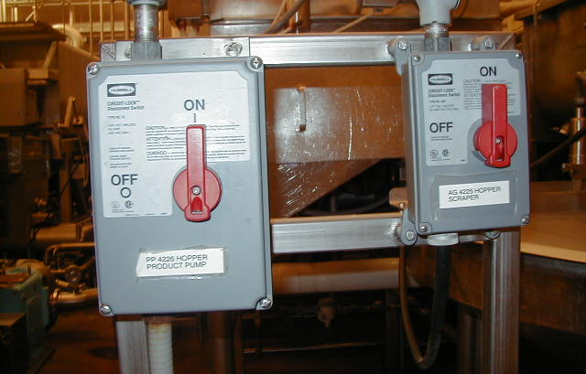
- Verify that the pump has been shut off by trying to start it.
Pump disconnect
- Once demonstrated that the pump will not start, return controls to the OFF position.
- Service or maintain the pump.

Unlocking Procedures
- Clear the area around the pump of work tools and employees.
- Remove lock and identity tags from the hopper pump disconnect and put them back in the lockout cabinet.
- Notify employees that servicing is finished.
- Start up the pump using normal start up procedures.
EXAMPLE

APPENDIX H—MACHINE-SPECFIC LOCKOUT PROCEDURES
[ENTER MACHINE NAME]
When servicing or maintaining equipment or machinery with more than one energy source, such as the [enter machine name], lockout procedures shall be utilized.

Locking Procedures
The following example specifies what steps are needed to properly lockout the [enter machine name] and can be used as a guide when servicing equipment with more than one energy source.
- To begin lockout, identify which switches, valves, etc. need to be locked out.

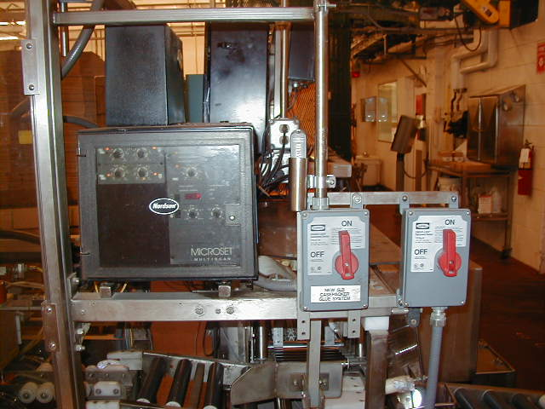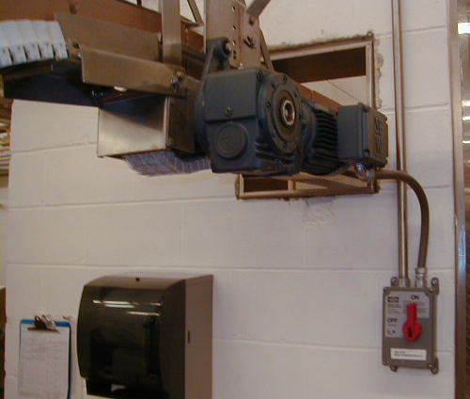
Identify
Identify
Identify

- Notify all employees that you are locking out the [enter machine name] for servicing and estimate how long it should take.
- Go to the lockout cabinets and get as many locks and identity tags and other lockout devices as needed.
- Shut down the case packer using normal shutdown procedures utilizing the control panel.
EXAMPLE
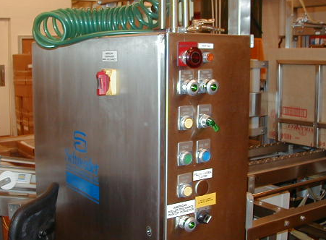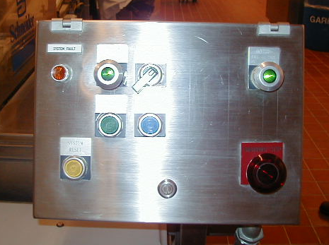
Primary electrical isolation device for the [Enter machine name]
- Isolate the main power source to the equipment by closing compressed air ball valves, disconnecting electrical sources by placing disconnect switches in the “off” or “open” position, etc.
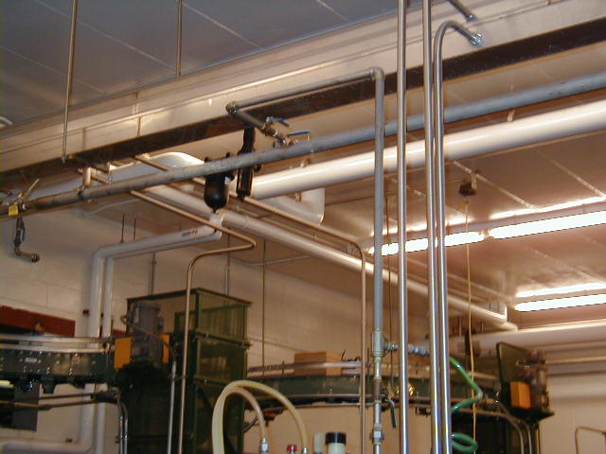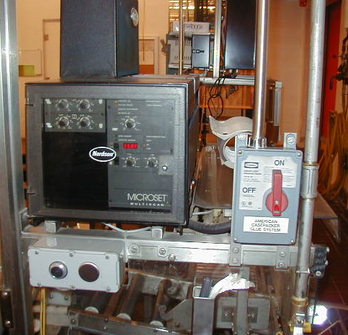
(#1) Compressed air isolation valve (#2) Hot melt electrical supply
- Apply the lockout devices. Remove keys and place them in your pockets.
- Dissipate or restrain all potentially hazardous energy by blocking, bleeding down, etc.
- Verify that the machine has been shut off by trying to start it. Turn (#1) and (#2) in the above pictures to the “on” position.
- Return all controls to the “off” position after verifying the machines inoperable status.
- Service or maintain the [enter machine name].
EXAMPLE

Unlocking Procedures
- When finished servicing, clear the area of tools and employees.
- Replace guards or safety devices.
- Remove all lockout devices and put them back in the lockout cabinet.
- Notify all affected employees that servicing is finished.
- Start up the machinery using normal start up procedures.

